Algebra 2 w/ Trig

4.7 Write and Apply Exponential and Power Functions

Warm-Up:

**1. Write an equation in slope-intercept form for the line through** (2, 5) **and** (6, –3)**.**

FYI:

Slope-intercept: $y=mx+b$

Point-slope: $y-y_{1}=m(x-x_{1})$

**2. Write an equation in point-slope form for the line through** (2, 4.53) **and** (5, 5.22)**.**

**3.** **What is the value of** *y***if the point** (10, *y*) **is on the line** *y* = 5.8*x* + 2.4**?**

--------------------------------------------------------------NOTES-----------------------------------------------------------------------------------------

Example 1: Write an exponential function

**Write an exponential function $y=ab^{x}$ whose graph passes through** (1, 12) **and** (3, 108)**.**

Example 2: Find an Exponential Model

**A store sells motor scooters. The table shows the number** *y***of scooters sold during the $x^{th}$ year that the store has been open.**



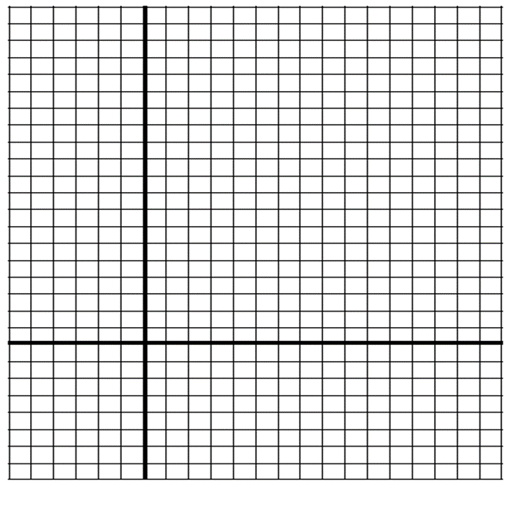**Draw a scatter plot of the data pairs** (*x*, ln *y*)**. Is an exponential model a good fit for the original data pairs** (*x*, *y*)**?**

**• Find an exponential model for the original data.**

Example 3: Use Exponential Regression

**Use a graphing calculator to find an exponential model for the data in Example** 2**. Predict the number of scooters sold in the eighth year.**

YOU TRY:

**Write an exponential function $y=ab^{x}$ whose graph passes through the given points.**

**1.** (1, 6), (3, 24) **2.** (2, 8), (3, 32) **3.** (3, 8), (6, 64)

**4. WHAT IF? In Examples 2 and 3, how would the exponential models change if the scooter sales were as shown in the table below?**

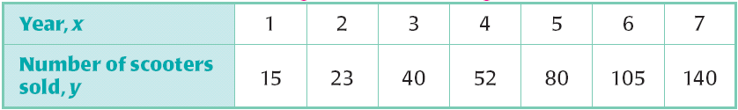

Example 2: Example 3:

Example 4: Write a Power Function

**Write a power function $y=ax^{b}$ whose graph passes through** (3, 2) **and** (6, 9).

YOU TRY:

**Write a power function $y = ax^{b}$ whose graph passes through the given points.**

5. (2, 1), (7, 6) **6.** (3, 4), (6, 15) **7.** (5, 8), (10, 34)

**8. Try using the method of Example 4 to find a power function whose graph passes through** (3, 5) **and** (3, 7)**. What can you conclude?**

Example 5: Find a Power Model

**The table at the right shows the typical wingspans** *x***(in feet) and the typical weights** *y***(in pounds) for several types of birds.**

**Draw a scatter plot of the data pairs (ln** *x***, ln** *y***). Is a power model a good fit for the original data pairs** (*x*, *y*)**?**

**• Find a power model for the original data.**

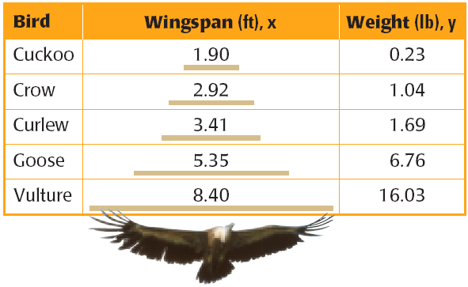

Example 6: Use a Power Regression

**Use a graphing calculator to find a power model for the data in Example** 5**. Estimate the weight of a bird with a wingspan of** 4.5 **feet.**

YOU TRY:

**9. The table below shows the atomic number** *x***and the melting point** *y***(in degrees Celsius) for the alkali metals. Find a power model for the data.**

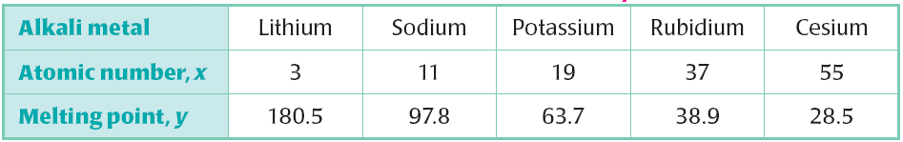

KEEP GOING:

1. **Write an exponential function** *y* = *abx* w**hose graph** **passes through** (2, 48) **and** (4, 768)**.**
2. **Find an exponential model for the data in the table.**

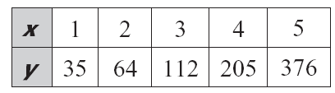

1. **Write a power function** *y* = *axb***whose graph** **passes through** (3, 8) **and** (6, 35)**.**
2. **Find a power model for the data in the table.**

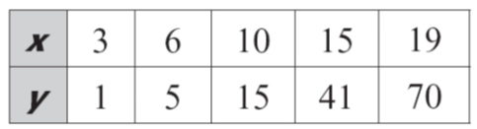

Hw: Section 4.7 p. 285 #3-9 odd, 15-21 odd