College Algebra 1
Section 5.6 – Parallel and Perpendicular Lines

Objective(s): To determine whether lines are parallel, perpendicular or neither.
To write equations of parallel and perpendicular lines.

Starter:
- Find the x- and y-intercepts of the given equation $-2x+4y=-24$

- Graph each equation

  - $y=4$
  - $x=-3$

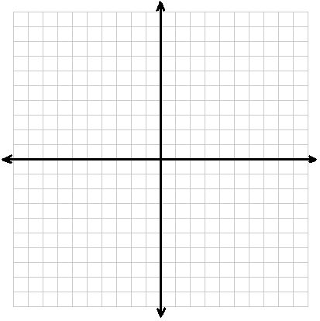

- Write each equation in standard form.

  - $y=\frac{1}{2}x-2$
  - $y+2=\frac{2}{3}\left(x+4\right)$

Notes: Parallel Lines
Graph the following lines on the given Coordinate axis.
What do you notice about the graphs of these lines?
$$y=2x-2$$
$$4y=8x+8$$
$$6y=12x+6$$
$$3y=6x-4$$
$$-2x+y=4$$
$$-2y=-4x+12$$
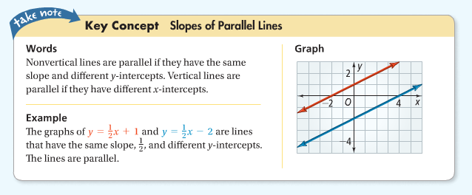

- You can use the fact that the slopes of parallel line are the same to write the equation of a line that is parallel to a given line.

Problem 1: Writing an equation of a Parallel Line
- A line passes through the point (12, 5) and is parallel to the graph of $y=\frac{2}{3}x-1$. What equation represents the line in slope-intercept form?

Step 1: Identify the slope of the given line.

Step 2: Write an equation of the line passing through (12, 5) with the slope from step 1.

Graph both lines to check your solution.

- Write an equation of a line that passes through (-3, -1) and is parallel to the graph of $y=2x+3$. Write the equation in slope-intercept form.

Step 1: Identify the slope of the given line.

Step 2: Write an equation of the line passing through (-3, -1) with the slope from step 1.

Graph both lines to check your solution.
Try these problems…

Write an equation in slope-intercept form of the line that passes through the given point and is parallel to the graph of the given equation.
- $\left(1, 3\right);y=3x+2$ | - $\left(1, -3\right);y+2=4\left(x-1\right)$
- $\left(2, -2\right);y=-x-2$ | - $\left(2, -1\right);y=-\frac{3}{2}x+6$
- $\left(4, 2\right);x=-3$ | - $\left(0, 0\right);y=\frac{2}{3}x+1$
Notes: Perpendicular Lines

Graph the pair of lines on the coordinate axis. Please label each line.
A: $y=\frac{1}{2}x-3$ C: $3x+y=3$
B: $y=-2x+2$ D: $y=\frac{1}{3}x$

What do you notice about the graphs of A and B?

What do you notice about the graphs of C and D?

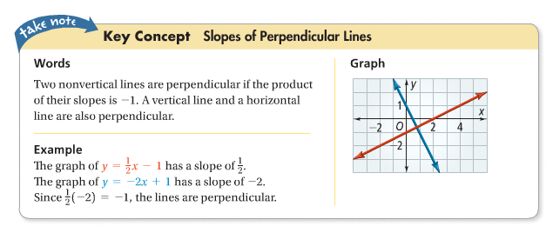

- You can use slope to determine whether two lines are perpendicular. Perpendicular lines are lines that intersect to form right angles
- Perpendicular lines have slopes that are opposite reciprocals of each other
  - Ex: $m=\frac{2}{3}, m perpendicular=-\frac{3}{2}$
  - Ex: $m=-2, m perpendicular=\frac{1}{2}$
Problem 2: Writing an Equation of a Perpendicular Line

- Write the equation of the line that passes through the point (2, 4) and is perpendicular to the graph of $y=\frac{1}{3}x-1$.

Step 1: Identify the slope of the given equation

Step 2: Find the opposite reciprocal of the slope from step 1.

Step 3: Use the slope from step 2 and the point to write the equation of the line.

- Write the equation of the line that passes through the point (1, 8) and is perpendicular to the graph of $y=2x+1$.

Step 1: Identify the slope of the given equation

Step 2: Find the opposite reciprocal of the slope from step 1.

Step 3: Use the slope from step 2 and the point to write the equation of the line.

You try…
Write an equation is slope-intercept form of the line that passes through the given point and is perpendicular to the graph of the given equation.

- $\left(0, 0\right);y=-3x+2$
- $\left(-2, 3\right);y=\frac{1}{2}x-1$

- $\left(1, -2\right);y=5x+4$
- $\left(-3, 2\right);x-2y=7$

- $\left(5, 0\right);y+1=2\left(x-3\right)$
- $\left(1, -6\right);x-2y=4$

HW: 5.6 p. 334 #7-27 odd, 28-30

