College Algebra 1
5.1 Rate of Change and Slope
Objectives: Students will be able to (a) find rates of change from tables and (b) find slope.
Starter:

You can use ratios to show a relationship between changing quantities, for example vertical and horizontal change.
___________________shows the relationship between two changing quantities.
When one quantity depends on the other, the following is true:

= --------------------

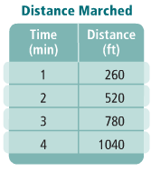
Finding Rate of Change Using a Table:
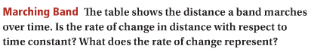

You Try:
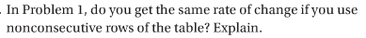

________ is the ratio of the vertical change (or rise) to the horizontal change (or run) between two points on the line.
=
**Moving up or to the right are positive movements
**Moving down or the left are negative movements
Finding the Slope Using a graph:
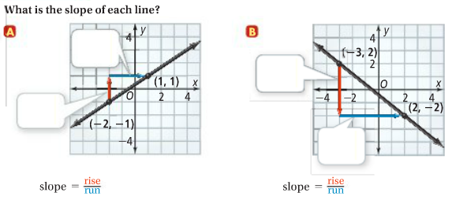

You try:
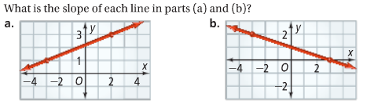

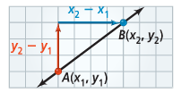
You can also use any two points on a line to find its slope.

Two find slope given two points:
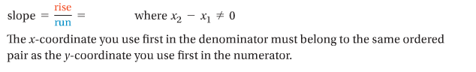

Finding Slope Using Points:

You Try:

Finding Slopes of Horizontal and Vertical Lines:
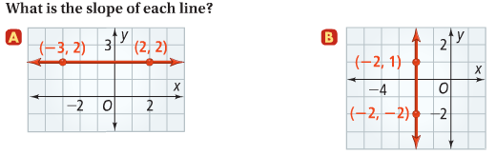
You Try:

5.2 Direct Variation
Objective: Students will be able to write and graph an equation of a direct variation.

**If the ratio of two variables is constant, then the variables have a special relationship. This relationship is known as ________________________________.
A direct variation is a relationship that can be represented by a function the form y = kx, where k is not equal to 0. The _________________________________________________________ k is the coefficient of x. By dividing each side of y = kx by x, you can see that the ratio of the variables is constant:

To determine if an equation is a direct variation solve for y!! If y = kx and k is not equal to 0 it represents a direct variation.

Identifying a Direct Variation:

You try:

Writing a Direct Variation Equation:

You Try:

Application and Graph:
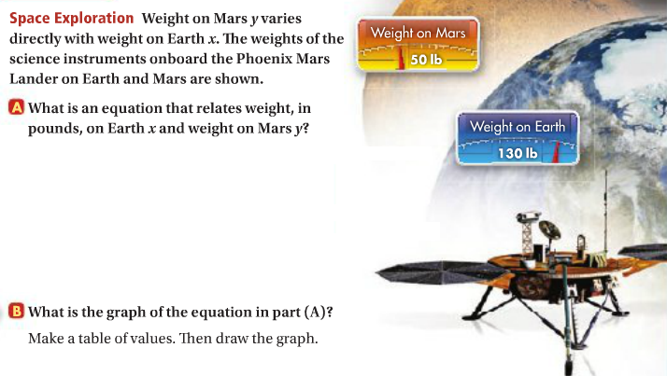

Concept Summary: Graphs of Direct Variation:
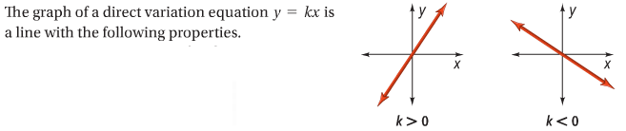

Writing a Direct Variation from a Table:
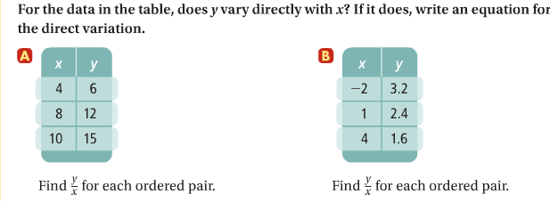

You Try:
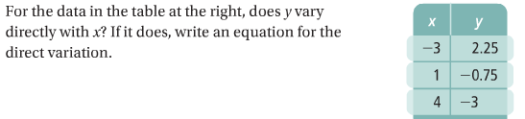

Hw: Section 5.2 p. 304 #9-29 odd, 30-32, 37-43 odd

