College Algebra 1
5.3 Slope-Intercept Form
Objectives: Students will be able to (a) write linear equations using slope intercept form and (b) graph linear equations in slope intercept form.
Starter:
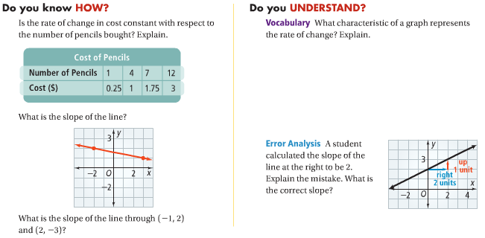

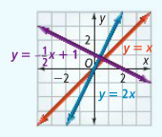
Recall: Linear Function: a function whose graph is a line is a linear function.
All graphs have what we call a ________________________. This is the simplest function with specific characteristics.
The __________________________________ is y = x or f(x) = x.
The following are examples of linear Functions:
A_______________________________ is an equation that models a linear function. The variables within a linear equation cannot be raised to a power other than 1.
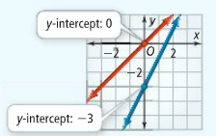
Graphs cross both the x and y axes. The point we will focus on is the ________________________ (the point the graph crosses the y axis.
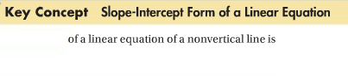
Identifying Slope and the y-intercept:

You Try:
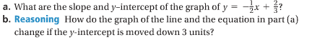

Writing an Equation in Slope-Intercept Form:

You Try:

Writing an Equation from a graph:
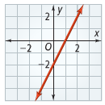
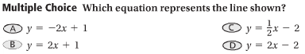

You try:
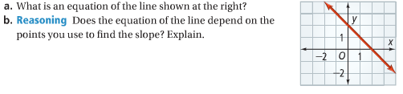

Writing an Equation from Two Points:

You Try:

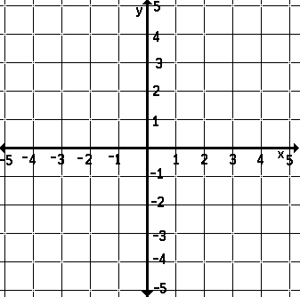
Graphing a Linear Equation:

You Try:
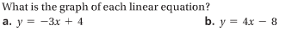
Real Life Application:
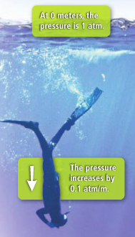
Modeling a Function:
