Algebra 2 w/ Trig
5.4 Multiplying and Dividing Rational Expressions
Warm-Up:
Factor the expression.
HINT FOR #3:
$$a^{3}-b^{3}=\left(a-b\right)\left(a^{2}+ab+b^{2}\right)$$
$$a^{3}+b^{3}=(a+b)(a^{2}-ab+b^{2})$$

- 10x – 5x² 2. x² – 2x – 48 3. x³ – 125

-------------------------------------------------------------------NOTES------------------------------------------------------------------------------------
Example 1: Simplify a Rational Expression
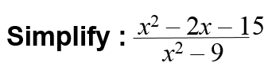

YOU TRY:
Simplify the expression, if possible.
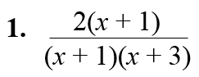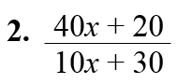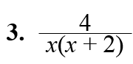

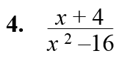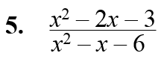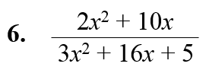

Example 2: Multiple Choice!
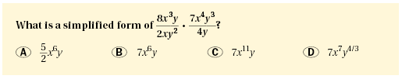
Example 3: Multiplying Rational Expressions Example 4: Multiply a Rational Expression by a Polynomial
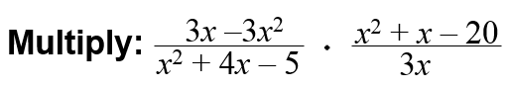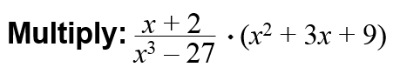

YOU TRY: Multiply the expressions. Simplify the result.
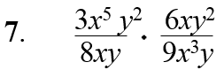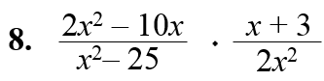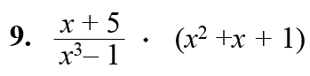

Example 5: Dividing Rational Expressions Example 6: Divide a Rational Expression by a Polynomial
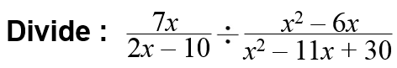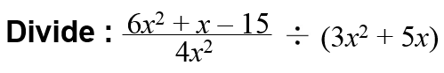

YOU TRY: Divide the expressions. Simplify the result.
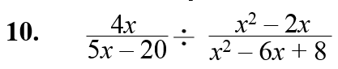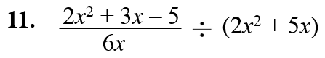

KEEP GOING:
Perform the operation.
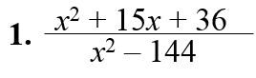

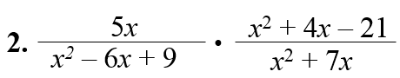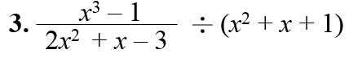

- A cube has edge length x. A rectangular prism has a square base with side length x and height x + 2. Write an expression in simplest form for the ratio of the surface area of the prism to the surface area of the cube.

Hw: Section 5.4 p. 331 #5-41 every other odd

