5.4 Point-Slope Form of a Linear Equation

Objective: Students will be able to write and graph linear equations using point-slope form.

Starter:

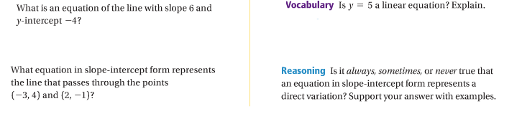

You have learned how to write an equation of a line by using its y-intercept. In this lesson, you will learn how to write an equation without using y intercept.

You can use the slope of a line and any point of the line!!!

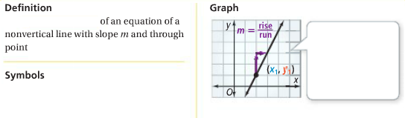

Writing an Equation in Point-Slope Form:





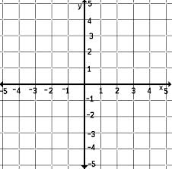Graphing Using Point-Slope Form:





Using Two Points to Write an Equation:

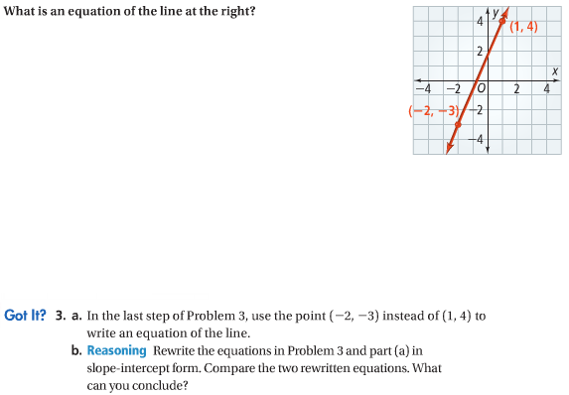

Using a Table to Write an Equation:

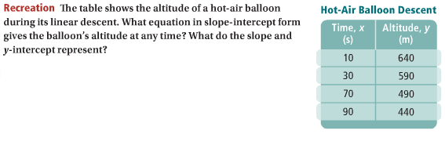

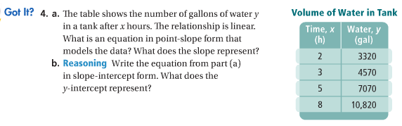

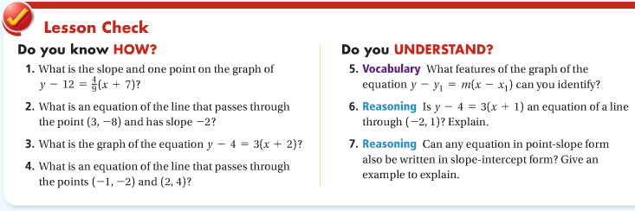

**Practice!!!!!!**

Hw: Section 5.4 p. 318 #8-21, 24-26

**Write an equation in point-slope form of the line that passes through the given point and has the given slope.**

|  |  |  |
| --- | --- | --- |
| **1.** (1, 3); *m =* 5 | **2.** (–2, –1); *m =* –3 | **3.** (4, –7); *m =* |

**Graph each equation.**

|  |  |  |
| --- | --- | --- |
| **4.** *y +* 1 = 3(*x –* 2) | **5.** *y –* 4 = –1(*x +* 2) | **6.** *y –* 3 = –2(*x +* 4) |

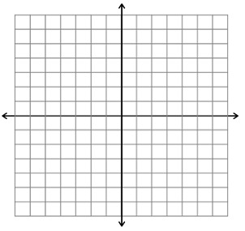

**Graph the line with the given point and slope.**

|  |  |  |
| --- | --- | --- |
| **7.** (–1, –3); *m =* 2 | **8.** (–3, –2); *m =* –4 | **9.** (–2, 6); *m =* |



**Write an equation in Point-Slope form for each line:**

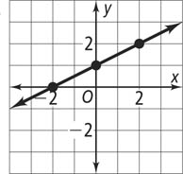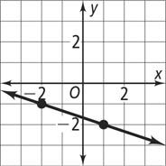**10. 11.**

**Write the equation of the line that passes through the given points in Point-Slope form. Then write the equation in slope-intercept form.**

|  |  |
| --- | --- |
| **12.** (5, 1), (0, 2) | **13.** (–2, –3), (4, 3) |