Algebra 2 w/ Trig
5.5 Adding and Subtracting Rational Expressions
Warm-Up:
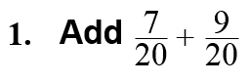

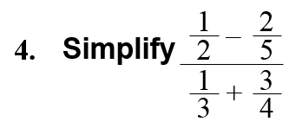
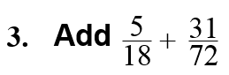

----------------------------------------------------------------NOTES---------------------------------------------------------------------------------------
Example 1: Add or Subtract with Like Denominators
Perform the indicated operation.
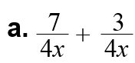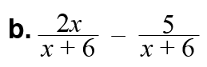

YOU TRY: Perform the indicated operation and simplify.
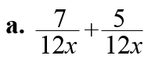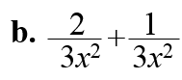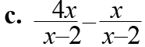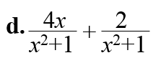

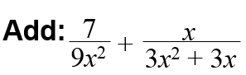
Example 2: Find a Least Common Multiple (LCM) Example 3: Add with Unlike Denominators
Find the least common multiple of 4x² –16 and 6x² –24x + 24.

Example 4: Subtract with Unlike Denominators
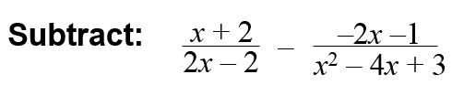

YOU TRY:
Find the least common multiple of the polynomials.
5. 5x³ and 10x²–15x 6. 8x – 16 and 12x² + 12x – 72

Add or subtract with unlike denominators.
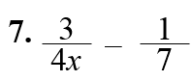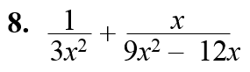

Hw: Section 5.5 p. 340 #3-23 odds
5.5 Day 2!
Warm Up: Add or subtract with unlike denominators.
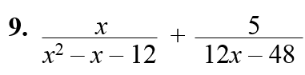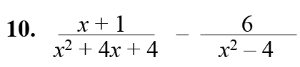

-----------------------------------------------------------------NOTES--------------------------------------------------------------------------------------
Example 5: Simplify a Complex Fraction (Method 1)
Let f be the focal length of a thin camera lens, p be the distance between an object being photographed and the lens, and q be the distance between the lens and the film. For the photograph to be in focus, the variables should satisfy the lens equation below. Simplify the complex fraction.
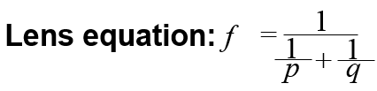

Example 6: Simplify a Complex Fraction (Method 2) YOU TRY:
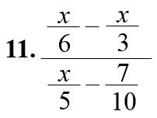
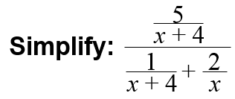

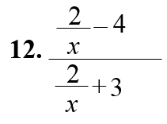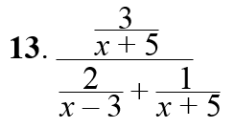

KEEP GOING:
- Find the least common multiple of 3x² – 6x – 45 and 2x² – 20x + 50.

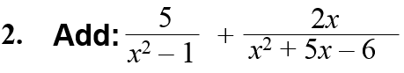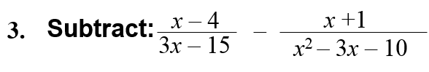

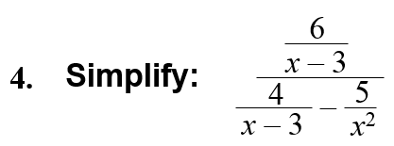
Hw: Section 5.5 p. 340 #27-33 all

