College Algebra 1
Section 5.5 – Standard Form

Starter(s):

- Write an equation of a line in Point-Slope form that goes through point (-3,2) and has a slope of -5.

- Write an equation of a line in Point-Slope form that goes through points (1,2) and (5,6). Then switch the equation to Slope-Intercept form.

Objective: To graph linear equations using intercepts and to write linear equations in standard form.

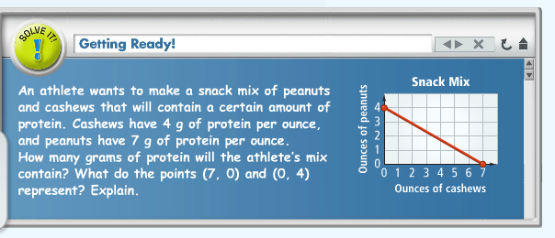

x-intercept:
y-intercept:

Problem 1: Finding the x- and y-intercepts
What are the x- and y-intercepts of the graph of $3x+4y=24$?

Step 1: To find the x-intercepts, substitute 0 in for y. Solve for x.

Step 2: To find the y-intercepts, substitute 0 in for x. Solve for y.

Try it!

a) $5x-6y=60$
b) $3x+8y=12$

Problem 2: Graphing a Line Using Intercepts
Try it!
What is the graph of $x-2y=-2$?
What is the graph of $2x+5y=20?$

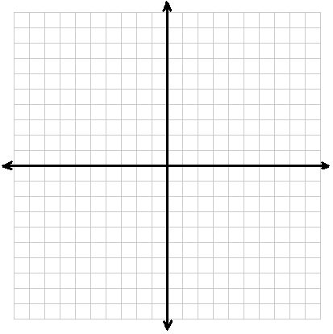

Problem 3: Graphing Horizontal and Vertical Lines

$x=3$ $y=2$

Problem 4: Transforming to Standard Form
- Given an equation in point-slope form or y-intercept form, you can rewrite the equation in Standard Form.

What is $y=-2x+5$ written in standard form?

What is $y=\frac{3}{7}x+2$ written in standard form?

What is $y-2=-\frac{1}{3}(x+6)$ written in standard form?

You try!
Hw: 5.5 p. 326 #17-22, 27-38, 52, 60
- What are the x- and y-intercepts of the graph of $3x-4y=9?$

- What is the graph of $5x+4y=20?$

- What is the graph of $y=-2$? What type of line is it?

- What is $y=\frac{1}{2}x+3$ written in standard form?

