College Algebra 1
5.7 Scatter Plots and Trend Lines
Starter:
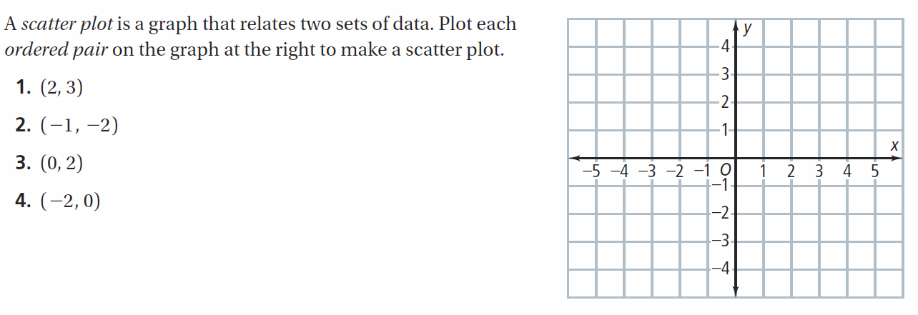
Scatter Plots and Prediction Equations
Data with two variables, such as year and number of visitors, are called _____________. A set of bivariate data graphed as ordered pairs in a coordinate plane is called a ___________ or _________. A ____________ is a measure of the strength of a relationship between two quantities.
A scatter plot can show whether there is a _______, ________, or ____ correlation between two variables. Correlations are usually described as ______ or ______. In a strong correlation the points of the scatter plot are closer to the graph of the line than the points representing a weak correlation. When you find a line that closely approximates a set of data, you are finding a ______________ for the data. _______________ is when a change in one quantity causes a change in a second quantity. A correlation between quantities does not always imply causation.
An equation of such a line is often called a _______________ because it can be used to predict one of the variables given the other variable. To find the line of best fit and a prediction equation for a set of data, select two points that appear to represent the data well. This is a matter of personal judgment so your line and prediction equation may differ from those of others.
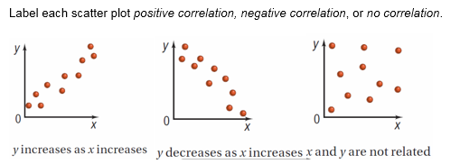

- GOT IT? Consider the population of a city and the number of letters in the name of the city. Would you expect a positive correlation, a negative correlation, or no correlation between the two sets of data? Explain your reasoning.

- GOT IT? Consider the cost of a family's vacation and the size of their house. Is there likely to be a correlation? If so, does the correlation reflect a causal relationship? Explain.
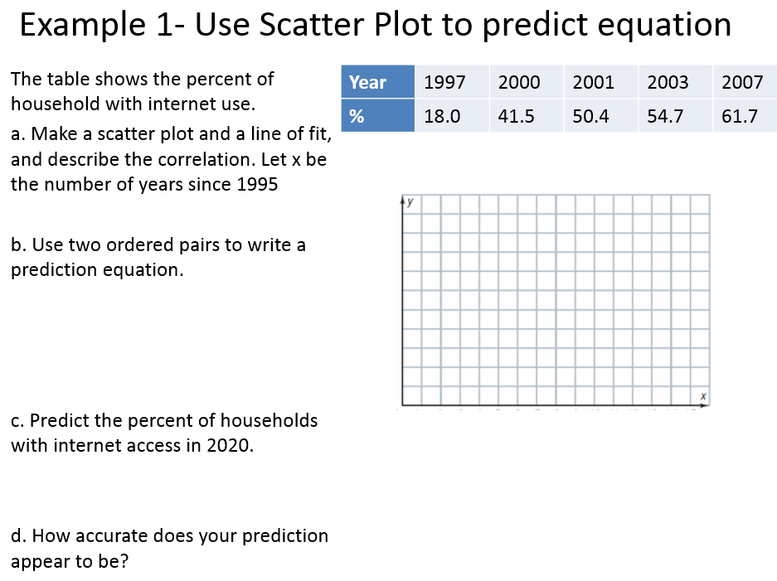

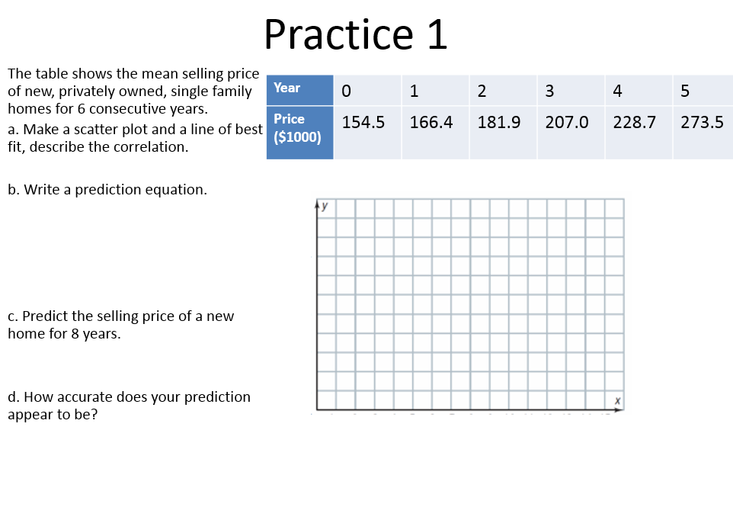

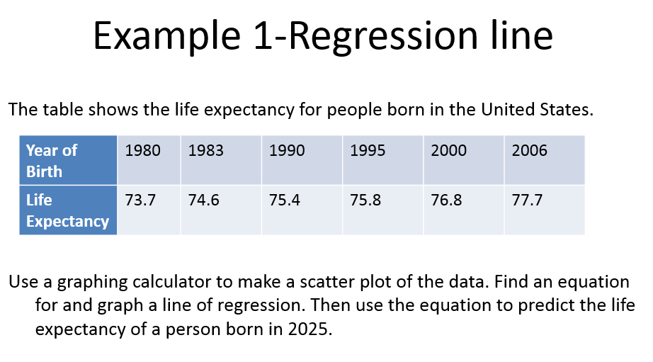

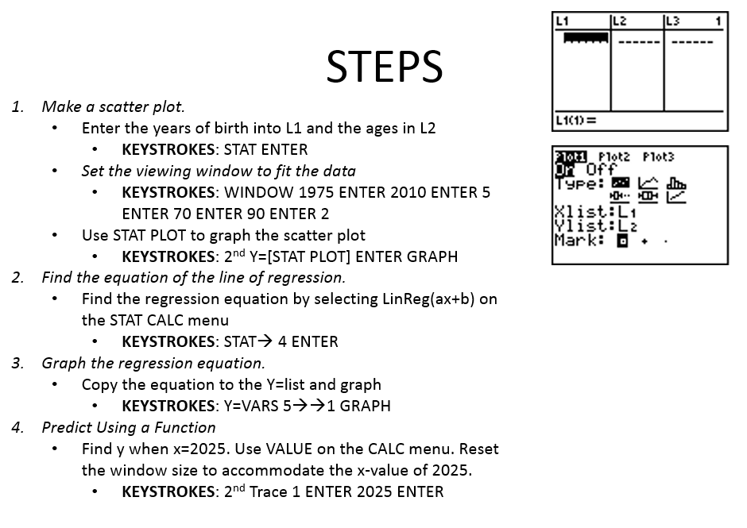
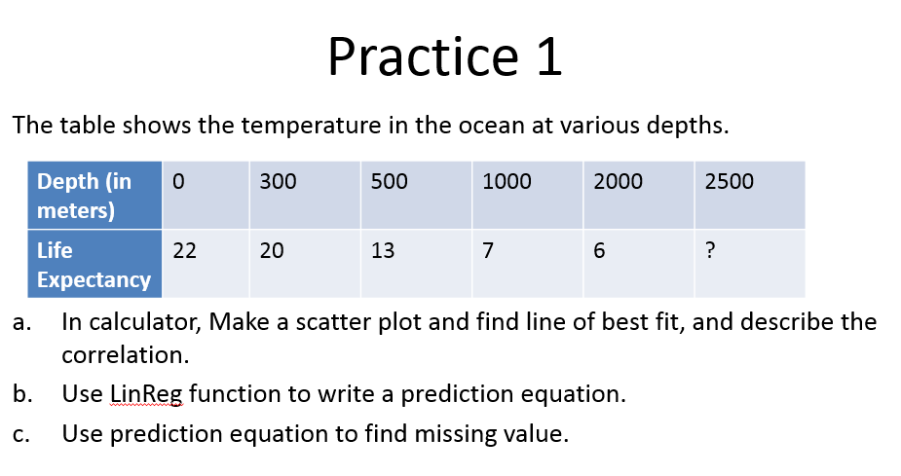

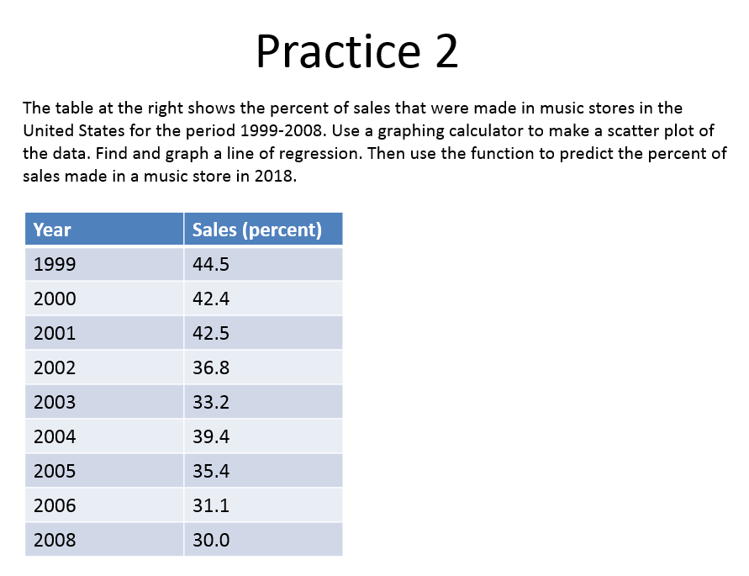
Hw: Section 5.7 p. 340 #1-6 (Use Graph Paper)

