College Algebra 1

5.8 Graphing Absolute Value and Step Functions

Aim: How do we graph an absolute value function?

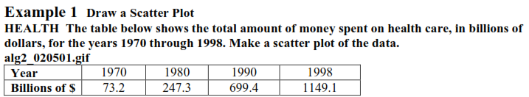

2. Find a prediction equation.

3. Predict the amount of money spent on healthcare in 2005.

Example - Graphing an absolute value function

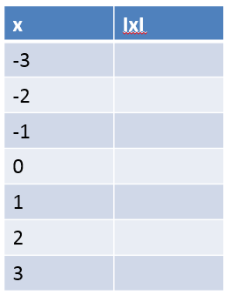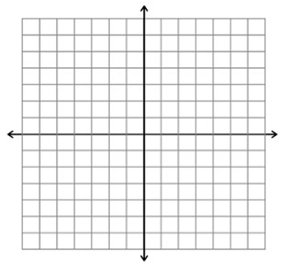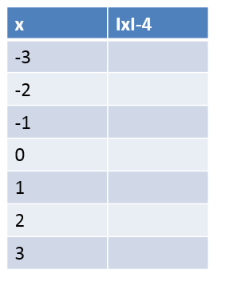 

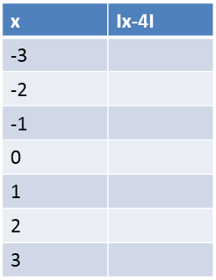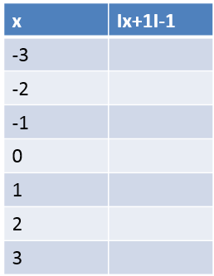 

***RULES***



Example 5- Graphing absolute value function without a table





Practice!!!!

   

STEP FUNCTIONS. . .

Hw: Section 5.8 p. 348 #1-8, 9-33 odd

|  |  |
| --- | --- |
| Example)  An automotive repair center charges $50 for any part of the first hour of labor, and $35 for any part of each additional hour. Draw a graph that represents this situation. | Practice)  One psychologist charges for counseling sessions at a rate of $85 per hour or any fraction thereof. Draw a graph that represents this situation. |