Algebra 2 w/ Trig

6.1 Use Combinations

Warm Up:

HINT: $7!=7∙6∙5∙4∙3∙2∙1$

**Evaluate the expression.**

**1.** 5! **2.** (4 *–* 2) !3!

**3**. **4.** 7 *P*5

**5.** **In how many ways can** 6 **people line up to buy tickets for a movie?**

-----------------------------------------------------------------NOTES--------------------------------------------------------------------------------------

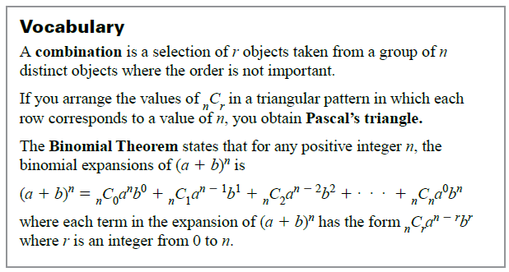

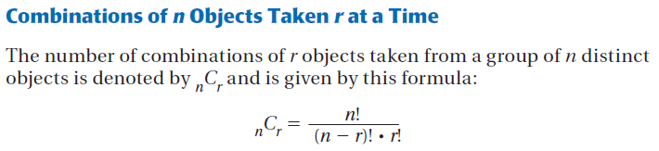

Example 1: Find Combinations

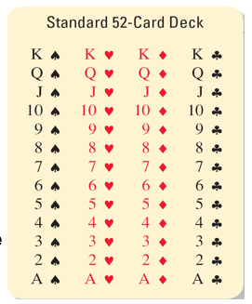**A standard deck of** 52 **playing cards has** 4 **suits with** 13 **different cards in each suit.**

1. **If the order in which the cards are dealt is not important, how many different** 5-**card hands are possible?**
2. **In how many** 5**-card hands are all** 5 **cards of the same color?**

Example 2: Decide to Multiply or Add Combinations

**William Shakespeare wrote** 38 **plays that can be divided into three genres. Of the** 38 **plays,** 18 **are comedies,** 10 **are histories, and** 10 **are tragedies.**

1. **How many different sets of *exactly*** 2 **comedies and** 1 **tragedy can you read?**
2. **How many different sets of *at most*** 3 **plays can you read?**

Example 3: Solve a multi-step problem

**During the school year, the girl’s basketball team is scheduled to play** 12 **home games. You want to attend *at least*** 3 **of the games. How many different combinations of games can you attend?**

YOU TRY:

**Find the number of combinations.**

**1.** 8*C*3 **2.** 10*C*6

**3.** 7*C*2 **4.** 14*C*5

**5. What If? In Example** 2**, how many different sets of *exactly*** 3 **tragedies and** 2 **histories can you read?**

**KEEP GOING:**

**Find Combinations**

1. Committee Members - The board of directors of an organization has 7 members. In how many ways can the board choose a committee of 3 board members?

Find the number of combinations.

2. 6C4 3. 10C7 4. 9C3 5. 13C2

6. A teacher is holding tryouts for the school musical. There are 15 students trying out for 7 identical chorus parts. In how many ways can the teacher select the chorus members?**Decide to Multiply or Add**

7. Sporting Events - Your school has scheduled three rugby games, four football games, and two soccer games.

In how many ways can you go to two rugby games and one other game?

In how many ways can you go to at least three of the four football games?

Find the number of possible 5-card hands that contain the cards specified. The cards are taken from a standard 52-card deck.

8. 5 red cards 9. 3 face cards and 2 cards that are not face cards

10. 2 aces and 3 cards that are not aces 11. At most 1 diamond

12. A youth soccer team has 6 starting players. The starting players must consist of 3 boys and 3 girls. There are 7 boys and 6 girls on the team. Each player can play each position. In how many ways can the coach select players to start the game?

13. You have a plastic sheet that holds 9 trading cards. You want to fill the sheet with football cards consisting of 4 quarterbacks, 3 running backs, and 2 wide receivers. In your collection of cards, you have 10 quarterbacks, 7 running backs, and 8 wide receivers. In how many different ways can you select the cards?

HW: pg 382 #2-18 all, 38-40 all

Algebra 2 w/ Trig

6.1 Day 2! (Binomial Theorem)

Warm-Up:

1. **Find** 9*C*5**.**
2. **The manager of a chain of restaurants must choose** 6 **restaurants from** 11 **for a promotion.   
   How many different selection can be made?**
3. **A committee consists of** 10 **Republicans and** 8 **Democrats. In how many ways can a subcommittee be chosen if it has** 5 **Republicans and** 4 **Democrats?**

-----------------------------------------------------------------------NOTES--------------------------------------------------------------------------------

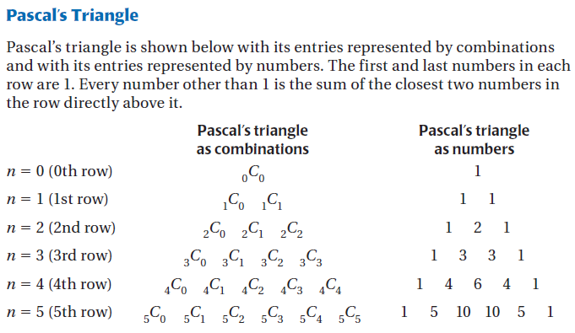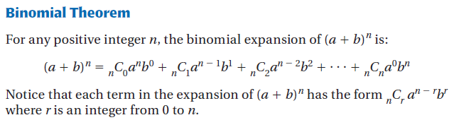

Example 4: Use Pascal’s Triangle

**The** 6 **members of a Model UN club must choose** 2 **representatives to attend a state convention. Use Pascal’s triangle to find the number of combinations of** 2 **members that can be chosen as representatives.**

YOU TRY:

**What If? In Example** 4**, use Pascal’s triangle to find the number of combinations of** 2 **members that can be chosen if the Model UN club has** 7 **members.**

Example 5: Expand a Power of a Binomial Sum Example 6: Expand a Power of a Binomial Difference

**Use the binomial theorem to write the binomial expansion.**

*(x*2 + *y*)3 (*a* –2*b* )4

YOU TRY:

**Use the binomial theorem to write the binomial expansion.**

**7.** (*x* + 3)5 **8.** (*a* + 2*b*)4

**9.** (2*p* – *q*)4 **10.** (5 – 2*y*)3

Example 7: Find a Coefficient in an Expansion

**Find the coefficient of** *x*4 **in the expansion of** (3*x* + 2)10**.**

YOU TRY:

**11. Find the coefficient of** *x*5 **in the expansion of** (*x* – 3)7**. 12. Find the coefficient of *x*3 in the expansion of (2*x* + 5)8.**

KEEP GOING:

**Use Pascal’s Triangle**

1. Committee Members - Use Pascal’s triangle to find the number of combinations of 3 committee members chosen from 8 available members.

**Expand a Power of a Binomial Difference**

1. Use the binomial theorem to write the binomial expansion.



**Find a Coefficient in an Expansion**

3. Find the coefficient of  in the expansion of.

4. Use the binomial theorem to write the binomial expansion. 

5. Use the binomial theorem to write the binomial expansion. 

6. Find the coefficient of the  term in 

HW: pg 383 #19-35 odd