Algebra 2 w/ Trig

6.3 Use Normal Distributions

Warm-Up:

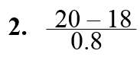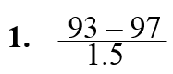**Simplify the expression.**

**4. Sixty-eight percent of a sample of cars tested got between** 27 **and** 32 **miles per gallon of gasoline. What percent of the cars tested got less than** 27 **miles per gallon or more than** 32 **miles per gallon?**

------------------------------------------------------------------NOTES-------------------------------------------------------------------------------------

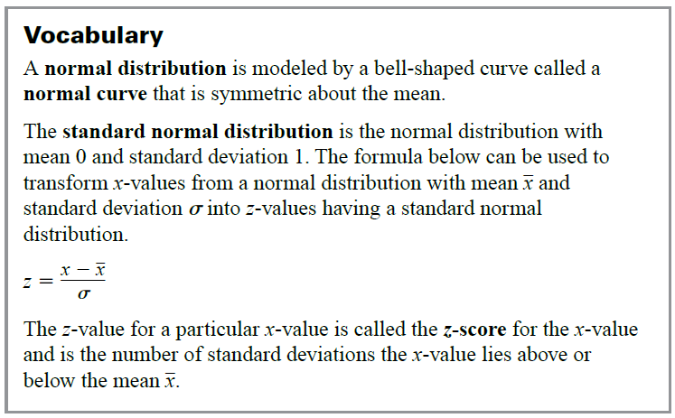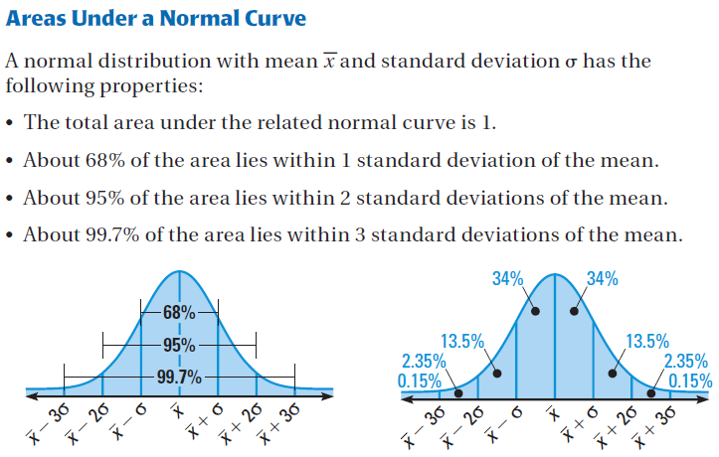

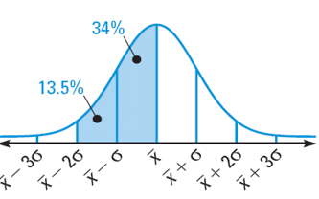Example 1: Find a normal probability

**A normal distribution has mean** *x***and standard deviation σ. For a randomly selected** *x***-value from the distribution, find $P(\overline{x} – 2σ ≤ x ≤ \overline{x}).$**

Example 2: Interpret normally distribute data

**The blood cholesterol readings for a group of women are normally distributed with a mean of** 172 mg/dl **and a standard deviation of** 14 mg/dl**.**

1. **About what percent of the women have readings between** 158 **and** 186?
2. **Readings less than** 158 **are considered desirable. About what percent of the readings are undesirable?**

YOU TRY:

**A normal distribution has meanand standard deviation** σ**. Find the indicated probability for a randomly selected *x*-value from the distribution.**

$1. P(x ≤\overline{x} )$**2. $P( x \underline{>}\overline{x} )$ 3. $P(\overline{x} \underline{<}x \underline{<}\overline{x} + 2σ )$**

**4. $P( \overline{x} – σ \underline{<} x \underline{<} \overline{x} )$*5. $P(x ≤ \overline{x} – 3σ)$ 6. $P(x \underline{>} \overline{x} + σ)$***

**7. WHAT IF? In Example** 2**, what percent of the women have readings between** 172 **and** 200**?**

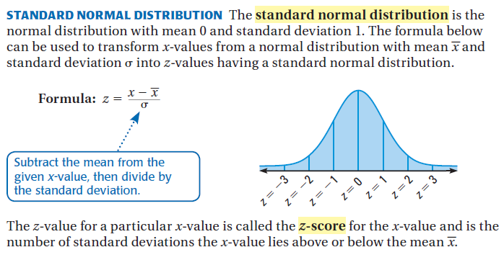

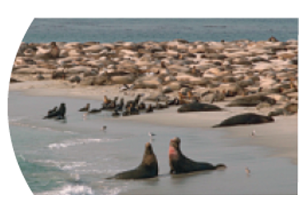Example 3: Use a z-score and the standard normal table

**Scientists conducted aerial surveys of a seal sanctuary and recorded the number** *x* **of seals they observed during each survey. The numbers of seals observed were normally distributed with a mean of** 73 **seals and a standard deviation of** 14.1 **seals. Find the probability that at most** 50 **seals were observed during a survey.**

Step 1: **Find: the** *z***-score corresponding to an** *x***-value of** 50**.**

Step 2: **Use: the table to find $P(x \underline{<} 50)≈P(z \underline{<} – 1.6).$**

|  |  |  |  |  |  |  |  |  |  |  |
| --- | --- | --- | --- | --- | --- | --- | --- | --- | --- | --- |
| **Standard Normal Tab** | | | | | | | **le** | | | |
| ***z*** | **.0** | **.1** | **.2** | **.3** | **.4** | **.5** | **.6** | **.7** | **.8** | **.9** |
| -**3** | .0013 | .0010 | .0007 | .0005 | .0003 | .0002 | .0002 | .0001 | .0001 | .0000+ |
| -**2** | .0228 | .0179 | .0139 | .0107 | .0082 | .0062 | .0047 | .0035 | .0026 | .0019 |
| **-1** | .1587 | .1357 | .1151 | .0968 | .0808 | .0668 | .0548 | .0446 | .0359 | .0287 |
| **0** | .5000 | .4602 | .4207 | .3821 | .3446 | .3085 | .2743 | .2420 | .2119 | .1841 |
| **0** | .5000 | .5398 | .5793 | .6179 | .6554 | .6915 | .7257 | .7580 | .7881 | .8159 |
| **1** | .8413 | .8643 | .8849 | .9032 | .9192 | .9332 | .9452 | .9554 | .9641 | .9713 |
| **2** | .9772 | .9821 | .9861 | .9893 | .9918 | .9938 | .9953 | .9965 | .9974 | .9981 |
| **3** | .9987 | .9990 | .9993 | .9995 | .9997 | .9998 | .9998 | .9999 | .9999 | 1.000- |

YOU TRY:

**8. WHAT IF? In Example** 3, **find the probability that at most** 90 **seals were observed during a survey.**

**9. REASONING: *Explain* why it makes sense that $P(z < 0) = 0.5.$**

**KEEP GOING:**

**1. A normal distribution has mean** *x***and standard deviation***σ***. For a randomly selected** *x***-value from the distribution, find $P(x\underline{<}\overline{x} – 2).$**

**2. The average donation during a fund drive was** $75**.** **The donations were normally distributed with a standard deviation of** $15**. Use a standard normal table to find the probability that a donation is at** **most** $115**.**

**3. A normal distribution has meanand standard deviation . For a randomly selected x-value from the distribution, find .**

**A normal distribution has meanand standard deviation . Find the indicated probability for a randomly selected x-value from the distribution.**

**4.  5.  6. **

**7.  8.  9. **

**10. Oak Trees – The heights (in feet) of fully gown white oak trees are normally distributed with a mean of 90 feet and a standard deviation of 3.5 feet. About what percent of white oak trees have heights between 86.5 feet and 93.5 feet?**

**11. In Question 10, find the probability that a randomly selected white oak tree has a height of at most 94 feet.**

**12. About what percent of white oak trees have heights below 97 feet?**

**13. About what percent of white oak trees have heights between 83 feet and 90 feet?**

**14. Find the probability that a randomly selected white oak tree has a height of at most 85 feet.**

Hw: Section 6.3 p. 402 #1-27 odd