Algebra 2 w/ Trig
6.4 Select and Draw Conclusions from Samples
Warm-Up:
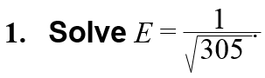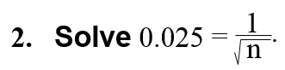

3. The mean score on an exam was 78. You scored within 5 points of the mean. If $x = 78±5$ represents your possible score x on the exam, what is the range of your score?

------------------------------------------------------------------------NOTES-------------------------------------------------------------------------------
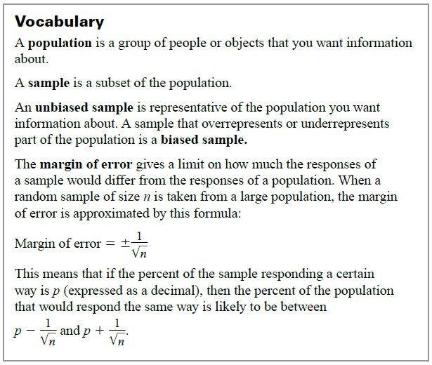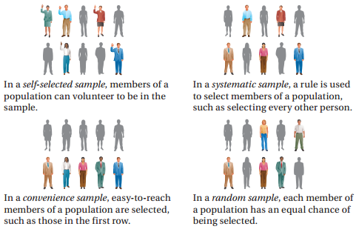
Example 1: Classify Samples
A sportswriter wants to survey college baseball coaches about whether they think wooden bats should be mandatory throughout college baseball. Identify the type of sample described.
- The sportswriter contacts only the coaches that he has cell phone numbers for in order to get quick responses.

- The sportswriter mails out surveys to all the coaches and uses only the surveys that are returned.

Example 2: Identify a Biased Sample
The manager of a concert hall wants to know how often people in the community attend concerts. The manager asks 50 people standing in line for a rock concert how many concerts per year they attend. Tell whether the sample is biased or unbiased. Explain your reasoning.

Example 3: Choose an Unbiased Sample
You are a member of the prom committee. You want to poll members of the senior class to find out where they want to hold the prom. There are 324 students in the senior class. Describe a method for selecting a random sample of 40 seniors to poll.

YOU TRY:
- SCHOOL WEBSITE: A computer science teacher wants to know if students would like the morning announcements posted on the school’s website. He surveys students in one of his computer science classes. Identify the type of sample described, and tell whether the sample is biased.

- WHAT IF? In Example 3, what is another method you could use to generate a random sample of 40 students?

Example 4: Find a Margin of Error
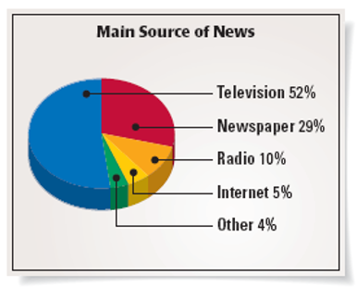
In a survey of 1011 people, 52% said that television is their main source of news.
- What is the margin of error for the survey?

- Give an interval that is likely to contain the exact percent of all people who use television as their main source of news.

Example 5: Use the Margin of Error Formula
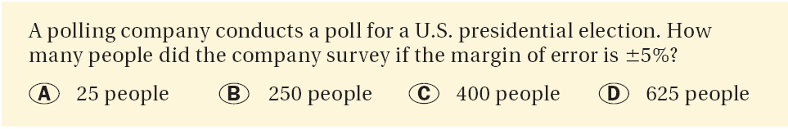

YOU TRY:
INTERNET: In a survey of 1202 people, 11% said that they use the Internet or e-mail more than 10 hours per week. What is the margin of error for the survey? How many people would need to be surveyed to reduce the margin of error to $±2\%$?

KEEP GOING:
- A cafeteria buys grated cheese from a food service. The cheese is packed in boxes labeled 10 pounds. To test that the weight is correct, the cafeteria manager weighs the first 5 boxes in a recent order.
  - Identify the type of sample and explain why it is biased.

  - In a random sample of 550 boxes, 52% weighed more than 10 pounds. Give the interval that is likely to contain the exact percent that weighed over 10 pounds. How many boxes would need to be weighed if the margin of error was 3.8%?

2. Lunch Habits - A business reporter wants to survey workers about where they eat lunch during a typical work week. Identify the type of sample described. Is the sample biased or unbiased?
a. The reporter writes a column asking workers to call a special phone number and identify where they eat lunch during a typical work week.

b. The reporter asks everyone in the newsroom where they eat lunch during a typical work week.

3. A real estate agent wants to know if first-time home buyers used the Internet to research home listings. The real-estate agent calls every fifth first-time home buyer and asks them if they used the Internet to research home listings. Identify the type of sample described. Is the sample biased or unbiased?

4. Lunch Habits - In a survey of 990 workers, 30% said they eat at home during a typical work week.
a. What is the margin of error for the survey?

b. Give an interval that is likely to contain the exact percent of all workers who eat at home during a typical work week.

5. In a survey of 1200 first-time home buyers, 41% said they used the Internet to research home listings.
a. What is the margin of error?

b. Give an interval that is likely to contain the exact percent of all first-time home buyers who used the Internet to research home listings.

6. In a survey of 1535 people, 48% preferred Coke over Pepsi and Sprite.
a. What is the margin of error for the survey?

b. Give an interval that is likely to obtain the exact percent of all people who prefer Coke.
Hw: Section 6.4 p. 409 #1-25 odd

