College Algebra 1
6.5 Linear Inequalities
Objective: To graph linear inequalities with two variables
To use linear inequalities when modeling real-world situations

Starter:
- Coins. You have a total of 21 coins, all nickels and dimes. The total value is $1.70. How many nickels and how many dimes do you have?

- Without solving, tell which method you would choose to solve each system: graphing, substitution, or elimination. Explain your answer.
  - $y=2x-5$ b. $2y+7x=3$
$4y+8x=15$ $y-7x=9$

Why do we need linear inequalities?
You are buying paperback and hardcover books at a book sale. You can spend at most $20. What are the possible combinations of paperback and hardcover books that you can buy?
Linear inequalities help us with problems where there is no one correct answer but many answers that work.

Linear Inequality, with two variables:

Solution of a Linear Inequality:

Problem 1. Identifying Solutions of a Linear Inequality
Is the ordered pair a solution of $y >x-3$?
- (1,2) B. (-3,-7)

You Try! Is (3,6) a solution of $y≤\frac{2}{3}x+4?$

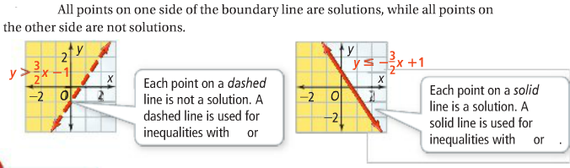

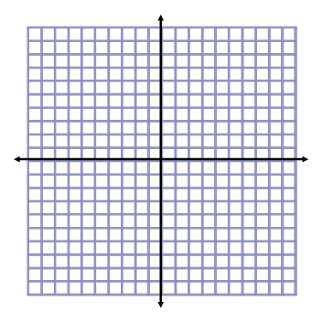
Problem 2. Graphing an Inequality with Two Variables
What is the graph of $y>x-2?$

You try! What is the graph of $y≤\frac{1}{2}x+1?$

An inequality with one variable can be graphed on a number line or in the coordinate plane. The boundary line will be a horizontal or vertical line.
Problem 3. Graphing a Linear Inequality with One Variable
What is the graph of each inequality on the coordinate plane?
- $x>-1$ B. $y≥2$

You try! Graph the inequality
- $y≤ -3$ B. $x< -6$

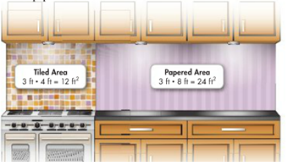
Let x=

Let y=

Write inequality, solve for y, and graph.

Which choices can you eliminate first? Why?

Simple Trick: If the inequality is $≤or <, then you will shade$________________ the line.
If the inequality is $≥, or >$, then you will shade ________________ the line.

You Try!

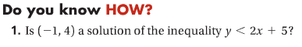

2.
a. b.

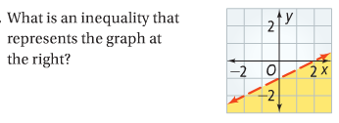
HW: p.397 # 8-29 ODDS

