College Algebra 1
6.6 Systems of Linear Inequalities
Objective: To solve systems of linear inequalities by graphing
To model real-world situations using systems of linear inequalities
Starter: Graph the following inequalities
$1. x≤ -4$ 2. $y≤2x+2$ 3. $x+y<3$
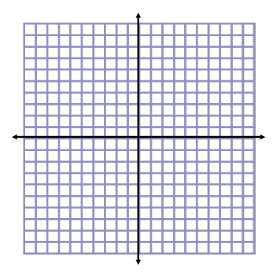

System of Linear Inequalities:

Solution of a system of inequalities:

Problem 1: Graphing a System of Inequalities

Check:

Your Turn!

Check:

Problem 2:Writing a System of Inequalities from a Graph
Green
Yellow
Blue
To write a system that is represented by the graph, write an inequality that represents the yellow region and an inequality that represents the blue region. Where they intersect is the green region.
- Identify boundary lines:

- Decide which inequality symbol to use (which direction)

Your Turn!
Green
Blue
Yellow

Problem 3:Using a System of Inequalities

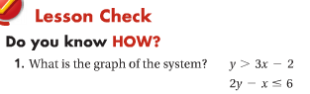

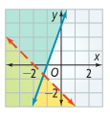
Blue
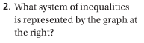
Green
Yellow

- Cherries cost $4/lb. Grapes cost $2.50/lb. You can spend no more than $15 on fruit, and you need at least 4 lb in all. What is the graph showing the amount of each fruit you can buy?

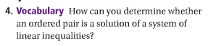

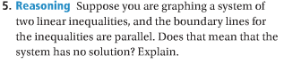

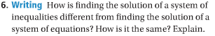
Hw: Section 6.6 p. 403 #7-25 odd, 26 (use graph paper)

