Topic: Exponent Properties Date: _____________________

Properties of Exponents:

Additional Rules (for all exponents):
Rule #6 (for a zero exponent): Rule #7 (for a negative exponent):

Note: Simplifying an expression using the properties of exponents means rewriting it WITHOUT
__________________________________ or any ____________________________________.
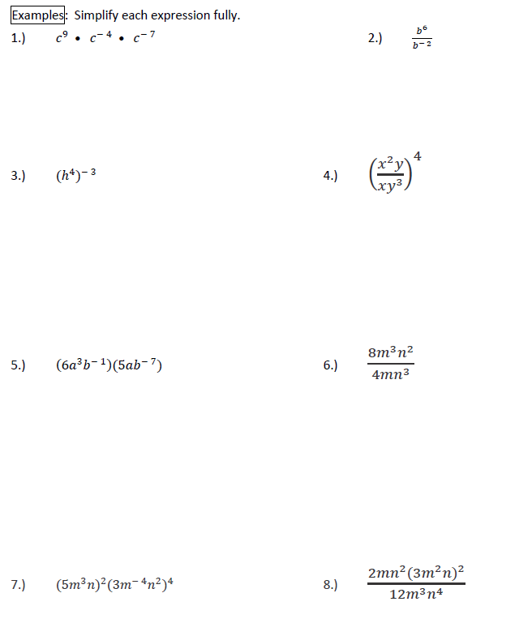

Extra Practice:
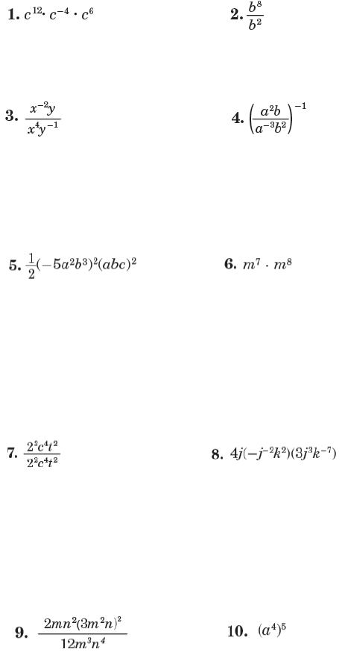
Directions: Simplify each expression fully using the rules of exponents.

Extra Practice: Exponent Rules
Directions: Simplify each expression fully using the rules of exponents.
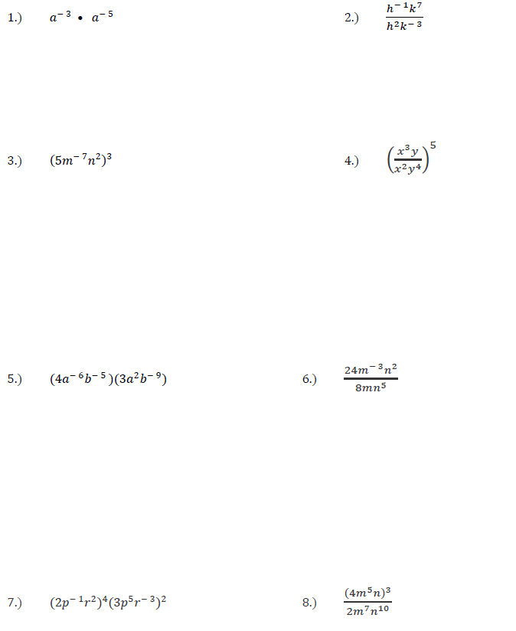

Homework: Exponent Rules
Directions: Simplify each expression fully using the rules of exponents.
