Name: Date:
7.6 Notes
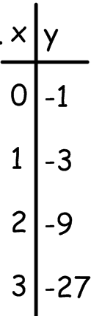
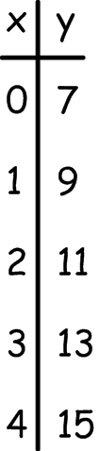
1. Does the data represent a linear or exponential function? Explain your answer.
A. B. Function: _____________________________________

Linear: ________________________________________

Exponential: __________________________________

3. Graph using a table of values using pencil. (C, D use another color)
A. y = 2^{x} B. y = ${\left(\frac{1}{2}\right)}^{x}$
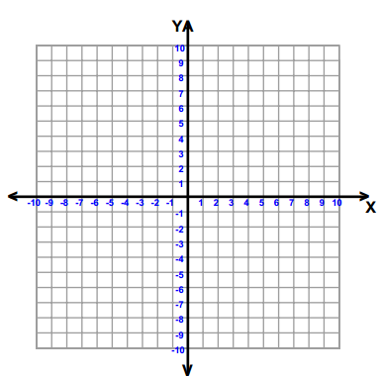

C. y = $-$ 2^{x} D. y = $-{\left(\frac{1}{2}\right)}^{x}$

Asymptote: _______________________________________________________________________________________

4. Suppose 30 flour beetles are left undisturbed in a warehouse bin. The beetle population doubles each week. The function f(x) = 30 ⦁ 2^{x} gives the population after x weeks. How many beetles will there be after 56 days?

5. Graph y = 3 ⦁ 2^{x} using a table of values. 6. Graph using a table of values.

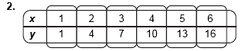
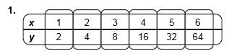
7. Does the data represent a linear or exponential function? Explain your answer.

8. Evaluate each function for the given value.
A. y = 4^{x} for x = 3 | B. f (x) = 2 • 3^{x} for x = 5
C. h(t) = 60 • 1.07^{t} for t = 8 | D. y = 5 • 7^{x} for x = 0

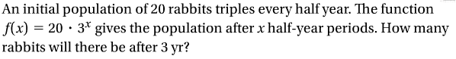
8.

11. Challenge: Solve each equation.
A. 2 ^{x} = 16 B. 10 • 3^{x} = 90 C. 5 ^{x} – 4 = 21 D.4 ^{x} + 6 = 70

