College Algebra 1
7.7 Exponential Growth and Decay
Objective: To model exponential growth and decay
Starter:
- ${\left(\frac{3xy^{5}}{x^{4}y}\right)}^{-2}$ 2. $\frac{\left(6a^{3}\right)\left(8b^{4}\right)}{\left(2a^{4}\right)\left(36b^{-1}\right)}$

- Make a table of values for the function $f\left(x\right)=3*2^{x}$ evaluated at {-2,-1,0,1,2,3,4}

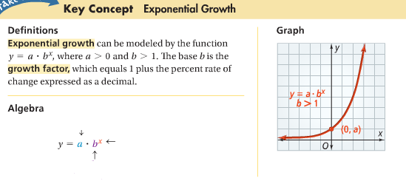

What is Interest? Tanya loaned $1000 for one year at a 5% interest rate. How much interest will she have to pay at the end of the year?
What is the principal?
What is the interest rate?
How much total will Tanya pay back to the bank at the end of 1 year?

When a bank pays interest on both the principal and the interest an account has already earned, the bank is paying _________________________. Compound Interested is an example of exponential growth.
You can use the following formula to find the balance of an account that earns compound interest.
$$A=P{\left(1+\frac{r}{n}\right)}^{nt}$$
A=
P=
R=
n=
t=

The function of $y=a*b^{x}$ can model exponential decay as well as exponential growth. In both cases, b represents _________________________. The value of b tells if the equation models exponential growth______, or decay_______.
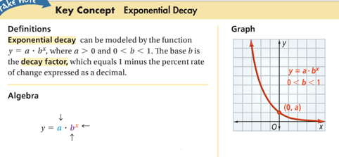

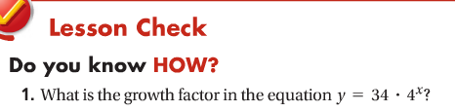
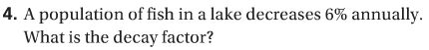

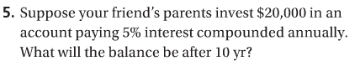

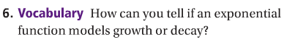
Hw: Section 7.7 p. 463 #1-33 odd, Finish Project

