College Algebra 1
7.8 Geometric Sequences
Objective: To recognize a pattern for a set of data points; to write a rule for a geometric sequence

Starter(s):
Identify the initial amount a and the growth factor b in each exponential function.
1. f (x) = 3 • 5^{x} | 2. y = 250 • 1.065^{x}
3. g (t) = 3.5^{t} | 4. h(x) = 5 • 1.02^{x}

Find the balance in each account after the given period.
5. $8000 principal earning 5% compounded annually, after 6 yr

6. $500 principal earning 4% compounded quarterly, after 10 yr

7. A business purchases a computer system for $3000. If the value of the system
decreases at a rate of 15% per year, how much is the computer worth after
4 years?

----------------------------------------------------------------------NOTES---------------------------------------------------------------------------------
Main Idea: A geometric sequence is a sequence of numbers where the ratio of any term to its preceding term is a constant value. All geometric sequences have a starting value and a common ratio.

Example: The sequence 2, 6, 18, 54, . . . is a geometric sequence because the ratio of any term to its preceding term is 3.

DO YOU GET IT??
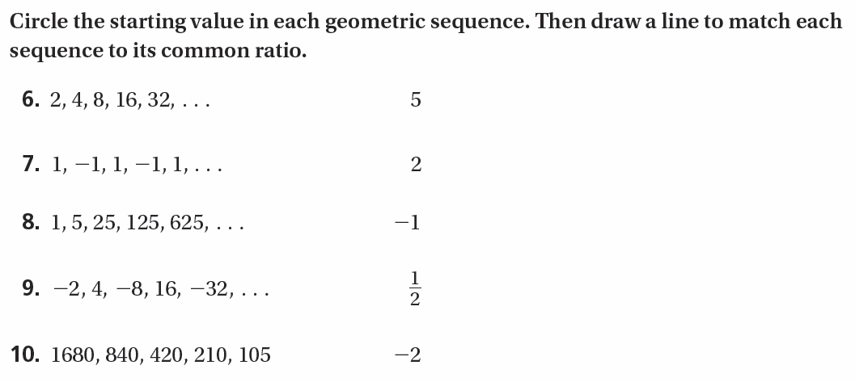

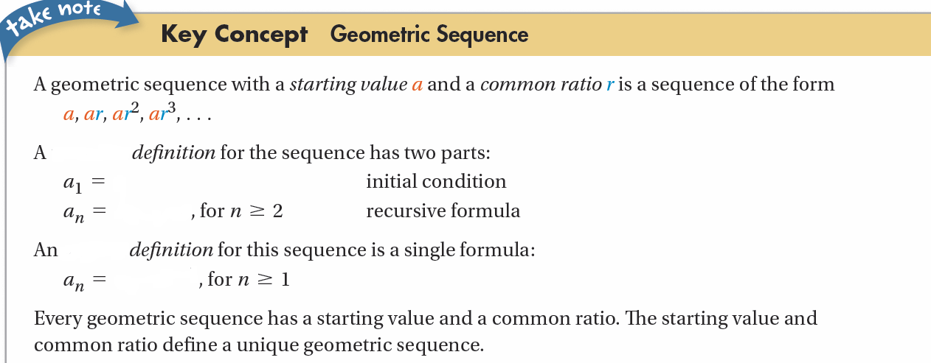

Which of the following are geometric sequences? If the sequence is not geometric, is it arithmetic?
a. 3, 6, 12, 24, 48, . . . b. 3, 6, 9, 12, 15, . . .

Find the recursive and explicit formulas for the sequence 2, 4, 8, 16, . . .

Complete the formulas with the correct values.
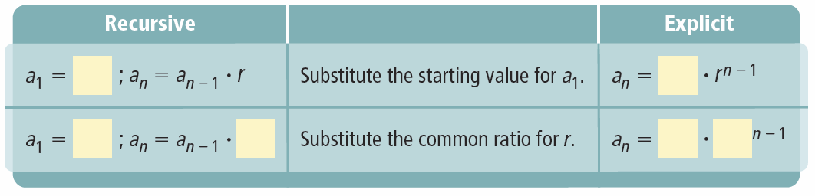

Write a recursive formula and an explicit formula for the sequence below. Find the 8th term of the sequence.
14, 84, 504, 3024, . . .

Formula: 8th term:

A geometric sequence has an initial value of 2 and a common ratio of 3.
Write a function to represent the sequence. Graph the function.

Substitute 2, 3, 4, and 5 for x in your function from Exercise 19 to find f (x) for each value. Complete to write the ordered pairs.

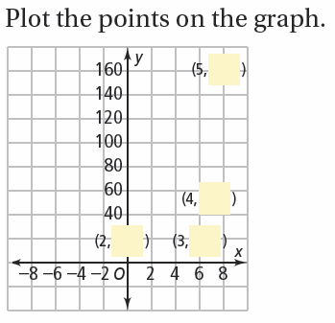

YOU TRY!!!
Write the explicit formula for each geometric sequence.
15. 5, 15, 45, 135, … | 16. –2, –12, –72, –432, …
17. 500, 100, 20, 4, … | 18. 75, 15, 3, , …
19. 45, 90, 180, 360, … | 20. 2, 2, 2, 2, …

Write the recursive formula for each geometric sequence.
21. 5, –20, 80, –320, … | 22. 7, 14, 28, 56, …
23. 1024, 512, 256, 128, … | 24. 45, –135, 405, –1215, …
Determine if each sequence is a geometric sequence. If it is, find the common
ratio and write the explicit and recursive formulas.
25. 3, 25, 50, 75, 100, … | 26. 1,, …
27. 3, –3, 3, –3, … | 28. 25, 50, 100, 200, …

Identify each sequence as arithmetic, geometric, or neither.
29. 5, 6, 8, 11, … | 30. 1,, …
31. 1, 4, 7, 10, … | 32. –5, 30, –180, 1080, …
Hw: Section 7.8 p. 470 #11-37 odd

