College Algebra 1
8.1 Adding and Subtracting Polynomials
Objective: To classify, add, and subtract polynomials

Starter:
- 2. $\frac{{\left(-2x^{4}y^{-3}\right)}^{-2}}{{\left(4x^{3}y^{3}\right)}^{2}(x^{2}y)}$ 3.

In some cases, you can model a situation with an expression composed of ____________________. A ___________________ is a real number, a variable, or a product of a real number and one or more variables with ____________________ exponents. Here are some examples of monomials
ESSENTIAL UNDERSTANDING. You can use monomials to form larger expressions called _____________________. These polynomials can be added and subtracted.
The ___________________________________ is the sum of the exponents of its variables. The degree of a nonzero constant is 0. Zero has no degree.
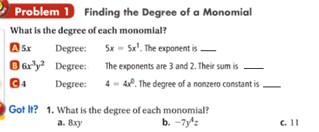
You can add or subtract monomials by adding or subtracting like terms.
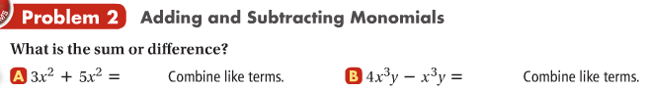

A _____________________________ is a monomial or a sum of monomials. The following polynomial is the sum of the monomials $3x^{4}, 5x^{2}, -7x, and 1.$
$3x^{4}+5x^{2}-7x+1$
Determine the degree of each monomial
The polynomial above is is standard form. Standard form of a polynomial means that ___________________________________________________________.
Degree of a polynomial in one variable:
The Degree of $3x^{4}+5x^{2}-7x+1$is _____

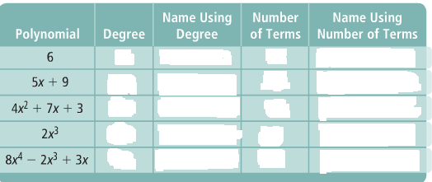

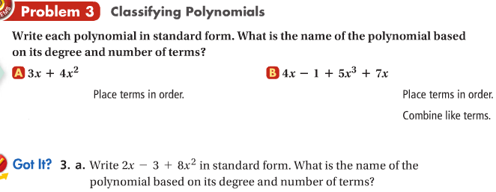

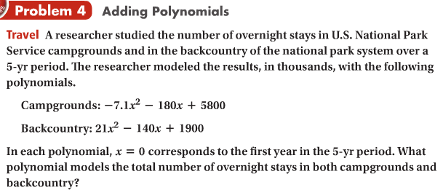

Hw: Section 8.1 p.489 #9-53 odd
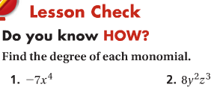

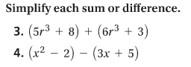

Find the degree of each monomial.

1. 2b²c² | 2. 5x | 3. 7y⁵ | 4. 19ab
5. 12 | 6. | 7. t | 8. 4d⁴e
Simplify.

9. 2a³b + 4a³b | 10. 5x³ – 4x³ | 11. 3m⁶n³ – 5m⁶n³
12. –6ab + 3ab | 13. 4c²d⁶ – 7c²d⁶ | 14. 315x² – 30x²
Write each polynomial in standard form. Then name each polynomial based on its degree and number of terms.

15. 15x – x³ + 3 | 16. 5x + 2x² – x + 3x⁴ | 17. 9x³
18. 7b² + 4b | 19. –3x² + 11 + 10x | 20. 12t² + 1 – 3x + 8 – 2x
Simplify.

21. | 8z – 12 | 22. | 9x³ + 3 | 23. | 6j² – 2j + 5
 | + 6z + 90 |  | + 4x³ + 7 |  | + 3j² + 4j – 6

24. (3k² + 5) + (16x² + 7) | 25. (g⁴ – 4g² + 11) + (–g³ + 8g)

26. A local deli kept track of the sandwiches it sold for three months. The polynomials below model the number of sandwiches sold, where s represents days.
Ham and Cheese: 4s³ – 28s² + 33s + 250 Pastrami: –7.4s² + 32s + 180
Write a polynomial that models the total number of these sandwiches that were sold.

Simplify.

27. | 11n – 4 | 28. | 7x⁴ + 9 | 29. | 3d² + 8d – 2
 | – (5n + 2) |  | – (8x⁴ + 2) |  | – (2d² – 7d + 6)

30. (28e³ + 3e²) + (19e³ + e²) | 31. (–12h⁴ + h) – (–6h⁴ + 3h² – 4h)
32. A small town wants to compare the number of students enrolled in public and private schools. The polynomials below show the enrollment for each:
Public School: –19c² + 980c + 48,989 Private School: 40c + 4046
Write a polynomial for how many more students are enrolled in public school than private school.
Simplify. Write each answer in standard form.

33. (3a² + a + 5) – (2a – 5) | 34. (6d – 10d³ + 3d²) – (5d³ + 3d – 4)
35. (–4s³ + 2s – 3) + (–2s² + s + 7) | 36. (8p³ – 6p + 2p²) + (9p² – 5p – 11)
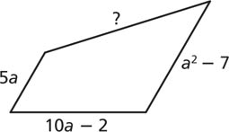
37. The fence around a quadrilateral-shaped pasture is 3a² + 15a + 9 long. Three sides of the fence have the following lengths: 5a, 10a – 2, a² – 7. What is the length of the fourth side of the fence?

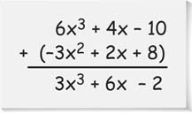
- Error Analysis Describe and correct the error in simplifying the sum shown at the

