College Algebra 1
8.3/8.4 Day 2!

Starter(s): Simplify the following.
- $(2x+1)(3x-7)$ 2. ${\left(3x-4\right)}^{2}$

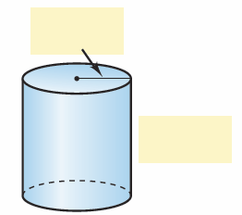
Word Problems!
- What is the total surface area of a cylinder with radius $\left(x+2\right)$ and height$(x+4)$? Write your answer as a polynomial in standard form.

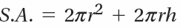
Formula:

YOU TRY:
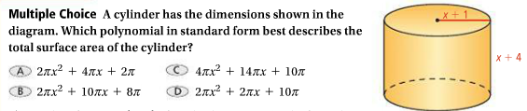

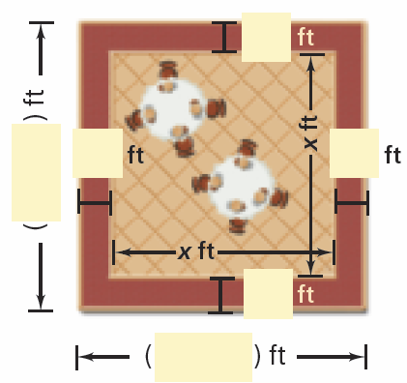
- A square outdoor patio is surrounded by a brick walkway as shown. Suppose the brick walkway is 4 ft wide. What is its area?

YOU TRY:
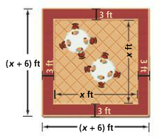
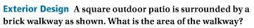

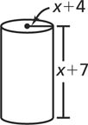
- What is the surface area of the cylinder at the right? Write your answer in simplified form.

- The radius of a cylindrical popcorn tin is (3x + 1) in. The height of the tin is three times the radius. What is the surface area of the cylinder? Write your answer in simplified form.

- The radius of a cylindrical tennis ball can is (2x + 1) cm. The height of the tennis ball can is six times the radius. What is the surface area of the cylinder? Write your answer in simplified form.

- A medical center’s rectangular parking lot currently has a length of 30 meters and a width of 20 meters. The center plans to expand both the length and the width of the parking lot by 2x meters. What polynomial in standard form represents the area of the expanded parking lo
5. The height of a painting is twice its width x. You want a 3 inch wide wooden frame for the painting. The area of the frame alone is 216 square inches.
a. Draw a diagram that represents this situation.

b. Write a variable expression for the area of the frame alone.

c. What are the dimensions of the frame?

- A square brown tarp has a square green patch green in the corner. The side length of the tarp is (x + 8) and the side length of the patch is x. What is the area of the brown part of the tarp?

- A square red placemat has a gold square in the center. The side length of the gold square is (x– 2) inches and the width of the red region is 4 inches. What is the area of the red part of the placemat?

- The formula gives the volume of a sphere with radius r. Find the volume of a sphere with radius x + 9. Write your answer in standard form

