College Algebra 1
8.3/8.4 Multiplying Binomials and Special Case Binomials
Objective: To multiply two binomials or a binomial by a trinomial
To find the square of a binomial and to find the product of a sum and difference

Starter(s):
Find the degree of each monomial.

1. 3s³t³ | 2. 3n | 3. 5xy

Write each polynomial in standard form. Then name each polynomial based on its degree and number of terms.

4. −11d⁴ | 5. 2x³ − 9 + 2x + 8 − 4x

You can use the Distributive Property to multiply two Binomials

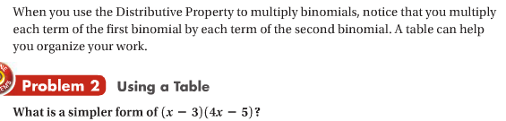
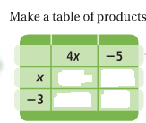

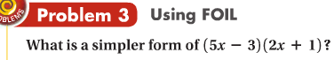

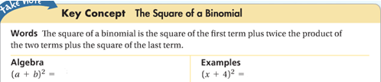

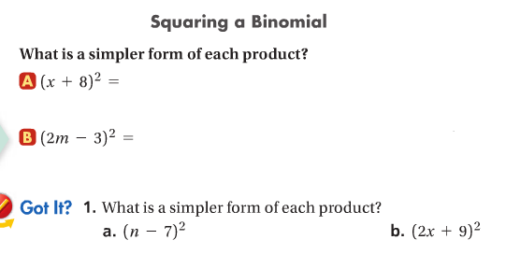

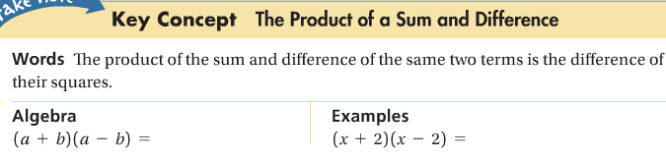
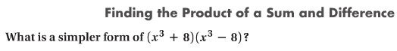

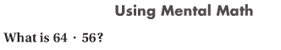

Multiply vertically or using the distributive property

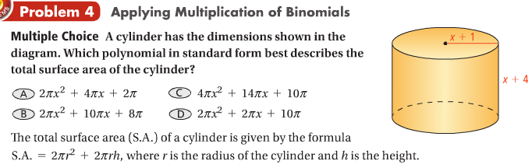

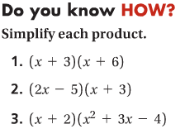

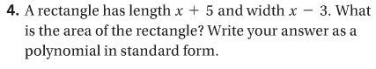

Find each product

