STATION 1
STATION 1:
Evaluate the six trigonometric functions of the angle θ.
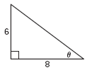
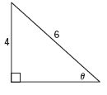

STATION 2:
STATION 2:
Let θ be an acute angle of a right triangle. Find the value of the other five trigonometric functions of θ.
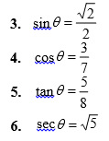

STATION 3:
STATION 3:
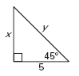
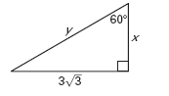
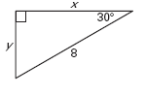

STATION 4:
STATION 4:
Solve Δ ABC using the diagram and the given measurements.
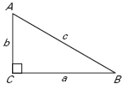
- B = 35°, c =10
- B = 48°, a = 8
- A = 52°, b = 7
STATION 5:
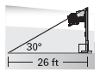
- Shadow A flagpole projects a shadow on the ground that is 26 feet long. The angle of elevation is 30°. What is the approximate height of the flagpole?
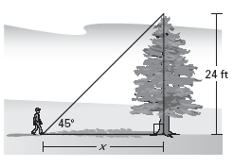
- Trees A hiker stands x feet from the base of a 24 foot tall tree. The angle of elevation to the top of the tree is 45°. How far is the hiker from the base?

STATION 6:
15. Mountains A hiker at the top of a mountain sees a farm and an airport in the distance.
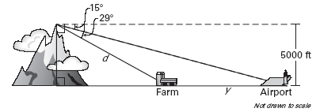
a. What is the distance d from the hiker to the farm?
b. What is the distance y from the farm to the airport?

Lesson 9.1

Practice Level A
3
4

cot

,
4
5

sec

,
3
5

csc

,
4
3

tan
,
5
4

cos

,
5
3

sin
=
=
=
=
=
=
θ
θ
θ
θ
θ
θ
2
5

cot

,
5
5
3

sec

,
2
3

csc

,
5
5
2

tan
,
3
5

cos

,
3
2

sin
=
=
=
=
=
=
θ
θ
θ
θ
θ
θ
1

cot

,
2

sec

,
2

csc

,
1

tan
,
2
2

cos
=
=
=
=
=
θ
θ
θ
θ
θ
20
10
3

cot

,
3
7

sec

,
20
10
7

csc

,
3
10
2

tan
,
7
10
2

sin
=
=
=
=
=
θ
θ
θ
θ
θ
5
8

cot

,
5
89

csc

,
8
89

sec

,
89
89
8

cos

,
89
89
5

sin
=
=
=
=
=
θ
θ
θ
θ
θ
2
1

cot

,
2
5

csc

,
2

tan
,
5
5

cos

,
5
5
2

sin
=
=
=
=
=
θ
θ
θ
θ
θ

2
5

5,

=
=
y
x
- x = 3, y = 6
4

,
3
4

=
=
y
x
- A = 55°, a ≈ 8.19, b ≈ 5.74
- A = 42°, b ≈ 8.88, c ≈ 11.96
- B = 38°, a ≈ 8.96, c ≈ 11.37
- about 15 ft
- 24 ft
15. a. about 10,313 ft b. about 9640 ft

