Trig Word Problems

Name___________________________ Period________
Algebra 2 with Trigonometry

Solve the following word problem. Show your all your work and round to 2 decimal places.
- Katie sees an airplane in the sky from her spot on the ground. The angle of elevation from Katie to the airplane is $35°$. If she steps back 100 feet, the new angle of elevation is $15°.$
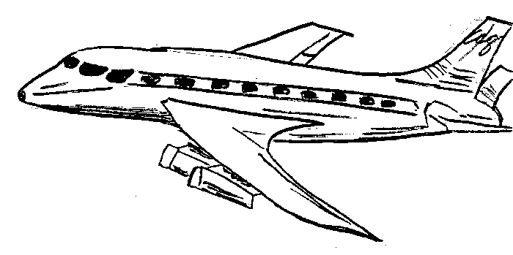
- Solve for y.

$$x$$

$$15°$$
$$35°$$
$$y$$
$$100 ft$$

___________

- If Katie is 5.75 feet tall, how far off the ground is the airplane?

___________

- Frankie sees a UFO in the sky from his spot on the ground. The angle of elevation from Frankie to the UFO is 50°. In fear, he runs back 300 feet. His new angle of elevation is 20°.
- Solve for y.

$$x$$

$$20°$$
$$50°$$
$$y$$
$$300 ft$$

___________

- If Frankie is 6 feet tall, how far off the ground is the UFO?

___________

- Brendan sees a kite in the sky from his spot on the ground. The angle of elevation from Brendan to the kite is 65°. If he steps back 275 feet, the new angle of elevation is 3$5°.$

- Solve for y.

- If Brendan is 6.25 feet tall, how far off the ground is the kite?

___________

- John sees an eagle in the sky from his spot on the ground. The angle of elevation from John to the eagle is 45°. In fear, he runs back 150 feet. His new angle of elevation is 10°.

- Solve for y.

- If John is 5.5 feet tall, how far off the ground is the eagle?

___________

