Algebra 2 w/ Trig
9.1 Use Trigonometry with Right Triangles
Warm-Up:
In right triangle ABC, a and b are the lengths of the legs and c is the length of the hypotenuse. Find the missing length. Give exact values.
1. a = 6, b = 8 2. c = 10, b = 7

3. If you walk 2.0 kilometers due east and then 1.5 kilometers due north, how far will you be from your starting point?

---------------------------------------------------------------------NOTES----------------------------------------------------------------------------------
Example 1: Evaluate Trigonometric Functions
Evaluate the six trigonometric functions of the angle$θ$.
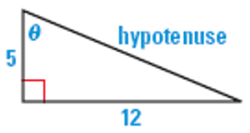

Example 2: Multiple Choice!!
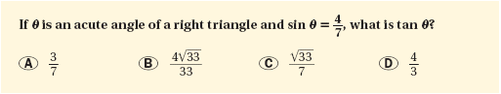

YOU TRY:
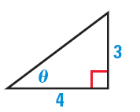
Evaluate the six trigonometric functions of the angle $θ$.
1.
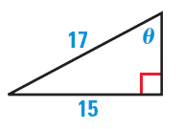

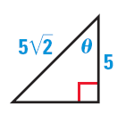
4. In a right triangle, $θ$ is an acute angle and $cos θ =\frac{7}{10}$ . What is $sin θ$?

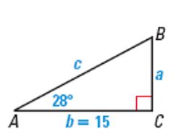
Example 3: Find an Unknown Side Length of a Right Triangle Example 4: Use a Calculator to Solve a Right Triangle
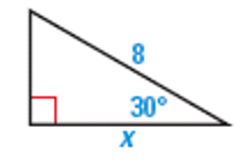

YOU TRY:
Solve $∆ABC$ using the diagram at the right and the given measurements.
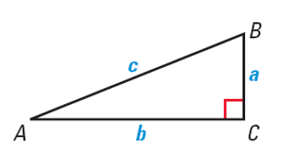
5. B = 45°, c = 5 6. A = 32°, b = 10

7. A = 71°, c = 20 8. B = 60°, a = 7

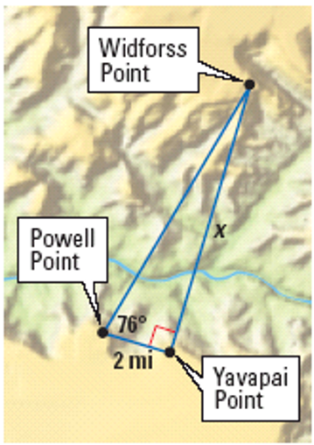
Example 5: Use Indirect Measurement
While standing at Yavapai Point near the Grand Canyon, you measure an angle of 90º between Powell Point and Widforss Point, as shown. You then walk to Powell Point and measure an angle of 76º between Yavapai Point and Widforss Point. The distance between Yavapai Point and Powell Point is about 2 miles. How wide is the Grand Canyon between Yavapai Point and Widforss Point?

Example 6: Use Angle of Elevation
A parasailer is attached to a boat with a rope 300 feet long. The angle of elevation from the boat to the parasailer is 48º. Estimate the parasailer’s height above the boat.
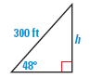

YOU TRY:
9. In Example 5, find the distance between Powell Point and Widforss Point.

10. What If? In Example 6, estimate the height of the parasailer above the boat if the angle of elevation is 38°.

KEEP GOING:
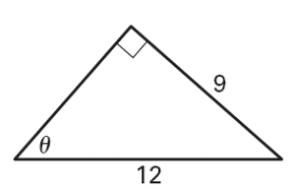
- Evaluate the six trigonometric functions of the angle $θ$.

- Solve $∆ABC.$
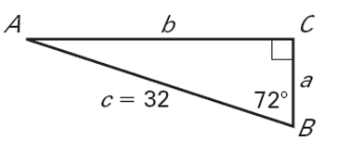

- From a point on the ground 64 feet from the base of a tree, the angle of elevation to the top of the tree is 28°. Estimate the height of the tree.
Hw: Section 9.1 p. 560 #3-27 odds, 30-32 all

