Algebra 2 w/ Trig
9.2 Define General Angles and Use Radian Measure
Warm-Up:
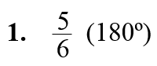
Write the expression in simplest form.
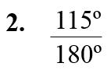

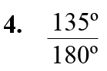
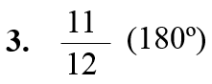

5. A compact disc has radius 6 centimeters. Find its circumference and area to the nearest tenth.

-------------------------------------------------------------------NOTES------------------------------------------------------------------------------------
Example 1: Draw Angles in Standard Position
Draw an angle with the given measure in standard position.
a. 240º b. 500º c. –50º

Example 2: Find Coterminal Angles
Find one positive angle and one negative angle that are coterminal with
(a) –45º (b) 395º.

YOU TRY:
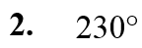
Draw an angle with the given measure in standard position. Then find one positive coterminal angle and one negative coterminal angle.
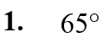

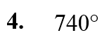
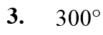

Example 3: Convert Between Radians and Degrees
Convert: (a) $125º$ to radians (b)$–\frac{π}{12}$ radians to degrees.

YOU TRY:
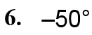
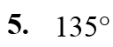
Convert the degree measure to radians or the radian measure to degrees.

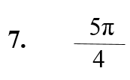
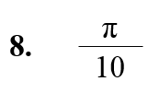

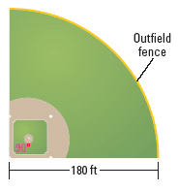
Example 4: Solve a multi-step problem
A softball field forms a sector with the dimensions shown. Find the length of the outfield fence and the area of the field.

YOU TRY:
9. What If? In Example 4, estimate the length of the outfield fence and the area of the field if the outfield fence is 220 feet from home plate.

KEEP GOING:
- Find one positive angle and one negative angle that are conterminal with 475°.

- Convert 315° to radians and $\frac{17π}{6}$radians to degrees.

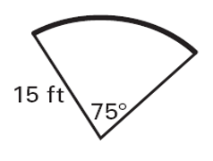
- You are planting a vegetable garden on a plot of land that is a sector of a circle. You want fencing along only the curved edge of the garden. Use the figure to find the length of fencing you will need and the area that will be available for planting.
Hw: Section 9.2 p. 566 #3-45 odds

