Starter(s):
1.) Find the vertex for the quadratic function. 2. Answer the following questions below.
$y= -x^{2}+8x + 9$

Use the graph above to answer the questions
- Vertex: _________________
- Axis of symmetry: ________
- Domain: ________________
- Range: _________________
- Y-Intercept: _____________
- X-Intercepts: ____________

Notes Topic: ___________________________________________________ Date: ___________________

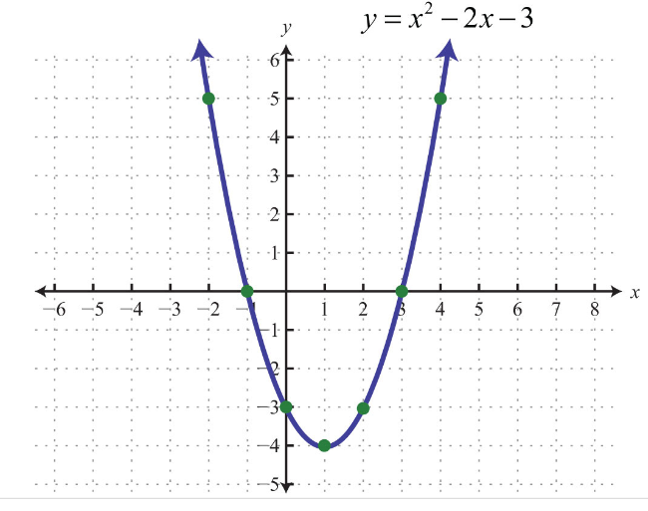

Answer: _____________________

Background:
A parabola ________________________________ y-intercept, which you can find by looking at the value of _________.
Examples:
What is the y-intercept to the following quadratic functions?
- $y= x^{2}-x$ Answer: ________________

- $y= x^{2} + 4x-16$ Answer: ________________

- $y= x^{2}$ Answer: ________________

Notes:

A parabola can have __________, __________, or __________ x-intercepts depending on whether the ____________________ is ____________________ or ____________________ the ____________________ and whether the parabola opens ____________ or ____________.

__________________________________________________________________________________________________
Big Idea:
We can determine how many _________________________ a quadratic equation has based on how many __________________________ the graph of its corresponding function would have.
For #1 – 2, graph each quadratic function algebraically and answer the following questions.
1.) $y=x^{2}+6x+9$

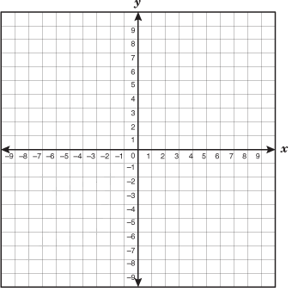

Domain: ____________________ Range: ____________________
Vertex: ____________________ Axis of symmetry: ___________
Y-intercept: ________________ # of X-Intercepts: ___________
Min OR Max: _______________

2.) $y={-x}^{2}+2x+3$

Domain: ____________________ Range: ____________________
Vertex: ____________________ Axis of symmetry: ___________
Y-intercept: ________________ # of X-Intercepts: ___________
Min OR Max: _______________

YOU TRY:

3.) $y=2{\left(x-2\right)}^{2}+3$

Domain: ____________________ Range: ____________________
Vertex: ____________________ Axis of symmetry: ___________
Y-intercept: ________________ # of X-Intercepts: ___________
Min OR Max: _______________

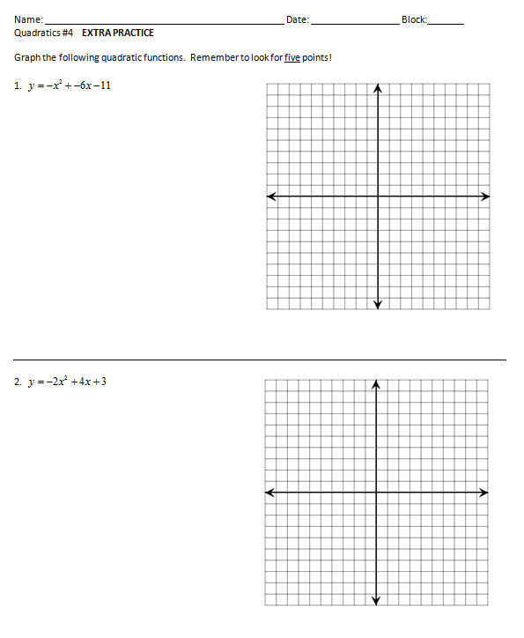

Domain: ____________________ Range: ____________________
Vertex: ____________________ Axis of symmetry: ___________
Y-intercept: ________________ # of X-Intercepts: ___________
Min OR Max: _______________

Domain: ____________________ Range: ____________________
Vertex: ____________________ Axis of symmetry: ___________
Y-intercept: ________________ # of X-Intercepts: ___________
Min OR Max: _______________

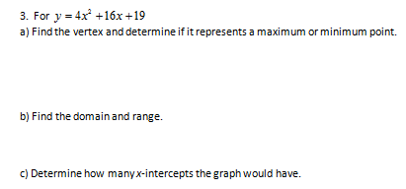

___________________________________________________________________________________________
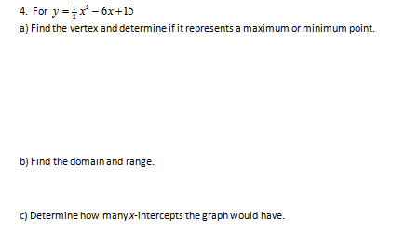

POTD:
A golf ball hit on the moon with an initial speed of 18 feet per second has a height, h, in feet given by the function, where t represents the number of seconds after the ball was hit.

- If the ball reaches its greatest height after 3 seconds, what is this greatest height?

- At what point(s) in time is the ball at a height of 24 feet?

- Create a graph of the function on the grid below for all values of t on the interval.

Make sure to properly label your axes.

- How many seconds does it take for the ball to hit the ground?

- Looking at your answer(s) to part (d), is there another way to find when the ball will hit the ground algebraically? (Hint: What is the height of the ball when it is on the ground and which variable represents height in the equation?) Explain how you get your answer.

Big Idea:
If a quadratic equation has _________ or _________ solutions, then sometimes we can find those solutions by ___________________________.

Steps: To find the solutions of a quadratic equation by factoring…
#1 – Move all the terms to the ______________ side of the equation using _____________________
or _____________________ so the right side of the equation is now _________.
#2 – If possible, _______________ each term by the ________ value.
#3 – _______________________!
#4 – Set each parenthesis equal to ________ and ________________.
_____________________________________________________________________________________________________________________________
Examples:
1.) $a^{2} - 14a + 48 = 0$ 2.) $h^{2} - 5h - 26 = 10$

_____________________________________________________________________________________________________________________________
3.) $p^{2} + 2p = 120$ 4.) $r^{2} = 7r - 6$

5.) ${- w}^{2} + 8w + 57 = 2w - 15$ 6.) $24m - 48 = {3m}^{2}$

____________________________________________________________________________________________________

7.) ${- 2n}^{2} - 240 = 46n$ 8.) $c^{2} = 36$

____________________________________________________________________________________________________
9.) ${6k}^{2} - 17k + 5 = 0$ 10.) ${12d}^{2}=11d + 15$

____________________________________________________________________________________________________
Result:
The solutions you just found for all the above questions represent the_______________________________ or _____________________. This is where the quadratic will cross the_____________________________.

Name: ______________________________________________ Date: _________________ Block:_______
Quadratics: Solve by Factoring

Directions: Solve each quadratic equation for the given variable (show all your work).

1.) $a^{2} + 19a + 84 = 0$ 2.) $h^{2} - h - 50 = 22$

3.) $p^{2} + 6p = 135$ 4.) $r^{2} = 20r - 100$

5.) ${- 2w}^{2} - 24w + 200 = 72$ 6.) $36m = 144 - {4m}^{2}$

7.) ${180 = 2n}^{2} - 18n$ 8.) ${- 5c}^{2}+ 62 =17$

9.) ${10k}^{2} - 41k + 21 = 0$ 10.) ${4d}^{2} + 15d = 54$

