Algebra 2 w/ Trig

9.3 Evaluate Trigonometric Functions of any Angle

Warm-Up:

1. **In right triangle** *ABC*, *a* = 3, *b* = 5, **and** *c* **is the length of** **hypotenuse.** **Evaluate** sin *A*, cos *A*, **and** tan *A****.***
2. **Evaluate** cos 60º**.**  **3.** **Evaluate** sec 45º**.**
3. **Evaluate** cot 30º**.**

------------------------------------------------------------------NOTES-------------------------------------------------------------------------------------

Example 1: Evaluate trigonometric functions given a point

**Let** (–4, 3) **be a point on the terminal side of an angle $θ$ in standard position. Evaluate the six trigonometric functions of $θ$.**

Example 2: Use the Unit Circle

**Use the unit circle to evaluate the six trigonometric functions of $θ$**  = 270°**.**

YOU TRY:

**Evaluate the six trigonometric functions of $θ$.**

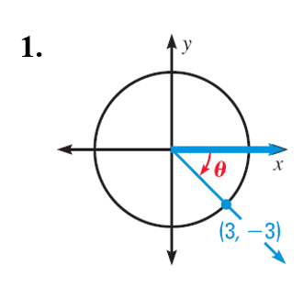 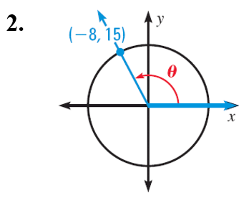

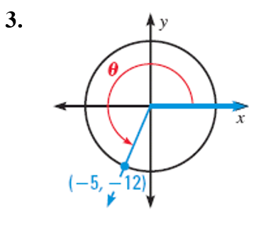

**4. Use the unit circle to evaluate the six trigonometric functions of $θ$** = 180°**.**

Example 3: Find Reference Angles

**Find the reference angle $θ'$**

***(a) $θ =\frac{5π}{3}$*** ***(b) $θ =-130°$***

Example 4: Use Reference Angles to Evaluate Functions

**Evaluate (**a**) $tan ( – 240°)$ (**b**) $csc \frac{17π}{6}$**

YOU TRY:

**Sketch the angle. Then find its reference angle.**

**5.** 210° **6.**  – 260°

**7.** **9.**

9. **Evaluate $cos ( –210°)$ without using a calculator.**

Example 5: Calculate horizontal distance traveled

**The “frogbot” is a robot designed for exploring rough terrain on other planets. It can jump at a** 45° **angle and with an initial speed of 16 feet per second. On Earth, the horizontal distance** *d***(in feet) traveled by a projectile launched at an angle $θ$ and with an initial speed** *v***(in feet per second) is given by:**

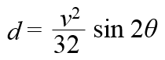

**How far can the frogbot jump on Earth?**

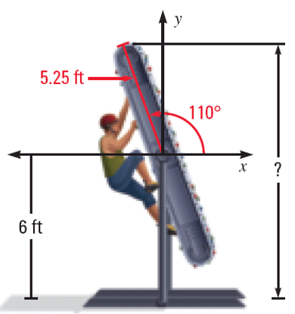Example 6: Model with a Trigonometric Function

**A rock climber is using a rock climbing treadmill that is** 10.5 **feet long. The climber begins by lying horizontally on the treadmill, which is then rotated about its midpoint by** 110° **so that the rock climber is climbing towards the top. If the midpoint of the treadmill is** 6 **feet above the ground, how high above the ground is the top of the treadmill?**

YOU TRY:

**10. Estimate the horizontal distance traveled by a track and field long jumper who jumps at an angle of** 20° **and with an initial speed of** 27 **feet per second.**

**11. WHAT IF? In Example** 6**, how high is the top of the rock climbing treadmill if it is rotated** 100° **about its midpoint?**

KEEP GOING:

1. **Let** (8, – 10) **be a point on the terminal side of an angle $θ$ in standard position. Evaluate $cos θ$.**
2. **Use the unit circle to evaluate** *csc* 540°**.**
3. **Find the reference angle $θ'$ *for $θ =\frac{11π}{6}$***
4. **Evaluate** *cot* **(**–225°).
5. **You kick a football at an initial speed of** 50 **feet per second, projected at an angle of** 36°**. About how far will the ball travel horizontally before hitting the ground?**

Day 1: Hw: Section 9.3 p. 574 #3-31 odds

Day 2: Hw: Section 9.3 p. 574 #4-30 even