Algebra 2 w/ Trig
9.4 Evaluate Inverse Trigonometric Functions
Warm-Up:
Evaluate the expression.
1. $cos 45º$ 2. $sin⁡(\frac{5π}{6}$) 3. $tan⁡(-60)$

4. $cos π$ 5. $tan⁡(\frac{-π}{6})$

----------------------------------------------------------------NOTES---------------------------------------------------------------------------------------
Example 1: Evaluate Inverse Trigonometric Functions
Evaluate the expression in both radians and degrees.
- $\cos^{-1}\frac{\sqrt{3}}{2}$ b. $\sin^{-1}(2)$ c. $\tan^{-1}(-\sqrt{3})$

Example 2: Solve a Trigonometric Equation
Solve the equation $sin θ = –\frac{5}{8}$ where $180° < θ < 270°.$

YOU TRY:
Evaluate the expression in both radians and degrees.
- $\sin^{-1}\frac{\sqrt{2}}{2}$ 2. $\cos^{-1}\frac{1}{2}$

3. $\tan^{-1}(-1)$ 4. $\sin^{-1}(-\frac{1}{2}$)

Solve the equation for $θ$
5. $cos θ = 0.4$ 6. $tan θ = 2.1$ 7. $sin θ = –0.23$
$270° < θ < 360°$ $180° < θ < 270°$ $270° < θ < 360°$

8. $tan θ = 4.7$ 9. $sin θ = 0.62$ 10. $cos θ = –0.39$
$180° < θ < 270°$ $90° < θ < 180°$ $180° < θ < 270°$

Example 3: Multiple Choice!!!
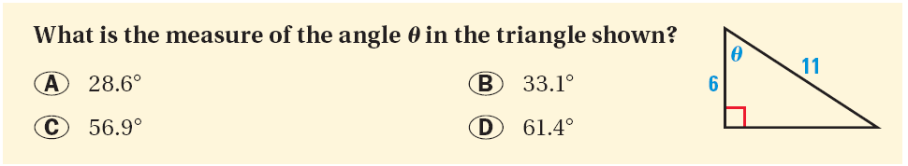
Example 4: Write and Solve a Trigonometric Equation
A monster truck drives off a ramp in order to jump onto a row of cars. The ramp has a height of 8 feet and a horizontal length of 20 feet. What is the angle $θ$ of the ramp?

YOU TRY:
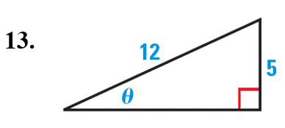
Find the measure of the angle $θ$.
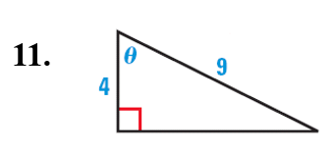
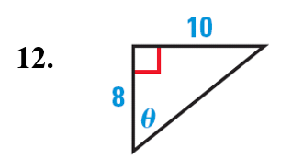

14. WHAT IF? In Example 4, suppose a monster truck drives 26 feet on a ramp before jumping onto a row of cars. If the ramp is 10 feet high, what is the angle $θ$ of the ramp?

KEEP GOING:
- $\sin^{-1}(-\frac{\sqrt{3}}{2})$

- Solve the equation $tan θ = –2.5$ where $90° < θ < 180°.$

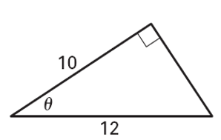
- What is the measure of the angle $θ$ in the triangle shown.

- A ramp goes from the ground to the entrance to a building. If the height of the ramp is 27 inches and the horizontal distance is 58 inches, what is the angle of the ramp?

HW: pg 582 #1-29 odd, 35, 36

