STATION 1
Find the value of c such that each expression is a perfect-square trinomial.

1. a² + 8a + c | 2. x² − 16x + c | 3. m² + 20m + c
4. p² − 14p + c | 5. y² − 10y + c | 6. b² + 18b + c
STATION 2
Solve each equation by completing the square. If necessary, round to the nearest hundredth.

10. b² + 10b = 75 | 11. y² − 18y = 63 | 12. n² − 20n = −75
STATION 3
Solve each equation by completing the square. If necessary, round to the nearest hundredth.
13. a² + 16a = −15 | 14. t² + 8t − 9 = 0 | 15. h² − 12h − 9 = 0
STATION 4
Use the quadratic formula to solve each equation.

1. x² − 19x + 70 = 0 | 2. x² + 32x + 175 = 0 | 3. 2x² + 37x − 19 = 0

STATION 5
Use the quadratic formula to solve each equation.
7. 20x² + 11x = 3 | 8. 4x² + 24x = −35 | 9. 15x² + 20 = 40x

STATION 6
Find the number of solutions of each equation.

 | 13. 3x² + 6x + 8 = 0 |  | 14. 3x² − 5x = −6 |  | 15. x² + 100 = 20x
16. 5x² − 7x = 2 |  | 17. 9x² + 4 = 12x |  | 18. 3x² + 5x = 2

STATION 1:
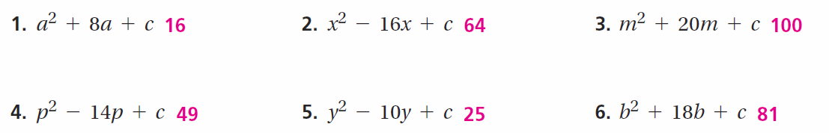

STATION 2:
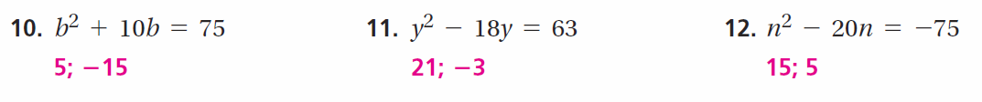

STATION 3:

STATION 4:

STATION 5:
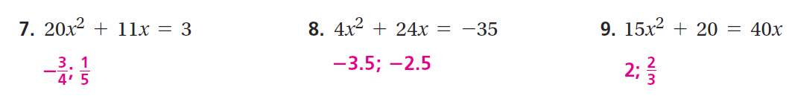
STATION 6:
