9.6 Solving Quadratic Equations by Using the Quadratic Formula

Warm-up: Evaluate for $x^{2}$
$$x=-1$$ | $$x=6$$
$$x=-3$$ | $$x=4$$

Evaluate for $b^{2}-4ac$
$$a=1, b=3, c=4$$ | $$a=1, b=-3, c=2$$
$$a=a=4, b=-3, c=7$$ | $$a=-1, b=-5, c=-7$$
Standard Form of a Quadratic Equation:

Discriminant

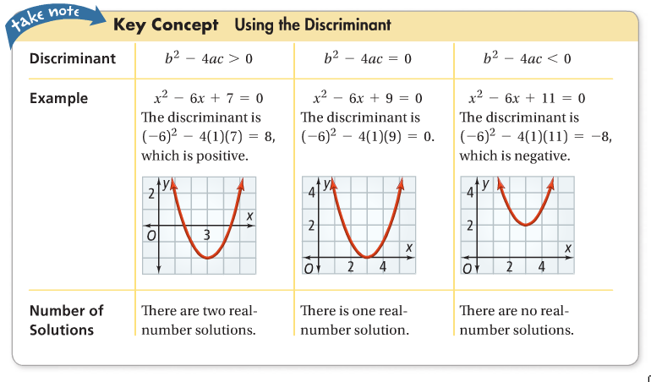
How many real solutions does the quadratic equation have?
- $3x^{2}+10+2=0$ | - $9x^{2}-6x=-1$
- $x^{2}+x+1=0$ | - $x^{2}+3=2x$

The Quadratic Formula:

Solve. Round to the nearest tenth, if necessary.
- $2x^{2}+3x-5=0$ | - $2x=x^{2}-3$
- $x^{2}-2x-4=0$ | - $2x^{2}-8x+1=0$

Your turn.

Find the number of real solutions.
- $x^{2}+7x-5=0$ | - $x^{2}-15=0$
- $2x^{2}+16=5x$ | - $9x^{2}+12x=-4$

Solve. Round to the nearest tenth, if necessary. (easy)
- $x^{2}-5x+4=0$ | - $x^{2}+8x+15=0$
- $x^{2}+x+3=0$ | - $x^{2}=-14x-40$
- $3x^{2}+14x-5=0$ | - $x^{2}-6x-7=0$
- $2x^{2}=7x-3$ | - $6x^{2}+x-1=0$

Hw: Section 9.6 p. 586 #7-15 odd, 23-39 odd

