Name: Date:
9.7 Notes
Equations:
Linear: ______________________ Quadratic: ______________________ Exponential: ______________________

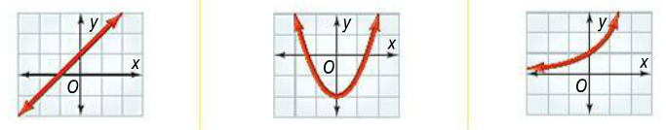

Graph the set of points. Which model is appropriate for each set?
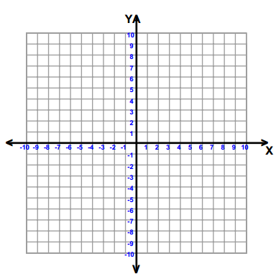
1. (–2, 0.75), (–1, 1.5), (0, 3), (1, 6) 2. (–2, –11), (–1, –5), (0, –3), (1, –5), (2, –11) 3. (–2, 1), (–1, 0), (0, 1), (1, 4), (2, 9)

Recognizing Patterns:___________________________________________________________________________

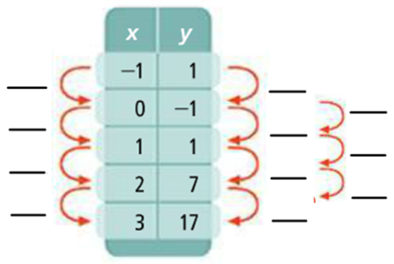
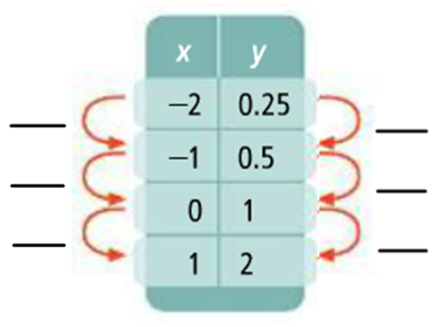
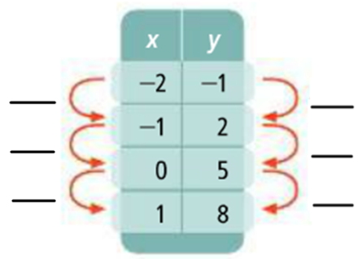
________________________ ________________________ ________________________

___________________________ ___________________________ ___________________________

You Try:
Hw: Section 9.7 p. 592 #9-17 all
1. Graph each set of points. Which model is most appropriate for each set?
A.(–1, –0.67), (0, –2), (1, –6), (2, –18) B. (–3, 10), (–1, 2), (0, 1), (1, 2), (3, 10) C. (–4, 0), (–2, –1), (0, –2), (2, –3), (4, –4)

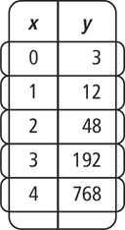
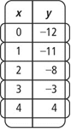
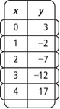
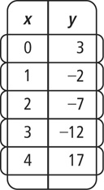
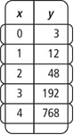
3. 4. 5.

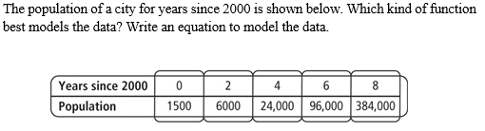
4.
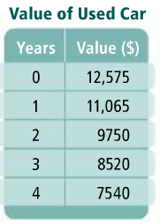

5. The data shows the value of a used car over time. Which function best models the data?
Write the equation.

