Name: Date:
9.8 Note Sheet
3 Ways to Solve Systems of Equations: ____________________ ____________________ ____________________
Types of Functions:
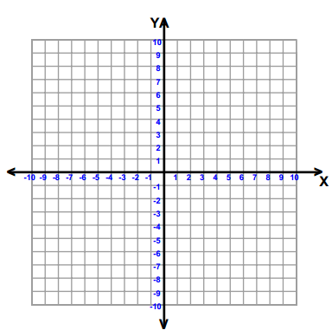
___________________________ ___________________________ ___________________________

Number of Solutions:
___________________________ ___________________________ ___________________________
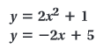
Example 1: ___________________________

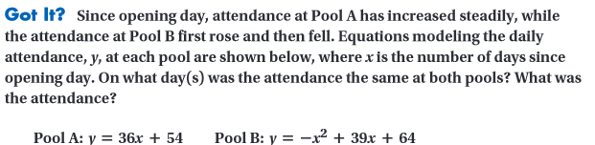
Example 2: ___________________________
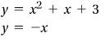

Hw: Section 9.8 p. 599 #9, 11, 15, 19, 17, 21, 23, 25, 29, 30 (no solving by graphing only substitution or elimination)
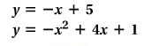
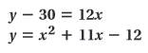
Example 3: ___________________________ Example 4: ___________________________

1. The weekly profits of two different companies selling similar items that opened for business at the same time are modeled by the equations shown below. The profit is represented by y and the number of weeks the companies have been in business is represented by x. According to the projections, what week(s) did the companies have the same profit? What was the profit of both companies during the week(s) of equal profit?
Company A: y = x² – 70x + 3341
Company X: y = 50x + 65

Solve by graphing. Solve using your graphing calculator.
1. y = x² + 1 y = x+ 1 2. y = x² + 5x + 13 y = –5x + 3

Solve using elimination. Solve each system using substitution.
3. y = –x² + 4x – 3 y = –x + 1 5. y = x² + x – 60 y = 2x – 4
4. y = –x² + 2x + 4 y = –x + 4 6. y = x² – 3x + 7 y = 4x – 3

