Name: ___________________________________________________ Date: ___________________

Block:________ Topic:______________________________________________

*Starter: Page 3 in yesterday’s packet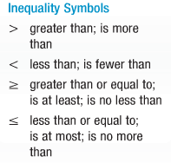*

Review:

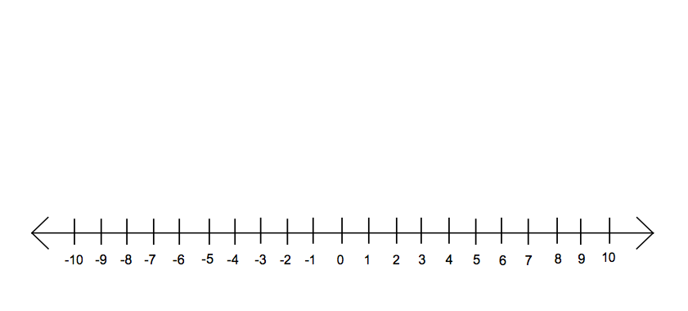Notes:

When you divide or multiply a negative number out, you must remember to _____________ the inequality sign.

Ex 1: Solve: $4y-3<5y+2.$ Graph the solution set on a number line.

Ex 2: Solve: $12< -4(3x-6)$. Graph the solution set on a number line.

Ex 3: Solve: $-x> \frac{x-7}{2}$. Graph the solution set on a number line.



Ex 4: Solve: $-4c ≤ \frac{5c + 58}{6}$. Graph the solution set on a number line.

Write the equation from a graph:

Ex5:

Equation: __________________________



Ex6:

Equation: __________________________



Ex7:

Equation: __________________________

**Compound Inequalities: AND OR**

**AND**:

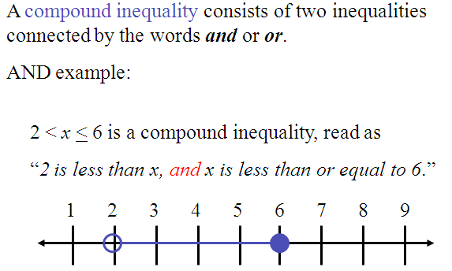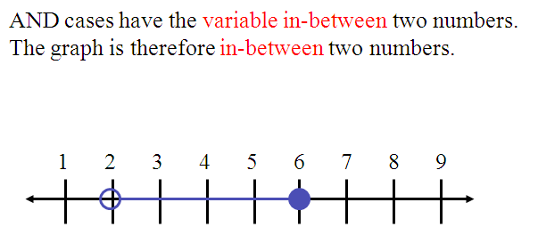

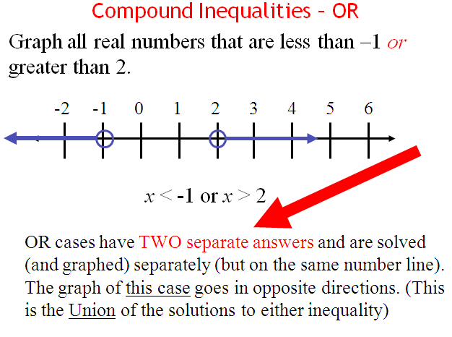

**OR**:

Directions: Solve the following inequalities, then graph the solution.



Ex8:



_____________________________________________________________________________________________

Ex9: $8<3y-7 ≤23$



_____________________________________________________________________________________________

Ex10: $k +6< -4 or 3k ≥12$

_______________________________________________________________________________________________

**Practice!**

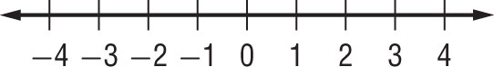**1.** 7*f* – 9 > 3*f* – 1

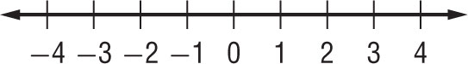**3.** 7*t* – (*t* – 4) ≤ 25

*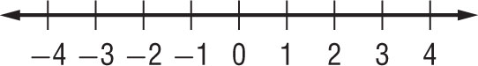***2.** –3*k* – 8 ≤ 5*k*

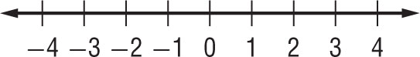**4.** 4(5*x* + 7) ≤ 13

**Solve each inequality. Graph the solution set on a number line.**

1. 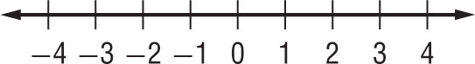2*c* + 1 > 5 or *c* < 0



1. –11 ≤ 4*y* – 3 ≤ 1
2. 10 > –5*x* > 5 



1. 4*a* ≥ –8 or *a* < –3

Starters:

1. Solve:  2. Solve for x: 

Notes:

The ________________________________________________ of a number is its distance from 0 on a number line. Since distance is nonnegative, the absolute value of a number is always nonnegative.

The symbol _________________ is used to represent the absolute value of a number $x$.

When evaluating expressions that involve absolute value, the bars act as a grouping symbol. Perform any operation inside the absolute bars first.

*Ex 1:* *Your Turn!*

Evaluate: $2.7+ \left|6 - 2x\right|$ if $x=4.$ Evaluate the following expression $-\left|abc\right|$ if:

$a= -3, b=-5 and c= -\frac{1}{2}$

**How to you solve Absolute Value *Equations*?**

Ex: |3x – 2| + 8 = 1

1. ______________________________________________________________________________________

1. ______________________________________________________________________________________
2. ______________________________________________________________________________________
3. ______________________________________________________________________________________
4. ______________________________________________________________________________________

Directions: Solve each absolute value equations. Check your solutions.

1. $\left|x+12\right|=9$ 2.) $6\left|5x+2\right|=312$

3.) $3\left|x+2\right|-7=14$ 4.) $3|2x – 3| - 5 = 4$

Notes:

Because the absolute value of a number is always ________________ or ________________ , an equation like $\left|x\right|=-4$ is never ___________________. Therefore, it has ____________________________________. The solution set for this type of equation is the ______________________________, symbolized by __________ or ___________.

Ex 1: Solve: $\left|3x-2\right|+8=1$

_____________________________________________________________________________________________

Notes:

It is possible for an absolute value equation to have only __________ solution. Even if the correct procedure is used for solving the equation, the answers may not be actual solutions to the original equation. Such a number is called an _____________________________________________________. This is why it is very important to check your answers.

Directions: Solve the following absolute value equations and check your solutions.

1. $\left|x+10\right|=4x-8$ 2.) $2\left|x+1\right|-x=3x-4$

Directions: Solve the following absolute value equations and check your solutions.

3.) $3\left|2x+2\right|-2x=x+3$ 4.) $2\left|3x-4\right|+8=6$

**Recap:**

1. What is an absolute value equation and how do solve an absolute value equation?
2. What does it mean to have an empty set?
3. What are the symbols for an empty set?
4. Give an example of an absolute value equation that would have no solution.
5. What is an extraneous solution?

Name: _____________________________________________ Date: _____________ Block:______

**Practice!**

**Evaluate each expression if *a* = –1, *b* = –8, *c* = 5, and *d* = –1.4.**

**1.** |6*a*| **2.** |2*b* + 4|

**3.** –|10*d* + *a*| **4.** |17*c*| + |3*b* – 5|

**5.** –6|10*a* – 12| **6.** |2*b* – 1| – |–8*b* + 5|

**Solve each equation. Check your solutions.**

**7.** |*n* – 4| = 13 **8.** 7|*x* + 3| = 42

**9.** |3*u* – 6| = 42 **10.** |5*x* – 4| = –6

**11.** –6|5 – 2*y*| = –9 **12.** |4*w* – 1| = 5*w* + 37

**13.** 4|2*y* – 7| + 5 = 9 **14.** –2|7 – 3*y*| – 6 = –14

**15.** 2|4 – *n*| = –3*n* **16.** 5 – 3|2 + 2*w*| = –7

**17.** 5|2*r* + 3| – 5 = 0 **18.** 3 – 5|2*d* – 3| = 4

Starters:

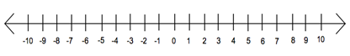1. 

2. 

3. 

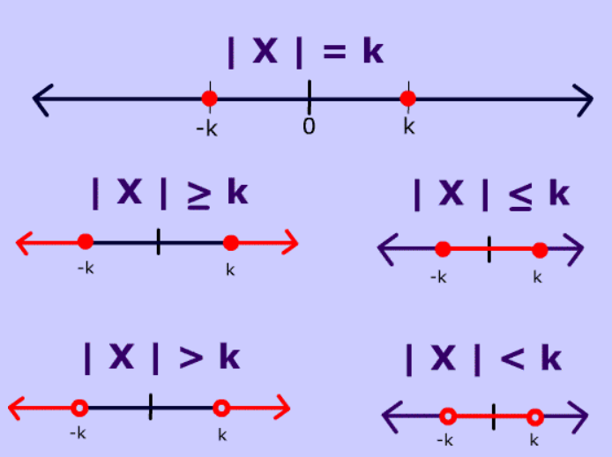Notes: To **solve absolute value inequality equation (ex: |x + 2| > 5)**, it is the same way you would solve absolute value equation (ex: |x + 2| = 5) but when you write your second equation, you need to flip the inequality sign.

Directions: Solve the following absolute value inequalities, then graph the solution.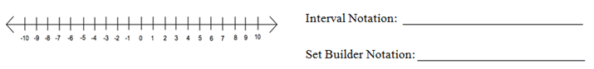

1.)



2.) $-3\left|5x+8\right|+7 ≥1$



3.)

Name: _____________________________________________ Date: _____________ Block:______

**Practice**

Directions: Solve the following absolute value inequalities, then graph the solution.

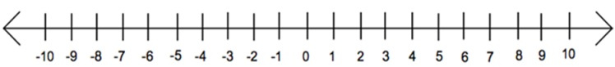1.)

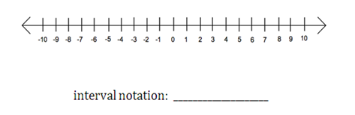__________________________________________________________________________________________________

2.)

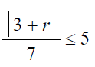__________________________________________________________________________________________________

3.)

__________________________________________________________________________________________________

4.)

