NAME: ____________________________________________________ DATE: ___________

**5.2/5.3: Graphing Rational Functions**

1. 
2. 

a) **Graph** a) **Graph**

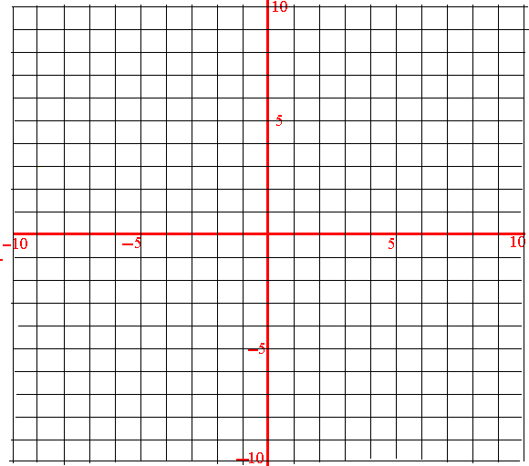

b) **Domain**: _______________________ b) **Domain**: _______________________

c) **Range**: _______________________ c) **Range**: _______________________

d) **Equations** of Vertical Asymptote(s): d) **Equations** of Vertical Asymptote(s):

____________________________ ____________________________

e) **Coordinates** of any hole(s): ___________ e) **Coordinates** of any hole(s): ___________

f) **Equation** of horizontal asymptote(s): f) **Equation** of horizontal asymptote(s):

____________________________ ____________________________

g) **Coordinates** of the x-intercept(s): _______ g) **Coordinates** of the x-intercept(s): _______

h) **Coordinates** of the y-intercept: _______ h) **Coordinates** of the y-intercept: _______

1. 
2. 

a) **Graph** a) **Graph**



b) **Domain**: _______________________ b) **Domain**: _______________________

c) **Range**: _______________________ c) **Range**: _______________________

d) **Equations** of Vertical Asymptote(s): d) **Equations** of Vertical Asymptote(s):

____________________________ ____________________________

e) **Coordinates** of any hole(s): ___________ e) **Coordinates** of any hole(s): ___________

f) **Equation** of horizontal asymptote(s): f) **Equation** of horizontal asymptote(s):

____________________________ ____________________________

g) **Coordinates** of the x-intercept(s): _______ g) **Coordinates** of the x-intercept(s): _______

h) **Coordinates** of the y-intercept: _______ h) **Coordinates** of the y-intercept: _______

1. 
2. 

a) **Graph** a) **Graph**



b) **Domain**: _______________________ b) **Domain**: _______________________

c) **Range**: _______________________ c) **Range**: _______________________

d) **Equations** of Vertical Asymptote(s): d) **Equations** of Vertical Asymptote(s):

____________________________ ____________________________

e) **Coordinates** of any hole(s): ___________ e) **Coordinates** of any hole(s): ___________

f) **Equation** of horizontal asymptote(s): f) **Equation** of horizontal asymptote(s):

____________________________ ____________________________

g) **Coordinates** of the x-intercept(s): _______ g) **Coordinates** of the x-intercept(s): _______

h) **Coordinates** of the y-intercept: _______ h) **Coordinates** of the y-intercept: _______

**5.4: Multiplying and Dividing Rational Expressions**

Perform the indicated operation.

1. 
2. 
3. 
4. 
5. 
6. 

**5.5: Adding and Subtracting Rational Expressions**

Perform the indicated operation.

1. 
2. 
3. 
4. 
5. 
6. 

**5.6: Solving Rational Equations**

Solve for x.

1. 
2. 
3. 
4. 
5. 
6. 