**College Algebra I Mid-Year Exam Review**

**Date:_______________________ Time:_____________ Location:______________**

**Materials to Bring:**

**REVIEW OF FOUNDATIONS OF ALGEBRA:**

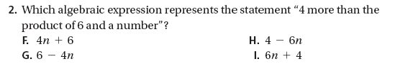

1

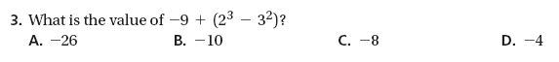

2



3

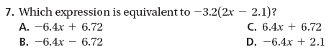

4

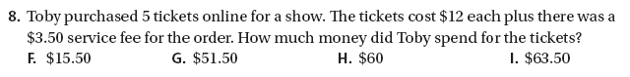

5



6



7

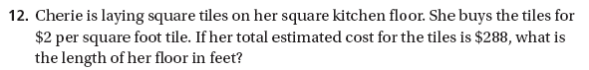

8



9

10





11



12



13

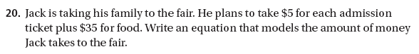

14



15

**REVIEW OF EQUATIONS:**

**Convert the given amount to the given unit.**

**16.** 8 ft; in. **17.** 2.5 miles; ft **18.** 260 sec; min

**Solve each proportion. Use the Multiplication Property of Equality or the Cross Product Property. Explain your choice.**

**19.  20.  21. **

**Solve each proportion.**

**22.  23.  24. **

1. What percent of 50 is 30? **26.** What is 45% of 120?

**Tell whether each percent change is an increase or decrease. Then find the percent change.**

|  |  |
| --- | --- |
| **13. 27.** Original amount: $46 New amount: $52 | **14. 28.** Original amount: $25 New amount:$35 |
|  |  |

1. There are 21 females in the Algebra 1 class. If 75% of the class is female, how   
   many students are there in the class?
2. In 2005, a car sold new for $12,500. In 2008, value of the car was $8750. Find   
   the percent decrease.

**Solve each equation. Check your answer.**

**31.** 9*g +* 12 = 84 **32. 33.** *n +* 11.2 = 25.1

**34.** 8*x –* 12 = 4*x +* 24 **35.  36. **

**Solve each equation. If the equation is an identity, write *identity*. If it has no real-number solution, write *no solution*.**

**37.  38. **

**39.** 2.6(*t +* 2) = 2(1.3*t +* 2) + 1.2 **40.** 2*x +* 4 = 5(*x +* 1) – 3(*x +* 2)

**Define a variable and write an equation for each situation. Then solve.**

1. A large cheese pizza costs $7.50. Each additional topping for the pizza costs $1.35. If the total bill for the pizza Sally ordered was $12.90, how many toppings did she order?

**REVIEW OF INEQUALITIES:**

42

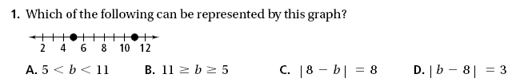

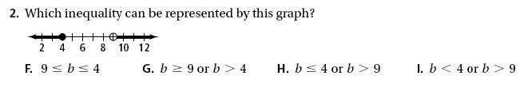

43

44

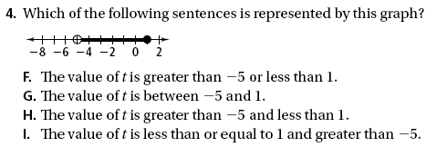**3.**

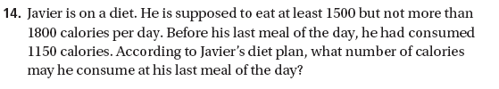

45



46

**5.**

47

**6. **

48



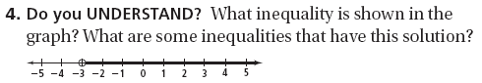

49

**8.**

**Solve each inequality. Graph the solutions.  
50.** 6*m +* 1 ≤ 3*m –* 8 **51.** 4(3*w* – 1) ≥ 20

**52. ** **53.** –2.2*t* ≥ 11

**Solve each inequality, if possible. If the inequality has no solution, write   
*no solution*. If the solutions are all real numbers, write *all real numbers*.**

1. 8*n –* 20 < 4(2*n –* 5) **55.** 4*d –* 9 ≤ 6*d +* 15

**56.** 5*t –* 6 – 3*t* ≤ 2(*t –* 2) **57.** 8 – 7*x* > 15

1. Suppose *U* = {3, 6, 9, 12, 15, 18, 21} is the universal set and *M =* {3, 9, 15, 21}. What is *M′* ?

**Solve each compound inequality.**

**59.** 4 < *n +* 7 ≤ 12 **60.** –1 ≤ –4*k* ≤ 8

**61.** 4*y <* –24 or 6*y >* 12 **62.** –2*p* ≤ –18 or 3*p <* 9

**Solve each equation or inequality. If there is not a solution, write *no solution*.**

**63.** *|x|* = 5 **64.** |*a +* 2| > 4

**65.** *|*3*z –* 6| = 9 **66.** |*v +* 4| ≤ 10

**67.** Given *F =* {3, 5, 7, 9, 11, 13} and *G =* {2, 5, 8, 11}, what is ?

**REVIEW OF FUNCTIONS:**

**Sketch a graph to represent the situation. Label each section.**

1. The level of water in a river rose rapidly during the storm and then gradually decreased back to the original level.
2. The volume of a ball increased as more air was added.

**Each set of ordered pairs represents a function. Write a rule that represents the function.**

**70.** (0, 5), (1, 6), (2, 7), (3, 8), (4, 9) **71.** (0, 0), (1, –2), (2, –4), (3, –6), (4, –8)

**72. For each table, determine whether the relationship is a function. Then represent the relationship using words, an equation, and a graph.**

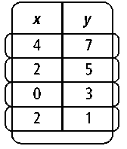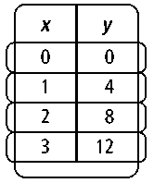

**Identify the domain and range of each relation. Use a mapping diagram to determine whether the relation is a function.**

**73.** {(3, 1), (5, 7), (8, 9), (10, 12)} **74.** {(3, 2.1), (4, 3.1), (5, 4.1), (6, 5.1)}

**Find the range of each function for the given domain.**

**75.** *f* (*x*) = 2*x +* 2; {–1, 0, 1, 2, 3} **76.** *f* (*x*) = *x*2 + 5; {–3, –1, 0, 2, 4}

**Tell whether each sequence is arithmetic. Justify your answer. If the sequence is arithmetic, write a function rule to represent it.**

**77.** 5, 10, 15, 20, … **78.** 200, 100, 50, 25, 12.5, … **79. –**8.1, –5.8, –3.5, –1.2, …

**REVIEW OF LINES:**

**Find the slope of each line.**

82

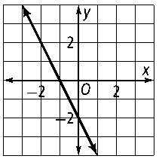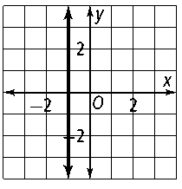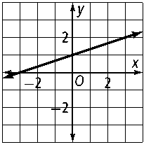

81

80

|  |  |  |  |  |  |
| --- | --- | --- | --- | --- | --- |
|  |  |  |  |  |  |

**Tell whether each equation is a direct variation. If it is, find the constant of variation.**

**83.** *y =* 2*x* – 2 **84.** 4*y =* *x* **85.**

**Graph the direct variation that includes the given point. Write the equation of the line.**

**86.** (5, 4) **87.** (7, 7)

**Find the rate of change for each situation.**

**88.** growing from 1.4 m to 1.6 m in one year

**89.** bicycling 3 mi in 15 min and 7 mi in 55 min

**Find the slope and *y*-intercept.**

**90.** *y =* 6*x +* 8 **91.** 3*x +* 4*y =* –24 **92.** 2*y =* 8

**A line passes through the given points. Write an equation for the line in slope-intercept form.**

**93.** (–2, 4) and (3, 9) **94.** (1, 6) and (9, –4)

**Graph each equation.**

**95.**  *x +* 4*y =* 8 **96.** *y = x* – 4

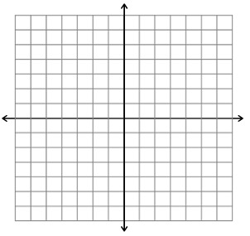

**97.** *y* – 5 = –2(*x +* 1) **98. 2***x +* 3y = 6



**Write an equation in point-slope form for the line through the given point with the given slope.**

**99.** (4, 6); *m =* –5 **100.** (3, –1); *m =* 1

**Write an equation in standard form that satisfies the given conditions.**

**101.** parallel to *y =* 4*x +* 1, **102.** perpendicular to *y =* *–x* – 3, through (–3, 5) through(0, 0)

**Graph each translation of *y = |*** ***x |*. Describe how the graph is related to the graph of *y = |x|*.**

|  |  |  |
| --- | --- | --- |
| **103.** *y =* |*x +* 7| | **104.** *y =* |*x –* 4| | **105.** *y =* |*x +* 5| |

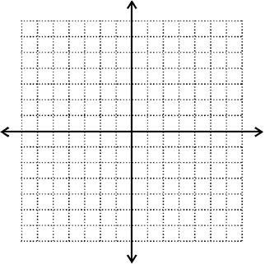

**106.** *y =* –|*x|* – 1 **107.** *y =* – | *x +* 3| **108.** *y =* |*x +* 1| – 4



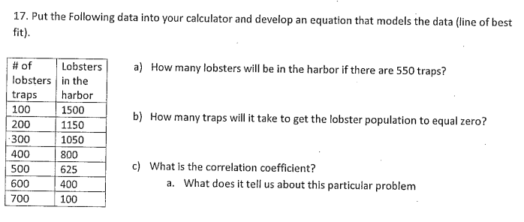

109

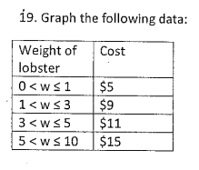

110.

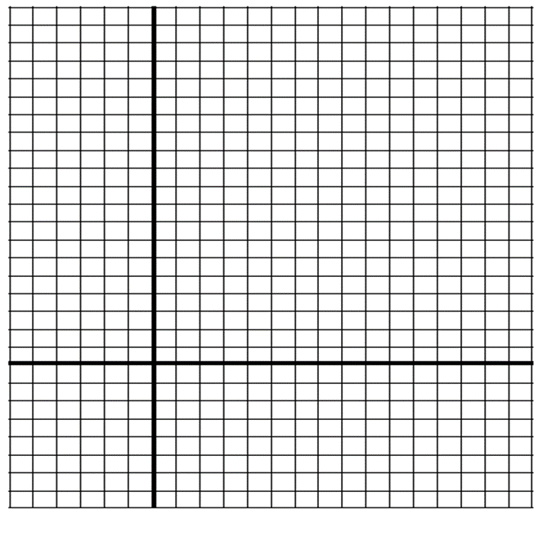

**REVIEW OF SYSTEMS OF LINEAR EQUATIONS AND INEQUALITIES:**

**Solve each system by graphing.**

|  |  |  |
| --- | --- | --- |
| **111.** *x*– *y =* 7 |  | **112.** *y* = –2*x +* 6 |
| 3*x +* 2*y =* 6 |  | 3*x +* 4*y =* 24 |



**Solve each system by using substitution.**

|  |  |  |
| --- | --- | --- |
| **113.** *x* – *y =* 13 | **114.** 3*x* – *y =* 4 | **115.** *x + y =* 4 |
| *y* – *x =* –13 | *x +* 5*y =* –4 | *y =* 7*x +* 4 |

**Solve each system by elimination.**

|  |  |  |
| --- | --- | --- |
| **116.** *x +* *y =* 19  *x* – *y =* –7 | **117.** –3*x +* 4*y =* 29  3*x +* 2*y =* –17 | **118.** 3*x +* *y =* 3  –3*x +* 2*y =* –30 |
| **119.** 6*x +* *y =* 13  *y* – *x =* –8 | **120.** 4*x* – 9*y =* 61  10*x +* 3*y =* 25 | **121.** 4*x* – *y =* 105  *x +* 7*y =* –10 |

**Write and solve a system of equations.**

**122.** Two groups of people order food at a restaurant. One group orders

4 hamburgers and 7 chicken sandwiches for $34.50. The other group orders 8 hamburgers and 3 chicken sandwiches for $30.50. Find the cost of each item.

1. You have a total of 21 coins, all nickels and dimes. The total value is $1.70. How many nickels and how many dimes do you have?

**124.** The sum of two numbers is 25. Their difference is 9. What are the two numbers?

**Determine whether the ordered pair is a solution of the linear inequality.**

**125.** *y* > *x* – 7; (2, 5) **126.** *x* ≤ 3; (–2, 6) **127.** *y* ≥ 4*x +* 3; (3, 9)

**Solve each system by graphing.**

|  |  |  |
| --- | --- | --- |
| **128.** *y* ≤ 5*x +* 1 | **129.** *y* > 4*x +* 3 |  |
| *y > x* – 3 | *y* ≥ –2*x* – 1 |  |



**Useful Formulas**

***Percents:***



**Percent Increase/ Decrease**

***Simple Interest:***







**Relative Error/ Percent Error**



***Arithmetic Sequences:***



***Area:***

**Rectangle**

**Triangle**

**Trapezoid**

**Circle **

***Volume of a Rectangular Prism:***



***Circle Circumference*** *:*

***Conversions:***







*Lines:*

Slope: 

Direct Variation: 

Standard Form: 

Point-Slope: 

Slope-Intercept: 