Name: ________________________________________ Date: _________________
Topic: ________________________________________

Starter:

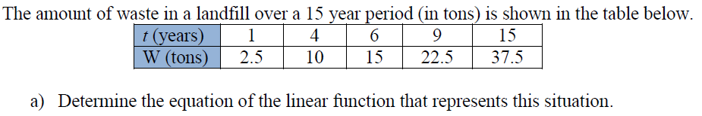

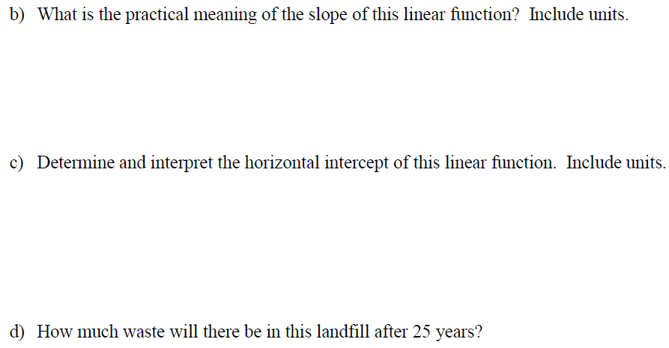

Notes:
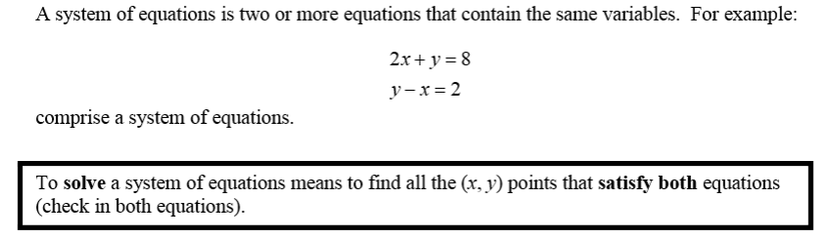

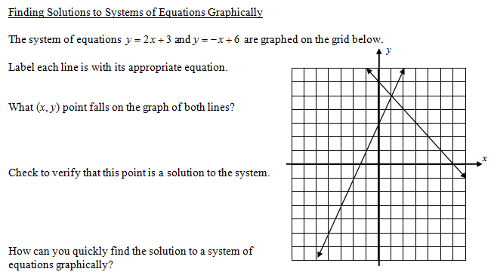

Directions: Solve the following systems of equations graphically.
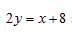
Example 1: Example 2:

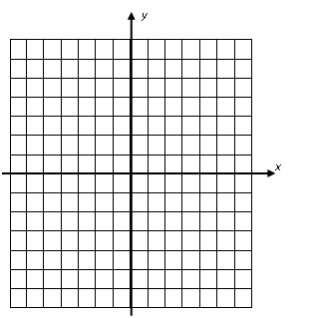

Answer: _________________________ Answer: _________________________

Examples:

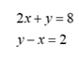
3. Consider the system of equations shown below. If you were to graph the two lines on the same graph, what
would there intersection be?

(a) (1, 6) (b) (5, 3) (c) (2, 4) (d) (0, 6)

__________________________________________________________________________________________
4.

__________________________________________________________________________________________
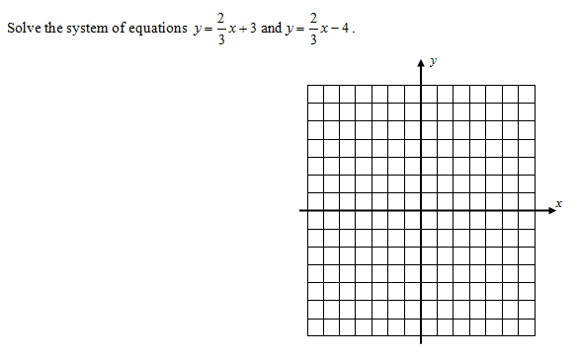
5.

Note:

Name: _________________________________________ Date: ______________
Practice: Solving Systems of Linear Equations Graphically

Directions: Solve the following systems of equations graphically.

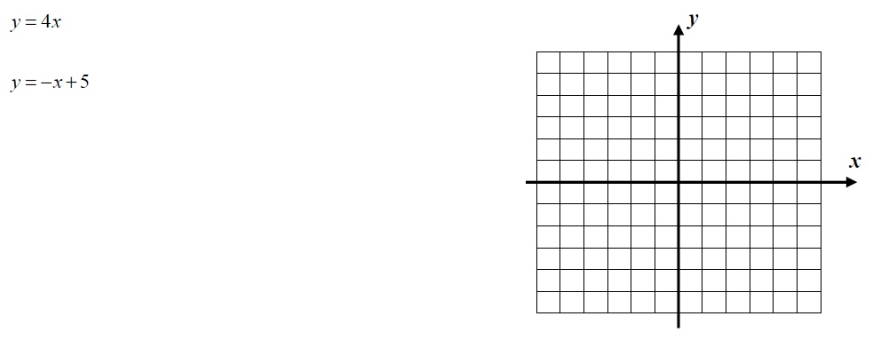
1.

__________________________________________________________________________________________
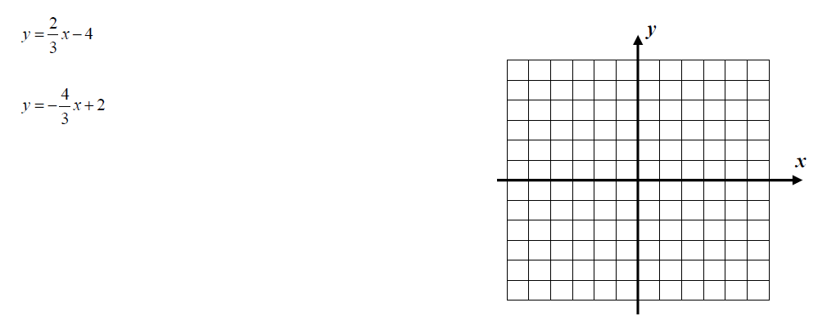
2.

__________________________________________________________________________________________
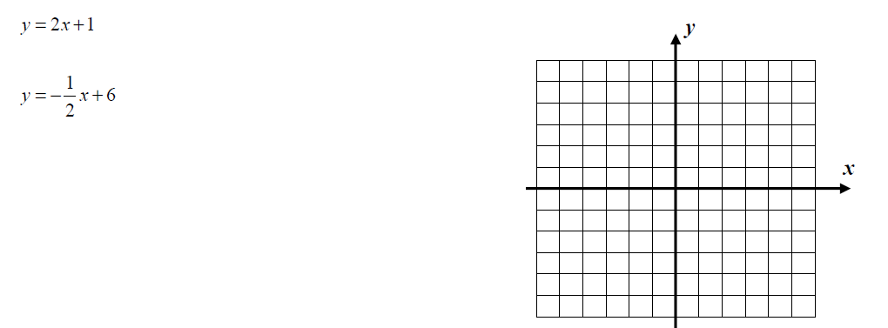

3.

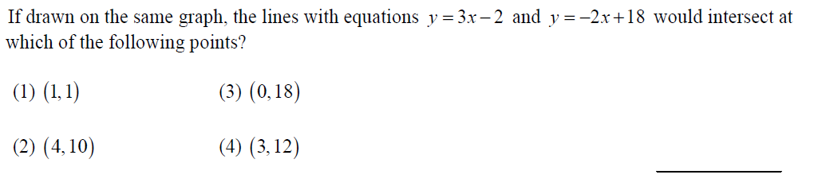
4.

__________________________________________________________________________________________

5. Solve the following systems of equations graphically. Use your graphing calculator, if needed.
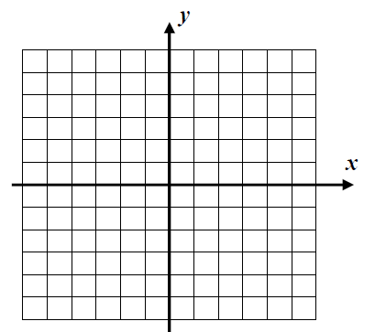
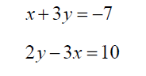

__________________________________________________________________________________________
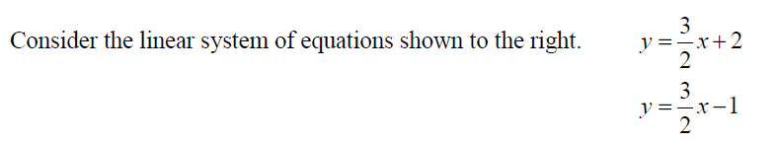
6.

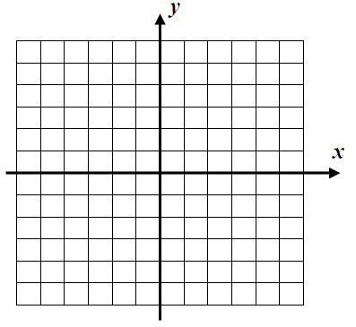
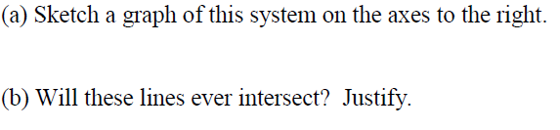

Name: _________________________________________ Date: ______________
EXTRA PRACTICE: Solving Systems of Linear Equations Graphically
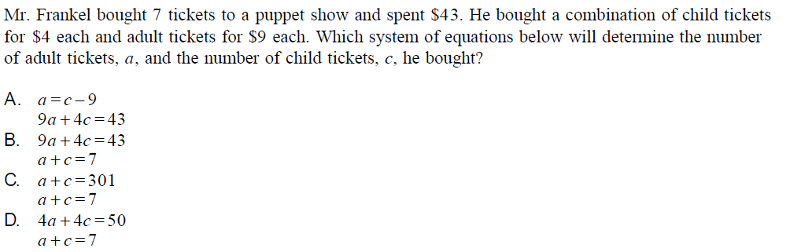
1.

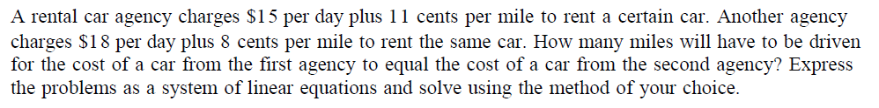
2.

3. Solve the following systems graphically. 4. Solve the following systems graphically.
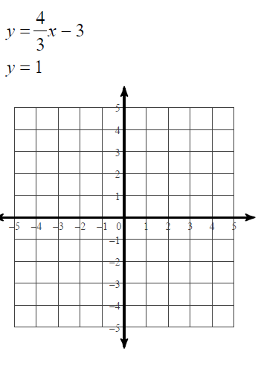
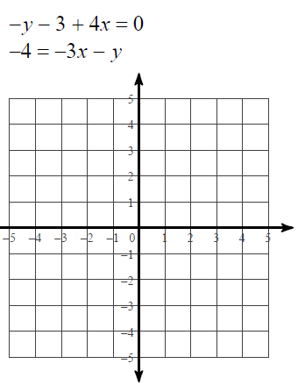

5. Solve the following systems graphically. 6. Solve the following systems graphically.
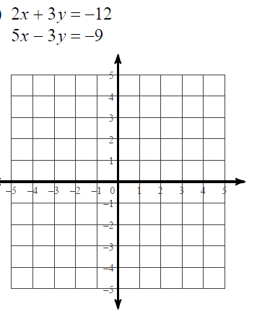
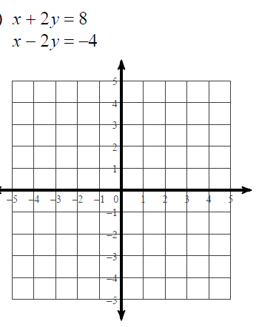

7. Solve the following systems graphically. 8. Solve the following systems graphically.
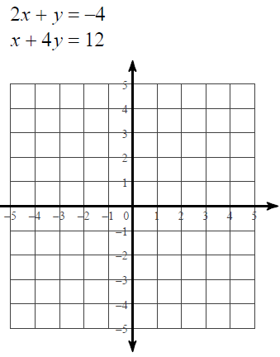
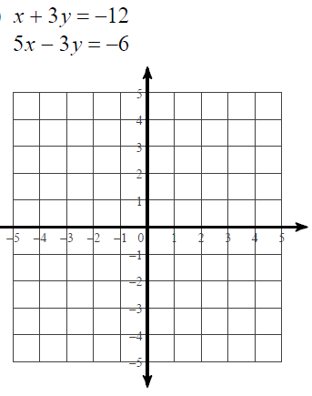

9. Find the equations for the two graphs below.
Explain why they do not intersect.
Answer:

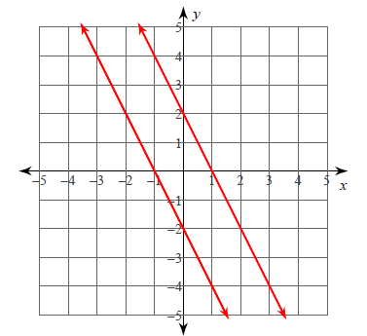

Topic: ________________________________________ Date: _________________

Starters:
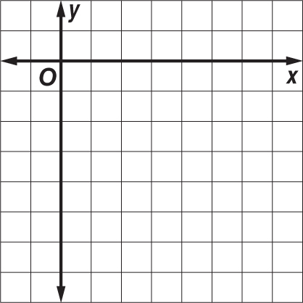
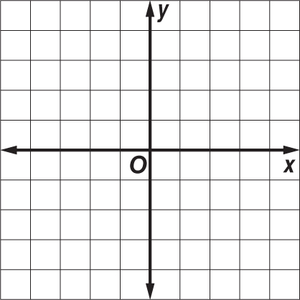
1. y = –3x 2. y = x – 5
y = –3x + 2 –2x + 2y = –10

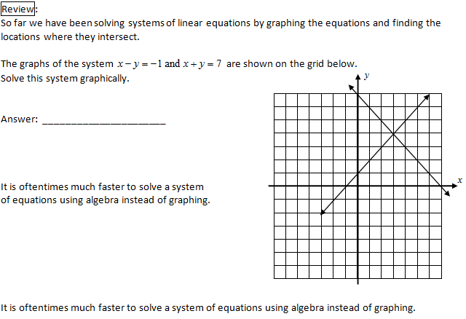

Notes:
There are two ways to solve systems of equations algebraically: (1) Elimination Method
(2) Substitution Method

Elimination Method:
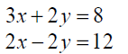
Example 1: Solve the following systems of equations using the elimination method:

__________________________________________________________________________________________

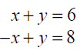
Elimination Method:

Example 2: Solve the following systems of equations using the elimination method:

__________________________________________________________________________________________

Note: Elimination occurred by simply adding the two equations together because one term in the second
equation was the additive inverse of a term in the first equation. When this isn’t the case, manipulation
of the equations must happen using the multiplication property of equality.
__________________________________________________________________________________________
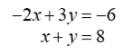

Example 3: Solve the following systems of equations using the elimination method:

Example 4: Solve the following systems of equations using the elimination method:

__________________________________________________________________________________________

Elimination Method:

Practice: Directions: Solve the following systems of equations by elimination.

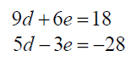
1. 2.

__________________________________________________________________________________________
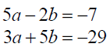
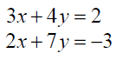
3. 4.

__________________________________________________________________________________________
5. 6.

Name: _________________________________________ Date: ______________
Practice: Solving Systems of Linear Equations Elimination

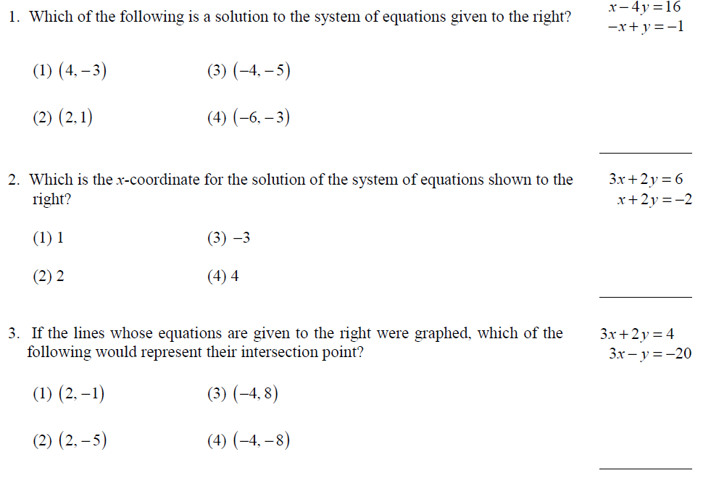

For numbers 4 and 5, solve the systems of equations by elimination only.

For numbers 6 – 9, solve the systems of equations by elimination only.

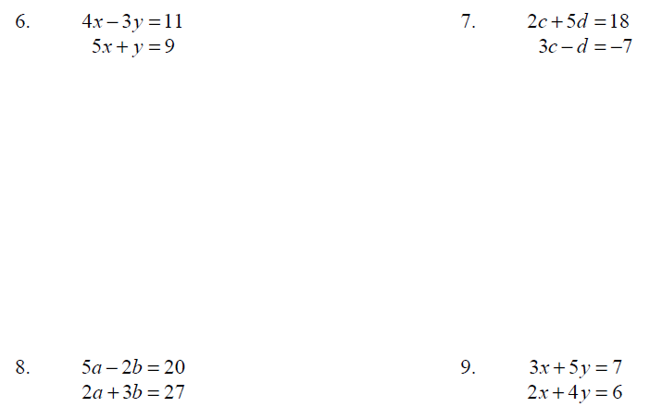

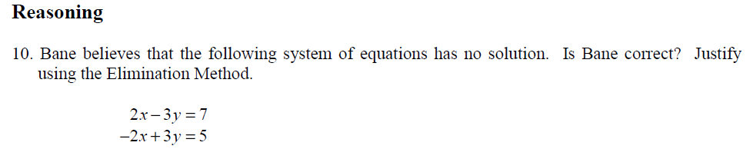

Topic: ________________________________________ Date: _________________

Starters: Directions: Use elimination to solve the systems of equations.

1. 2.

Notes:
There are two ways to solve systems of equations algebraically: (1) Elimination Method
(2) Substitution Method

Substitution Method:

Example 1: Solve the following systems of equations using the substitution method:

__________________________________________________________________________________________
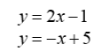

Example 2: Solve the following systems of equations using the substitution method:

Substitution Method: Directions: Solve the following questions using the substitution method.
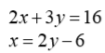

Example 3:

__________________________________________________________________________________________
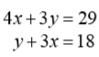

Example 4:

__________________________________________________________________________________________

Example 5:

__________________________________________________________________________________________
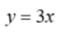
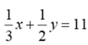
Example 6:

Name: _________________________________________ Date: ______________
Practice: Solving Systems of Linear Equations Substitution
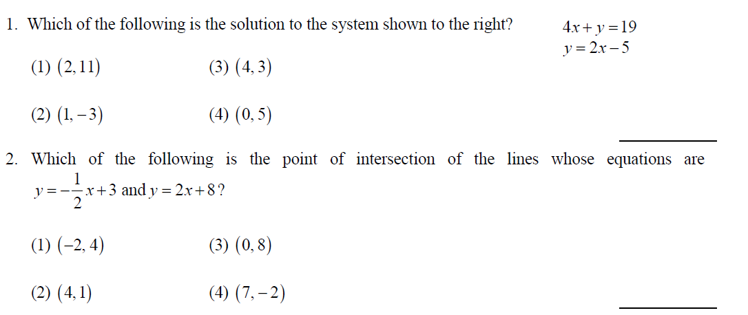

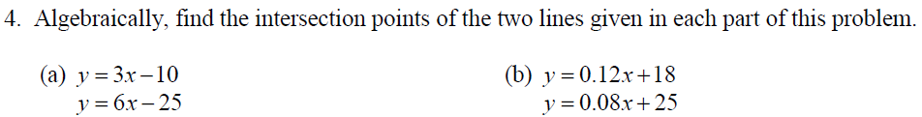

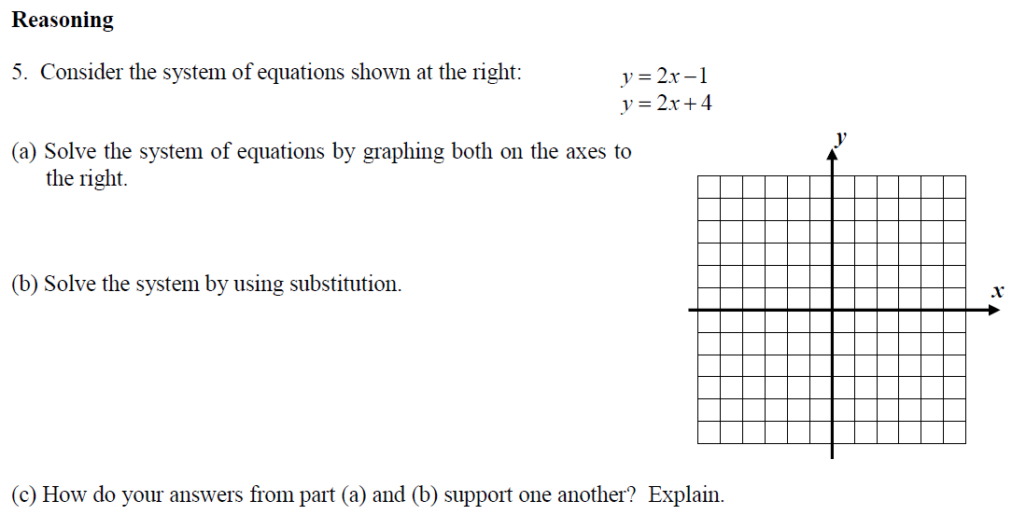

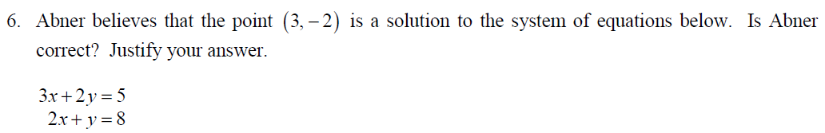

Topic: ________________________________________ Date: _________________

Often we are asked to solve a system of linear equations algebraically. The choice of the Substitution Method or the Elimination Method is typically not specified.

Note: Either method can always be used to solve a system if it has a solution.

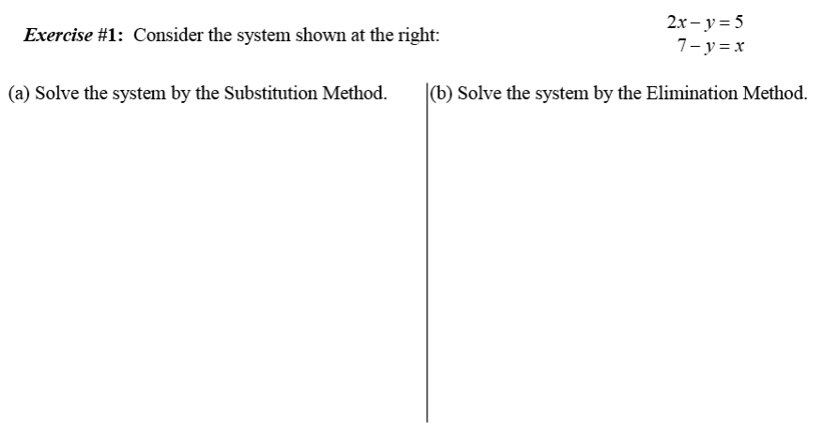

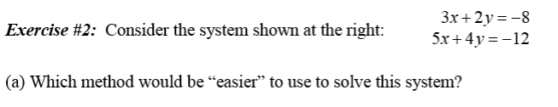

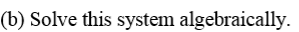

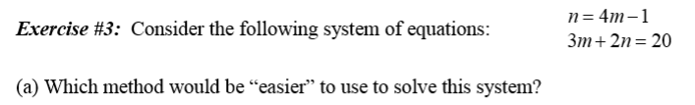

__________________________________________________________________________________________

__________________________________________________________________________________________

Name: _________________________________________ Date: ______________
Practice: Solving Systems of Linear Equations Algebraically

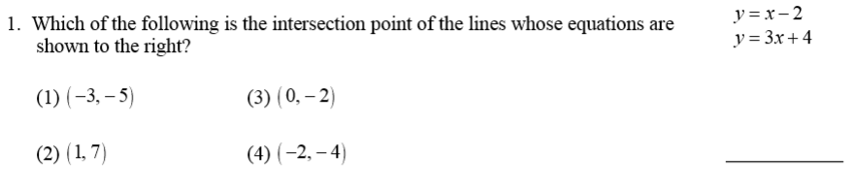

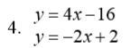

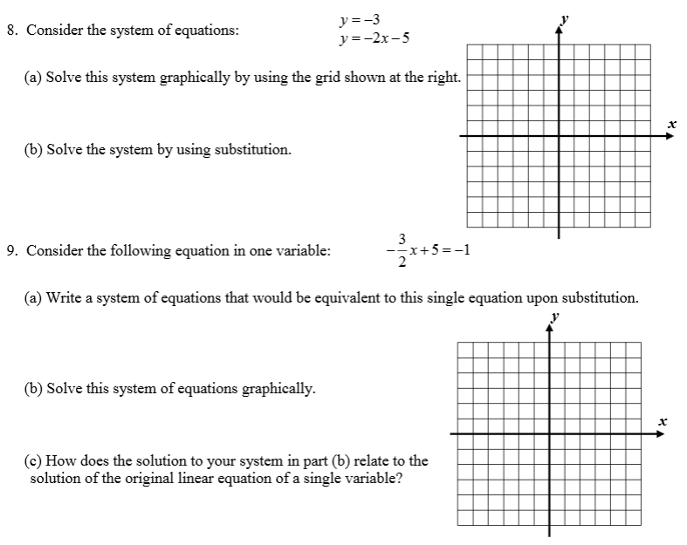

Topic: ________________________________________ Date: _________________

Starters: Solve the following systems of equations algebraically.
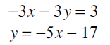
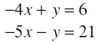
1. 2.

Notes:
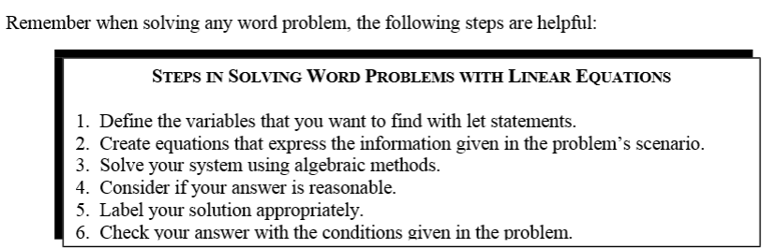

Word Problems:
1.

2.

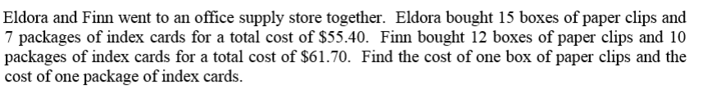
3.

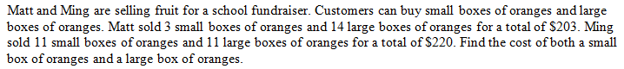
4.

5.

Name: _________________________________________ Date: ______________
Practice: Solving Systems of Linear Equations Real World Word Problems
Solve the following systems of equations algebraically
1.

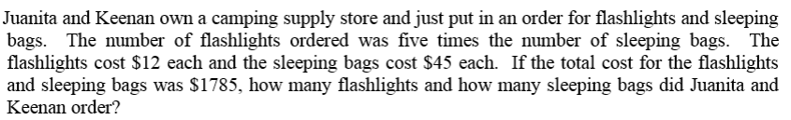
2.

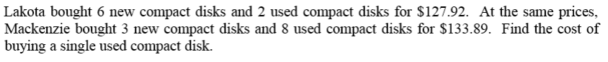
3.

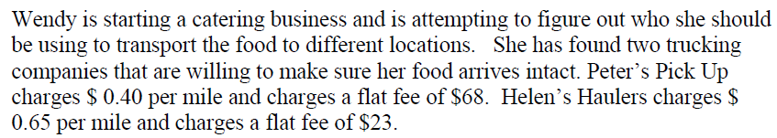
4.

5.

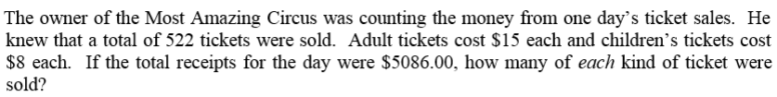
6.

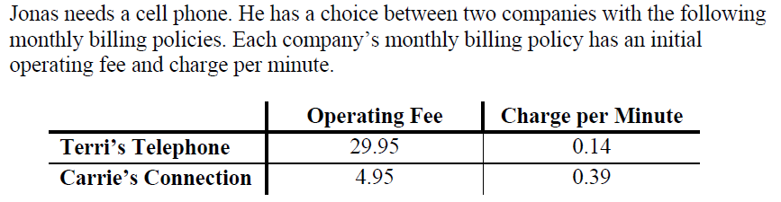
7.

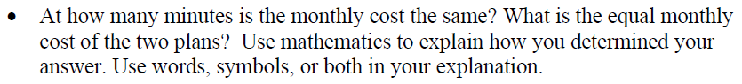

Name: _________________________________________ Date: ______________
Solving Systems of Linear Equations EXTRA PRACTICE - REVIEW

Solve problems 1-3 by graphing.
1. y = –3x 2. y = x – 5 3. 2x – 5y = 10
y = –3x + 2 –2x + 2y = –10 3x + y = 15

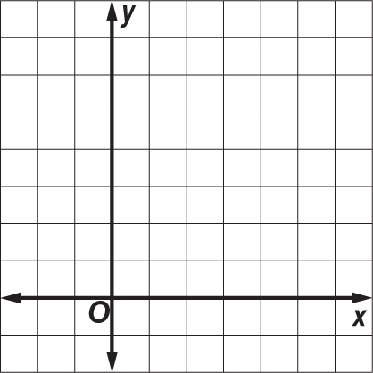

__________________________________________________________________________________________
Solve the following problems by substitution or elimination.

4. –r + t = 5 5. 2x – y = –5 6. x – 3y = –12
–2r + t = 4 4x + y = 2 2x + y = 11

Solve the following problems by substitution or elimination.

7. 2p – 3r = 6 8. 6w – 8z = 16 9. c + d = 6
–2p + 3r = –6 3w – 4z = 8 c – d = 0

10. 3y – z = –6 11. c + 2d = –2 12. 3r – 2t = 1
–3y – z = 6 –2c – 5d = 3 2r – 3t = 9

13. 8x + 3y = –5 14. 8q – 15r = –40 15. 3x – 4y = 12
10x + 6y = –13 4q + 2r = 56 $\frac{1}{3}$x – $\frac{4}{9}$y = $\frac{4}{3}$

Solve the following problems by substitution or elimination.

16. 4b – 2d = 5 17. x + 3y = 4 18. 4m – 2p = 0
–2b + d = 1 x = 1 –3m + 9p = 5

19. The sum of two numbers is 12. The difference of the same two numbers is –4. Find the numbers.

20. Twice a number minus a second number is –1. Twice the second number added to three times the first number is 9. Find the two numbers.

21. SPORTS Last year the volleyball team paid $5 per pair for socks and $17 per pair for shorts on a total purchase of $315. This year they spent $342 to buy the same number of pairs of socks and shorts because the socks now cost $6 a pair and the shorts cost $18.

a. Write a system of two equations that represents the number of pairs of socks and shorts bought each year.

b. How many pairs of socks and shorts did the team buy each year?

