**Name_______________________________________________________ Date________________**

**8.7: Alg. 1 : Perfect Square Trinomials**

**Starter(s):**

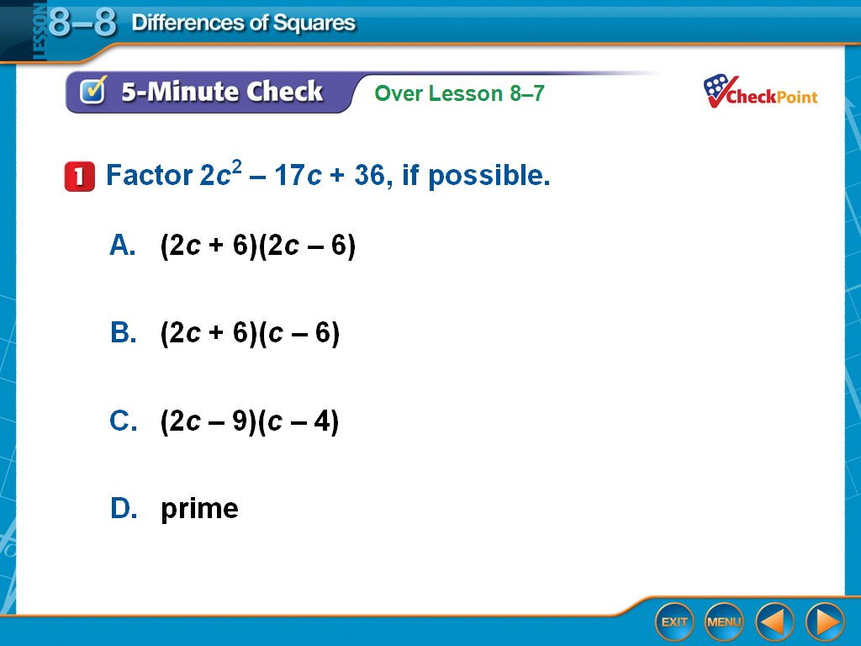 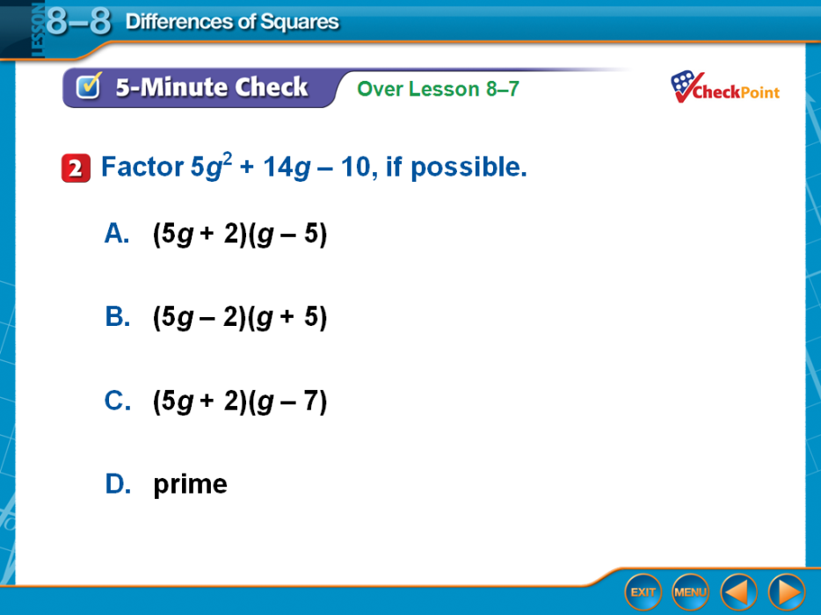

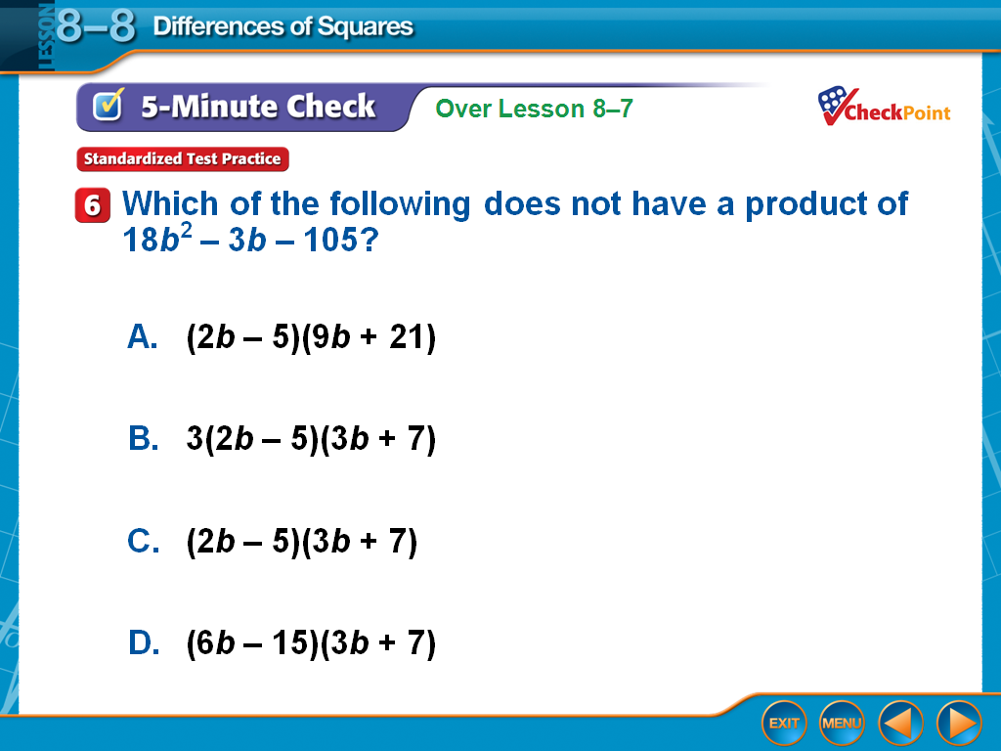

**3)**

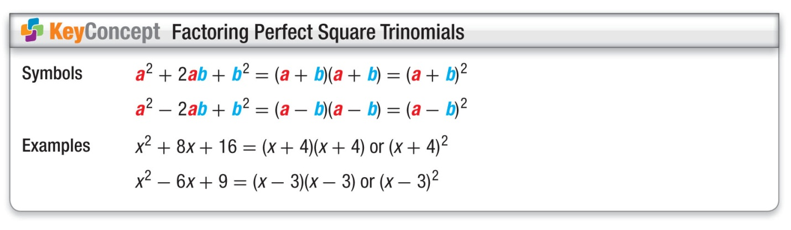

**Example 1) Factor $x^{2}+8x+16$. Practice 1) Factor $x^{2}-6x+9$.**

**Example 2)**

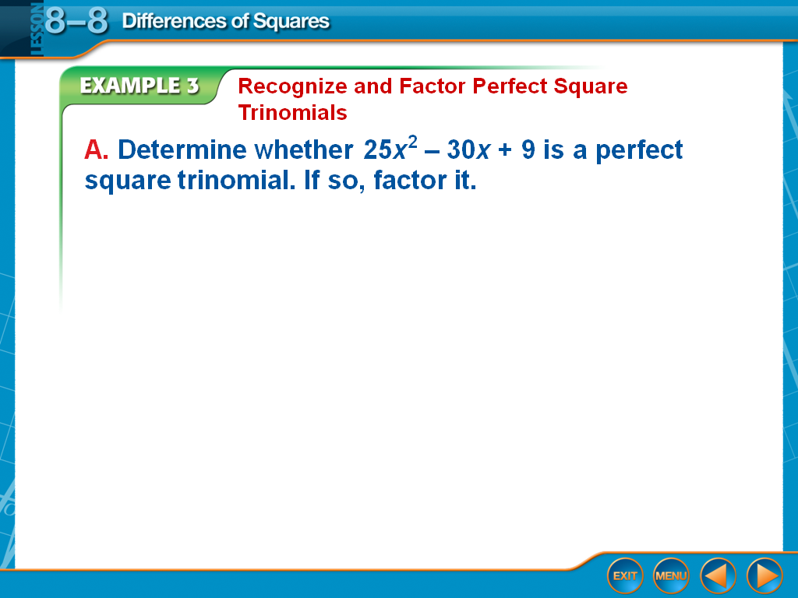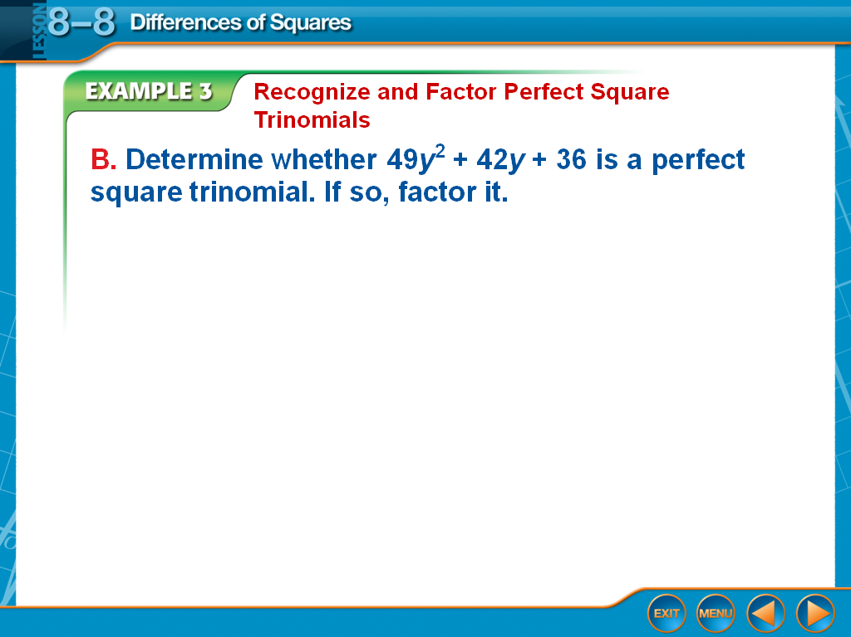

**Practice 2)**

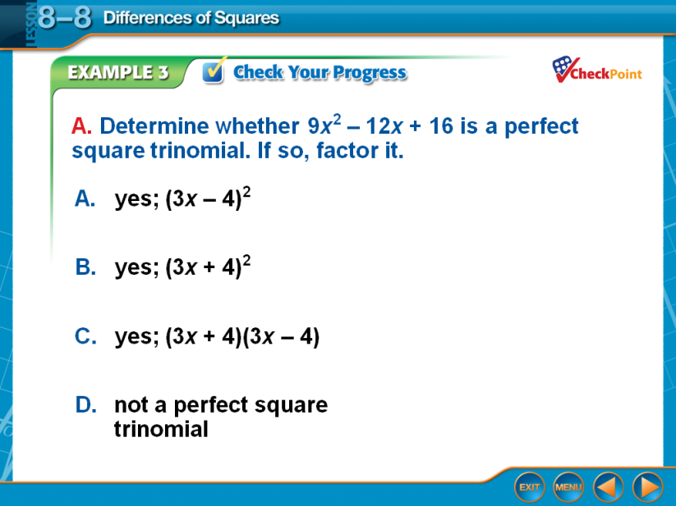 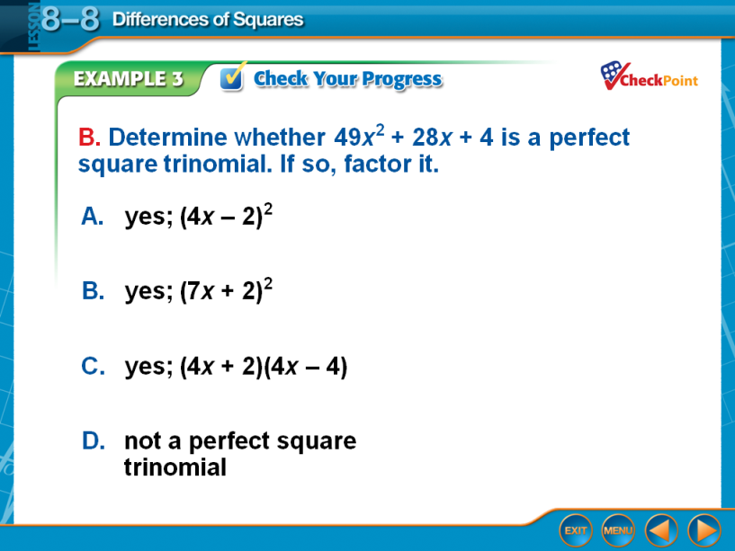

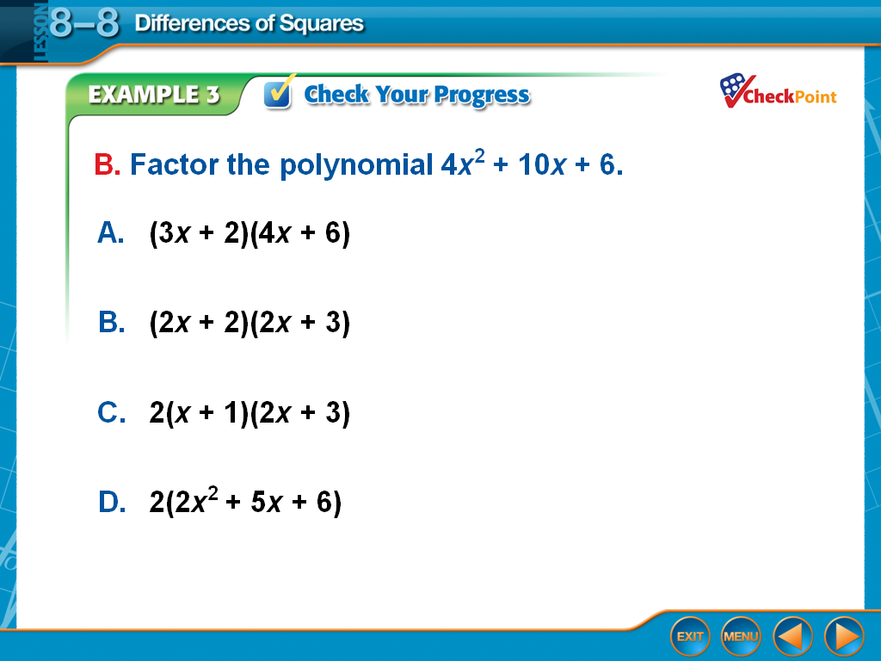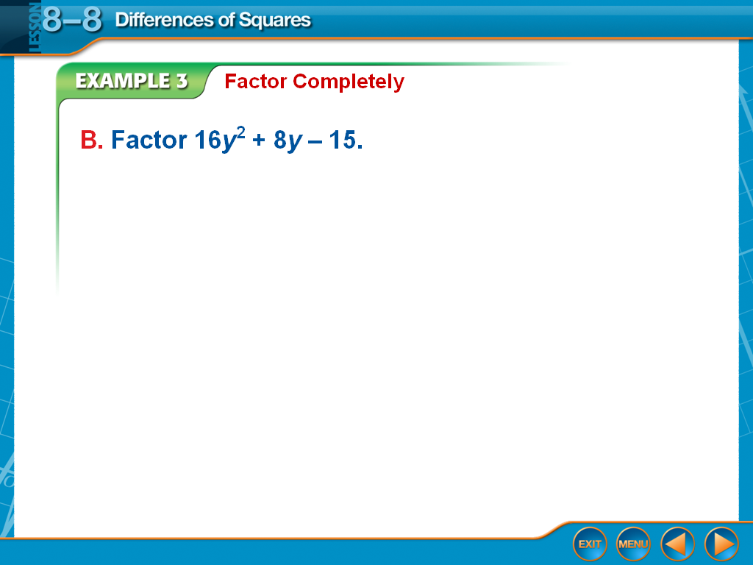**Example 3) Practice 3)**

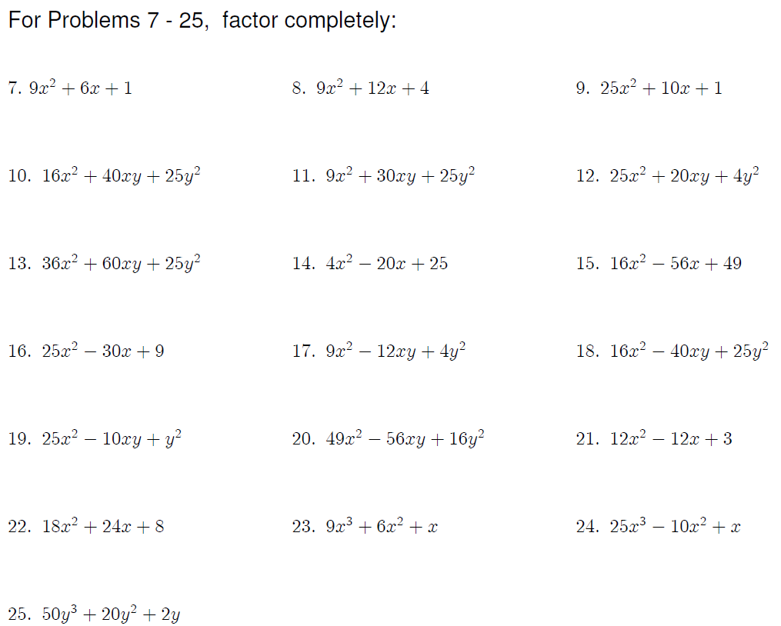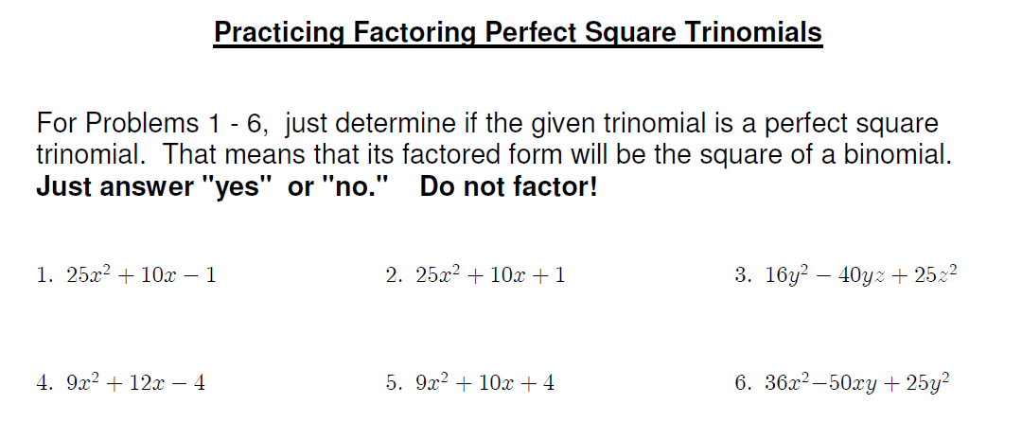

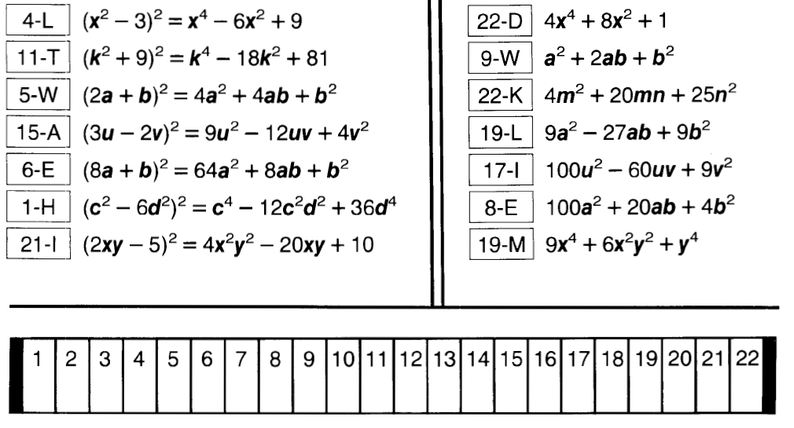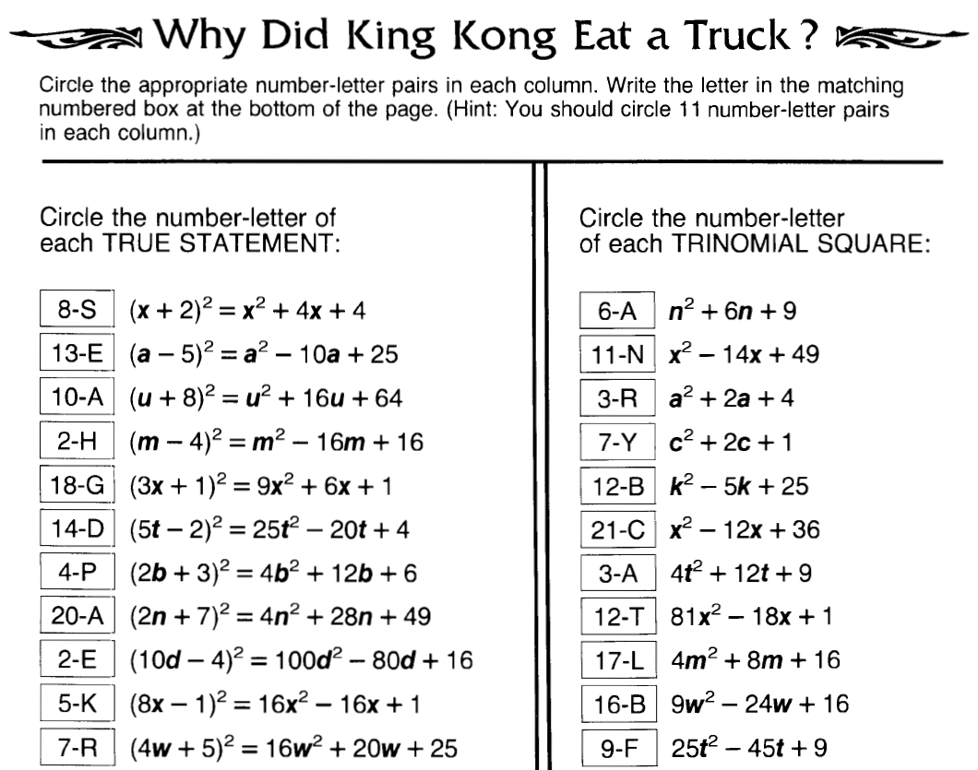

**Answers:**

