Algebra I – Quadratic Name______________________

Quiz 5-1-5.5 Review Date_______________________

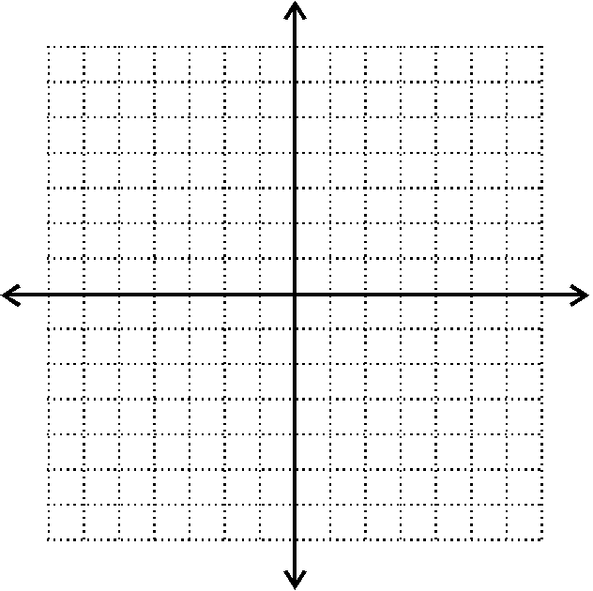

Find slope given the following information.

1.  2. 5x-3y = 18 3. (9,-5) (-3, 7) **4.**

6. James eats seven cakes every three days

**5.**

7. y varies directly with x and y = 14 when x = 3

- Find the constant of variation

- Write a direct variation equation that describes the relationship between x and y

- Find the value of y when x = 22

8. Does the following data represent direct variation? Show the work that justifies your answer.

|  |  |
| --- | --- |
| x | y |
| 3 | 17.1 |
| 8 | 45.6 |
| 11 | 62.7 |

9. Write the following equations in slope intercept form and then graph them.

a)  b) 4x+4y=20 c)  (change scale for graph)

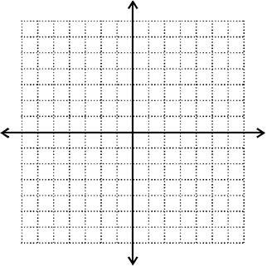

10 Write an equation in slope-intercept form given the

following information:

1. m= -3 b= 5 b) (3,8) (-2, 28) c)

11. Mario cannot stop shooting fireballs at the Koopa Troopas. Every time he eliminates one he gets 3 gold coins. If he started out with 123 coins to begins with, how many Koopa Troopa’s will he have to eliminate before he has 831 coins?

Write an equation in slope-intercept form and then use it to solve the problem.

12. Create an explicit formula for the pattern and then rewrite it as an equation in slope-intercept form.

-4,-11,-18,-25…..



11. Write an equation in Point-slope form given the following information:

1. m=8 (-3,10) b) (5,6) (7,14) c)

12. Write an equation in Standard form using integers given the following info:

a) 5x=24 -3y b)

13. Graph the following equations using the x and y intercepts:

a) 7x-5y=25 b) 3x +9y = 18 c) 5x -3y = 24

14. The Mountain Bike Club has $540 to spend on safety equipment. Helmets cost $90 and a set of elbow pads cost $60. Write an equation in standard form that models the different combinations of helmets and elbow pads that they could purchase. Use a graph to determine 3 different combinations of equipment that they could purchase for $540. You can use the calculator if you know how.