Standard Normal Tab |  |  |  |  |  |  | le
z | .0 | .1 | .2 | .3 | .4 | .5 | .6 | .7 | .8 | .9
-3 | .0013 | .0010 | .0007 | .0005 | .0003 | .0002 | .0002 | .0001 | .0001 | .0000+
-2 | .0228 | .0179 | .0139 | .0107 | .0082 | .0062 | .0047 | .0035 | .0026 | .0019
-1 | .1587 | .1357 | .1151 | .0968 | .0808 | .0668 | .0548 | .0446 | .0359 | .0287
0 | .5000 | .4602 | .4207 | .3821 | .3446 | .3085 | .2743 | .2420 | .2119 | .1841
0 | .5000 | .5398 | .5793 | .6179 | .6554 | .6915 | .7257 | .7580 | .7881 | .8159
1 | .8413 | .8643 | .8849 | .9032 | .9192 | .9332 | .9452 | .9554 | .9641 | .9713
2 | .9772 | .9821 | .9861 | .9893 | .9918 | .9938 | .9953 | .9965 | .9974 | .9981
3 | .9987 | .9990 | .9993 | .9995 | .9997 | .9998 | .9998 | .9999 | .9999 | 1.000-
Ch. 6 Test Reference Sheet

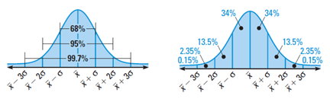
Areas Under Normal Curve

