Solving Systems of Equations & Graphing Linear Inequalities!

Name____________________________ Date_________

DO Now:

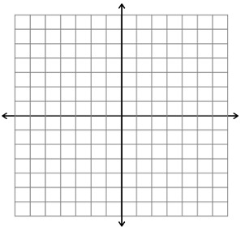1. Graph the line passing through the point (2,4) with a slope of .

2. Write the equation of a line perpendicular to the line  and passes through the point

(1,-2).

**Notes:**

I. Solve these systems of equations using the graphing technique:

Ex 1: Practice 1:



II. Solve these systems of equations using the substitution method:

Ex2: Practice 2:

III. Solve these systems of equations using the elimination method:

Ex3: Practice 3:

Solve this system of equations using all three methods. Which one was easiest for you?

Problem:

Method I:

Method II:

Method III:

Word Problems:

1. The difference of two numbers is 3. Their sum is 13. Find the numbers.

2. Matt and Ming are selling fruit for a school fundraiser. Customers can buy small boxes of oranges and large boxes of oranges. Matt sold 3 small boxes of oranges and 14 large boxes of oranges for a total of $203. Ming sold 11 small boxes of oranges and 11 large boxes of oranges for a total of $220. Find the cost of both a small box of oranges and a large box of oranges.

Graphing Systems of Equations!

**Solve each system of inequalities by graphing.**

**1.**  **2.** 



**3.**  **4.** 



**5.**  **6.** 

