Name_________________ Block_____ Date___________

**Aim:** How do we solve systems of equations in three variables?

**Do Now:**

Solve by substitution or elimination.

1.  **2. **

**Lesson:**

Like systems of equations in two variables, systems in three variables can have one solutions, infinite solutions, or no solutions. A solution of such is an ______________________.

|  |  |  |
| --- | --- | --- |
| One solution: | Infinitely many solutions: | No Solution: |

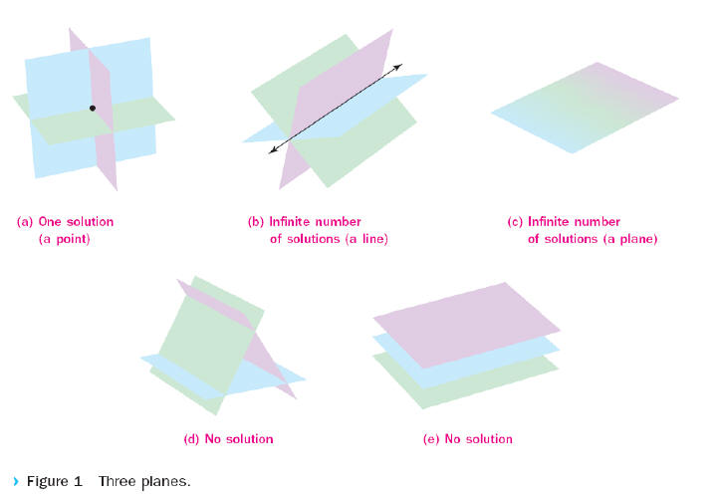

**Example 1 A System with One Solution**

**Solve the system of equations.**

***a* + 2*b* – 4*c* = 8**

**2*a* – *b* + *c* = –8**

**–*a* – 3*b* + 2*c* = –9**

**Example 2 No Solution and Infinite Solutions**

**Solve the system of equations.**

**2*x* + 4*y* – 2*z* = 10**

**–3*x* – 6*y* + 3*z* = –15**

**4*x* – 4*y* + 8*z* = 20**

**Example 3 Write and Solve a System of Equations**

**Scott is in charge of purchasing a variety of tickets to a baseball game to be given to employees who met or exceeded their sales quotas for the past month. There are 3 types of tickets available for the game at a cost of $25 apiece, $35 apiece, or $50 apiece. Scott needs to buy 40 tickets in all and can spend $1670. He wants to buy twice as many $35 tickets as $25 tickets. How many of each type of ticket should he buy?**