Geometry- Quadratic Emphasis
In Class Group Project
Where do I see these shapes in the real world?

In small cooperative learning groups (2-3 students), your task is to use http://www.geogebra.org to neatly trace images found in the real world and prove that they are regular polygons and specific quadrilaterals.
Your final grade will be based on:
- The quality of the pictures you obtain. If you cannot find any of the following shapes below in your daily travels find a decent image with a google search. (FYI: at least 5 of the 9 pictures must be pictures that you or your group members take)
- Accuracy, precision and detail of tracing and measuring angles, sides, diagonals etc. for common regular polygons and specific quadrilaterals that we see in everyday life.
- Your project must include the following shapes: triangle, rectangle, rhombus, square, kite, trapezoid, pentagon, hexagon, and octagon
- Overall group collaboration and input to the final product. You must be working diligently and cooperatively both days to earn the full credit.

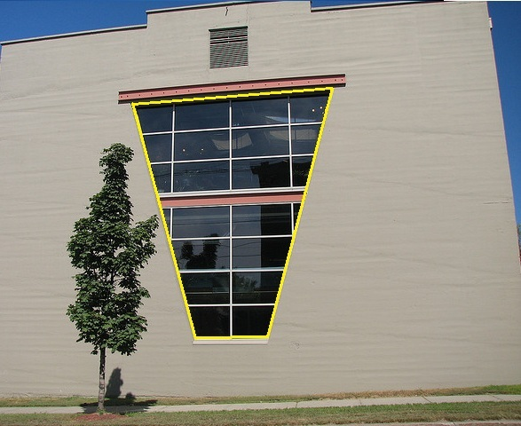
Directions:
STEP 1: Create a Geogebra account (everyone needs an account but only one person needs to submit this portion of the project)
You can either sign in with your HPS Google Account or sign in under your own e-mail address and password. You need an account so you can both save and share your work.
STEP 2: Upload a saved image.
Save your image provided to the Downloads folder of your Chromebook. See directions below for how to upload an image to Geogebra.

STEP 3: Create a page for each of the following shapes: triangle, rectangle, rhombus, square, kite, trapezoid, pentagon, hexagon, and octagon. FYI: (Each page should include a synopsis of the figure providing why it is the following figure)

STEP 4: When you’re done, get the link to your work. This can be done with the share button in the top right corner of the website, if you’re logged in. Paste the link to the comment box of the Term 2 Project Tab on my website.
Some quick how-tos:
How do I make an account?
Click on the icon in the top right corner. Click on in the drop down menu. Choose in the drop down menu. Follow through the steps to create an account.

How do I turn the axes off?
Click on the tool and unselect the highlighted grid .

How do I upload an image?
Click on the tool and select and click on the blank screen for an upload image to appear.

How do I trace an image to create a polygon?
Click on the 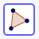 tool and select 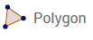. Trace your image without letting go of the curser. Adjust trace as needed.

How do I measure an angle?
Click on the 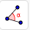 tool and select 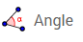. Click on the vertices that make up your angle going in the clockwise direction.

How do I measure a segment?
Click on the tool and select 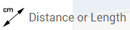. Click on the side that you wish to measure.

How do I create a segment?
Click on the tool and select . Click from point to point of the segment you would like to create.

How do I bisect a line?
Click on the 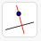 tool and select . Click from point to point for the side you would like to bisect.

How do I bisect an angle?
Click on the tool and select 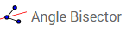. Click on the vertices that make the angle you would like to bisect going in the clockwise direction.

How do I add commentary?
Click on the or tool and select and click on the blank screen for a textbox to appear.

How do I save my work?
Click on the icon in the top right corner. Click on in the drop down menu. Title your document with the shapes name.

How do I revisit my saved work?
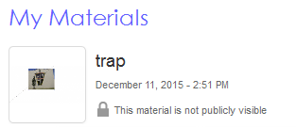
Go to the main page of geogebra.org. When you are signed in you should see a top selection bar. Click on . On the bottom of that page you should see your saved work:

What do I do when I am done with all of the shapes?
Go to the main page of geogebra.org. When you are signed in you should see a top selection bar. Click on . On the bottom of that page you should see click . Once you are on the next page title it “Shapes Project.” Add all of your different shapes by selecting .

Summary questions: (FYI: These must be typed, printed and passed in on the date this project is due)
- How does the angle at which the photo was taken affect the angles/ side measures of the figures?
- What figures belong to the same families? For what reasons?

This Project is DUE: _____________________________________________

