Solve each equation by graphing the related function. If the equation has no real-number solution, write no solution.
1. x² – 16 = 0 2. x² + 12 = 0 3. 2x² – 18 = 0
4. 7x² = 0

Solve each equation by finding square roots. If the equation has no real-number solution, write no solution.

10. t² = 25 | 11. k² = 484
13. d² – 14 = –50 | 14. 9y² – 16 = 0
Solve by factoring.

7. n² + 2n – 15 = 0 | 8. a² – 15a + 56 = 0 | 9. z² – 10z + 24 = 0
10. 8x² + 10x + 3 = 0
Solve by factoring.

 | 11. 3b² + 7b – 6 = 0 | 12. 5p² – 9p – 2 = 0
13. w² + w = 12 | 14. s² + 12s = –32
Solve by factoring.

7. n² + 2n – 15 = 0 | 8. a² – 15a + 56 = 0 | 9. z² – 10z + 24 = 0
10. 8x² + 10x + 3 = 0 | 11. 3b² + 7b – 6 = 0 | 12. 5p² – 9p – 2 = 0
13. w² + w = 12 | 14. s² + 12s = –32 | 15. d² = 5d
16. 3j² – 20j = –12 | 17. 12y² + 40y = 7 | 18. 27r² + 69r = 8

Solve by factoring.

 |  | 15. d² = 5d
16. 3j² – 20j = –12 | 17. 12y² + 40y = 7 | 18. 27r² + 69r = 8

Find the value of x as it relates to each rectangle or triangle.

27. Area = 60 cm²
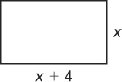
28. Area = 234 yd²
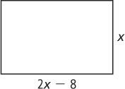

29. Area = 20 in.²
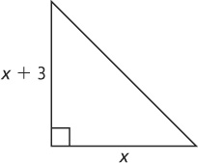
30. Area = 150 m²
