Name_______________________ Block____ Date_______

Systems of Equations and Graphing Inequalities REVIEW SHEET

**Solve each system by graphing.**

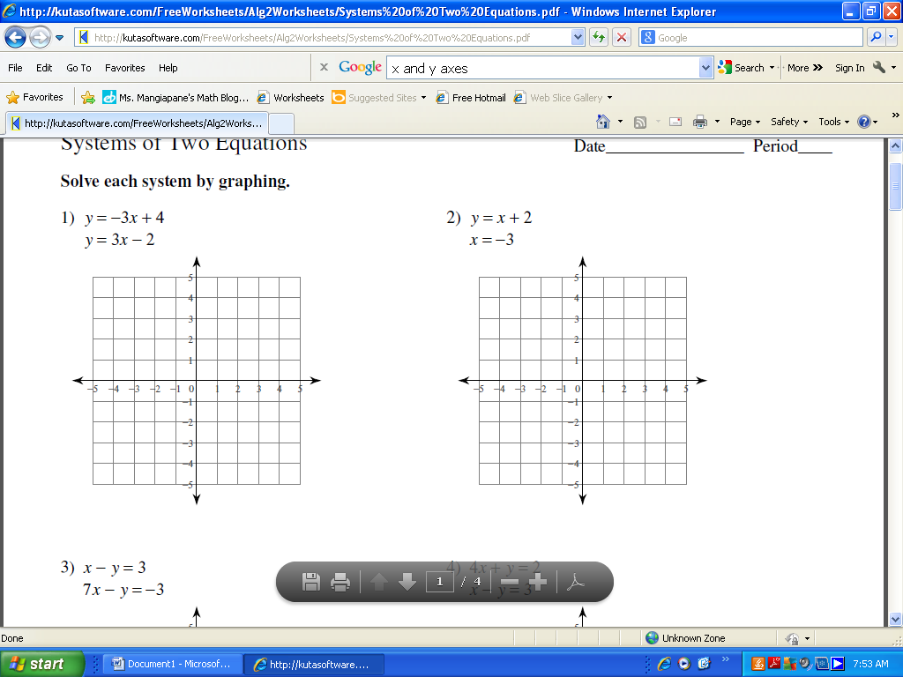 

**Solve each system by elimination.**

 

**Solve each system by substitution.**

 

7. The school that Joe goes to is selling tickets to a play. On the first day of ticket sales the school sold 4 senior citizen tickets and 4 students tickets for a total of $84. The school took in $246 on the second day by selling 11 senior citizen tickets and 12 student tickets. Find the price of a senior citizen ticket and the price of a student ticket.

8. The difference of two numbers is 3. Their sum is 13. Find the numbers.

**Sketch the solution to each system of inequalities.**

 

