Term 1 Project - Algebra I QE

For this project you will be creating a story book. Previously in class we solved word problems involving fractions, equations with one variable, multi-step equations, equations with variables on both sides, formulas, ratios, rates, conversions, proportions, similar figures, percent, percent change, and inequalities. Now it is your job to create a story connecting three of these topics.
- Step One: Research real world situations that are modeled by three of these topics. (You may use your textbook, notes, or online resources.)
- Step Two: Write out short detailed descriptions of real word situations that can be modeled by these topics and connect them with a story. Make sure to include realistic data.
- Step Three: Solve your word problems.
- For example:
  - The first page of you story could say: Sarah just bought a new phone but does not know whether to choose Verizon or AT&T. She goes to each store and finds out Verizon costs $20 a month and 10 cents per text. AT&T costs $15 a month and 20 cents per text. She debates which plan is better on her walk home. Which is better for her if she normally sends 200 texts per month?
  - When you flip the page you should find the solution: Sarah should choose Verizon because that is the cheaper plan after sending 50 texts (with work shown).
  - Then your story can continue on to the next page with: Sarah wants to buy songs and apps to put on her new phone. If she has a gift card for $40 and she spends $7 on apps how many songs can she buy if they each cost $1.50? Set up an inequality and solve.
  - When you flip the page you should find the solution: She can buy up to 22 songs ( $x≤22$) (with work shown).
  - Then continue with a third word problem.
You MUST have at least three word problems in your story involving three DIFFERENT mathematical concepts. Your examples must be original and connected by a story line.
CHECKLIST:
- A cover page with title, author, and any illustrations/pictures
- At least 6 pages (3 word problems with illustrations/pictures and 3 pages of correct solutions)
- Solutions are detailed and include use of proper units
- A story line that connects all the word problems.

DUE DATE: ___________________________________

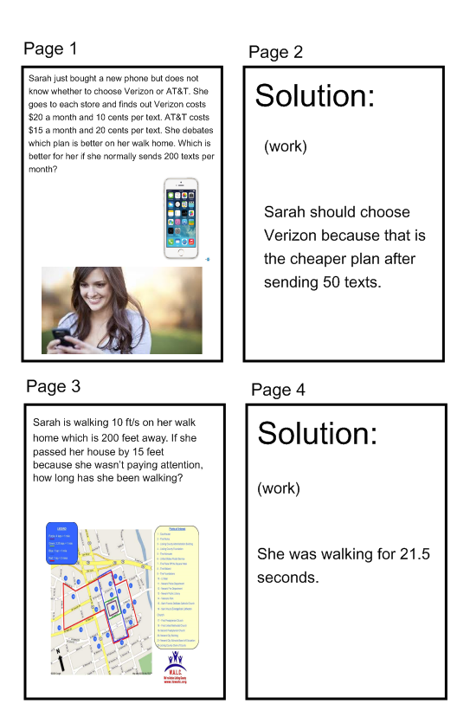
She can buy up to 22 songs
(x $≤22$)
Sarah wants to buy songs and apps to put on her new phone. If she has a gift card for $40 and she spends $7 on apps how many songs can she buy if they each cost $1.50? Set up an inequality and solve.

