The Normal Distribution – What is a “Standard Normal Distribution”?
https://goo.gl/9duFTU
What three ideas should come to mind when you read the words normal distribution?

- _______________________________________________________________

- _______________________________________________________________

- _______________________________________________________________

Sketch the normal distribution curve below:

What two additional ideas should come to mind when you see the word “standard” to describe the normal distribution?

- _______________________________________________________________

- _______________________________________________________________

The Normal Distribution – Normal Distribution (Part 1)
https://goo.gl/N3P6hf
When we have symmetrical data we use the ______________________________________________.
The mean goes in the _______________________.
How many standard deviations go on each side of the mean? ____________.
What percent of data falls between the first standard deviations? _________.
Fill out the rest of the normal distribution curve below if the mean is 75 and the standard deviation if 5.
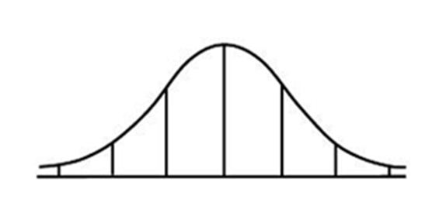
85
70

Using the normal distribution curve above answer the following questions:
About what percent of the data falls between 70 and 80? ___________________________
About what percent of the data falls between 65 and 85? ___________________________
About what percent of the data falls between 70 and 75? ___________________________
About what percent of the data falls between 70 and 85? ___________________________
About what percent of the data falls between 60 and 65? ___________________________
About what percent of the data is below 75? _____________________________________

