Algebra I Quadratic Emphasis Name___________________________
9.1-9.4 Project Date____________________________

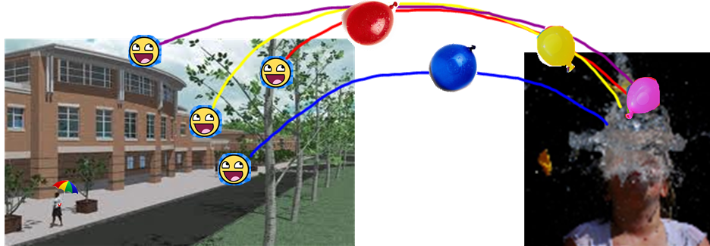
This project is due: _____________________________________

Alpha (Red)  Equation: ______________________________________  Maximum Height: ________________________________  Time of impact: __________________________________ | Beta (Blue)  Equation: ______________________________________  Maximum Height: ________________________________  Time of impact: __________________________________
Charlie (Green)  Equation: ______________________________________  Maximum Height: ________________________________  Time of impact: __________________________________  v | Delta (Purple)  Equation: ______________________________________  Maximum Height: ________________________________  Time of impact: __________________________________

